Quantitative Strategies on High-Frequency Data

Elgun Ismayilov

2025-01-26

Table of Contents

# Introduction

In this project, we implement two simple trading strategies for a single asset: the NASDAQ index futures contract.

## Strategy 1: Exponential Moving Average (EMA)

This strategy uses a 120-period EMA. The trading logic is as follows:

* If, at time $t_{i−1}$, the asset’s price is higher than the EMA, a buy order is placed.
* Otherwise, a sell order is executed at time $t_{i}$.

## Strategy 2: EMA with Volatility Band

This strategy uses a 60-period EMA along with a volatility band based on a 120-period window. The trading logic is as follows:

* If, at time $t_{i−1}$, the asset’s price is greater than the EMA plus the volatility band, a buy order is placed.
* Otherwise, a sell order is executed.

# Load necessary libraries

library(xts) # For handling xts time-series objects (e.g., lag.xts, diff.xts)  
library(TTR) # For technical trading rules, used here for EMA calculation  
library(quantmod) # For financial modeling and charting (e.g., chartSeries)  
library(PerformanceAnalytics) # Used for performance metrics (e.g., Sortino ratio)  
library(tseries) # Used for maxdrawdown  
library(roll) # Used for rolling statistics (e.g., roll_mean)  
library(chron) # Used for handling and comparing times (e.g., times function)  
library(DT) # Used for create table

source("https://raw.githubusercontent.com/ptwojcik/HFD/master/function_positionVB.R") # Load custom function for position calculation

# Load datas in sample period

load("/Users/elgun/Desktop/Quantitative-strategies-on-High-Frequency-Data/data/data1_2022_Q1.RData")  
load("/Users/elgun/Desktop/Quantitative-strategies-on-High-Frequency-Data/data/data1_2022_Q3.RData")  
load("/Users/elgun/Desktop/Quantitative-strategies-on-High-Frequency-Data/data/data1_2022_Q4.RData")  
load("/Users/elgun/Desktop/Quantitative-strategies-on-High-Frequency-Data/data/data1_2023_Q2.RData")  
load("/Users/elgun/Desktop/Quantitative-strategies-on-High-Frequency-Data/data/data1_2023_Q4.RData")  
load("/Users/elgun/Desktop/Quantitative-strategies-on-High-Frequency-Data/data/data1_2024_Q1.RData")  
load("/Users/elgun/Desktop/Quantitative-strategies-on-High-Frequency-Data/data/data1_2024_Q2.RData")

# Load datas in sample period

load("/Users/elgun/Desktop/Quantitative-strategies-on-High-Frequency-Data/data/data1_2022_Q2.RData")  
load("/Users/elgun/Desktop/Quantitative-strategies-on-High-Frequency-Data/data/data1_2023_Q1.RData")  
load("/Users/elgun/Desktop/Quantitative-strategies-on-High-Frequency-Data/data/data1_2023_Q3.RData")  
load("/Users/elgun/Desktop/Quantitative-strategies-on-High-Frequency-Data/data/data1_2024_Q3.RData")  
load("/Users/elgun/Desktop/Quantitative-strategies-on-High-Frequency-Data/data/data1_2024_Q4.RData")

# Data preparation

## Convert ‘time’ column to POSIXlt datetime format with GMT timezone

data1_2022_Q1$time <- strptime(data1_2022_Q1$time,   
 format = "%d.%m.%Y %H:%M:%OS",  
 tz = "GMT")

data1_2022_Q2$time <- strptime(data1_2022_Q2$time,   
 format = "%d.%m.%Y %H:%M:%OS",  
 tz = "GMT")

data1_2022_Q3$time <- strptime(data1_2022_Q3$time,   
 format = "%d.%m.%Y %H:%M:%OS",  
 tz = "GMT")

data1_2022_Q4$time <- strptime(data1_2022_Q3$time,   
 format = "%d.%m.%Y %H:%M:%OS",  
 tz = "GMT")

data1_2023_Q1$time <- strptime(data1_2023_Q1$time,   
 format = "%d.%m.%Y %H:%M:%OS",  
 tz = "GMT")

data1_2023_Q2$time <- strptime(data1_2023_Q2$time,   
 format = "%d.%m.%Y %H:%M:%OS",  
 tz = "GMT")

data1_2023_Q3$time <- strptime(data1_2023_Q3$time,   
 format = "%d.%m.%Y %H:%M:%OS",  
 tz = "GMT")

data1_2023_Q4$time <- strptime(data1_2023_Q4$time,   
 format = "%d.%m.%Y %H:%M:%OS",  
 tz = "GMT")

data1_2024_Q1$time <- strptime(data1_2024_Q1$time,   
 format = "%d.%m.%Y %H:%M:%OS",  
 tz = "GMT")

data1_2024_Q2$time <- strptime(data1_2024_Q2$time,   
 format = "%d.%m.%Y %H:%M:%OS",  
 tz = "GMT")

data1_2024_Q3$time <- strptime(data1_2024_Q3$time,   
 format = "%d.%m.%Y %H:%M:%OS",  
 tz = "GMT")

data1_2024_Q4$time <- strptime(data1_2024_Q4$time,   
 format = "%d.%m.%Y %H:%M:%OS",  
 tz = "GMT")

## Extract time (HH:MM:SS) for the entire index

times_data_2022_Q1 <- substr(index(data1_2022_Q1), 12, 19)  
times_data_2022_Q2 <- substr(index(data1_2022_Q2), 12, 19)  
times_data_2022_Q3 <- substr(index(data1_2022_Q3), 12, 19)  
times_data_2022_Q4 <- substr(index(data1_2022_Q4), 12, 19)  
times_data_2023_Q1 <- substr(index(data1_2023_Q1), 12, 19)  
times_data_2023_Q2 <- substr(index(data1_2023_Q2), 12, 19)  
times_data_2023_Q3 <- substr(index(data1_2023_Q3), 12, 19)  
times_data_2023_Q4 <- substr(index(data1_2023_Q4), 12, 19)  
times_data_2024_Q1 <- substr(index(data1_2024_Q1), 12, 19)  
times_data_2024_Q2 <- substr(index(data1_2024_Q2), 12, 19)  
times_data_2024_Q3 <- substr(index(data1_2024_Q3), 12, 19)  
times_data_2024_Q4 <- substr(index(data1_2024_Q4), 12, 19)

# Plot of price series

# Set up a grid layout for plots (4 rows, 3 columns)  
par(mfrow = c(4, 3), mar = c(4, 4, 2, 1))   
  
# Generate individual plots for each dataset  
plot(data1_2022_Q1$NQ, type = "l", col = "blue", main = "2022 Q1")  
plot(data1_2022_Q2$NQ, type = "l", col = "blue", main = "2022 Q2")  
plot(data1_2022_Q3$NQ, type = "l", col = "blue", main = "2022 Q3")  
plot(data1_2022_Q4$NQ, type = "l", col = "blue", main = "2022 Q4")  
plot(data1_2023_Q1$NQ, type = "l", col = "blue", main = "2023 Q1")  
plot(data1_2023_Q2$NQ, type = "l", col = "blue", main = "2023 Q2")  
plot(data1_2023_Q3$NQ, type = "l", col = "blue", main = "2023 Q3")  
plot(data1_2023_Q4$NQ, type = "l", col = "blue", main = "2023 Q4")  
plot(data1_2024_Q1$NQ, type = "l", col = "blue", main = "2024 Q1")  
plot(data1_2024_Q2$NQ, type = "l", col = "blue", main = "2024 Q2")  
plot(data1_2024_Q3$NQ, type = "l", col = "blue", main = "2024 Q3")  
plot(data1_2024_Q4$NQ, type = "l", col = "blue", main = "2024 Q4")

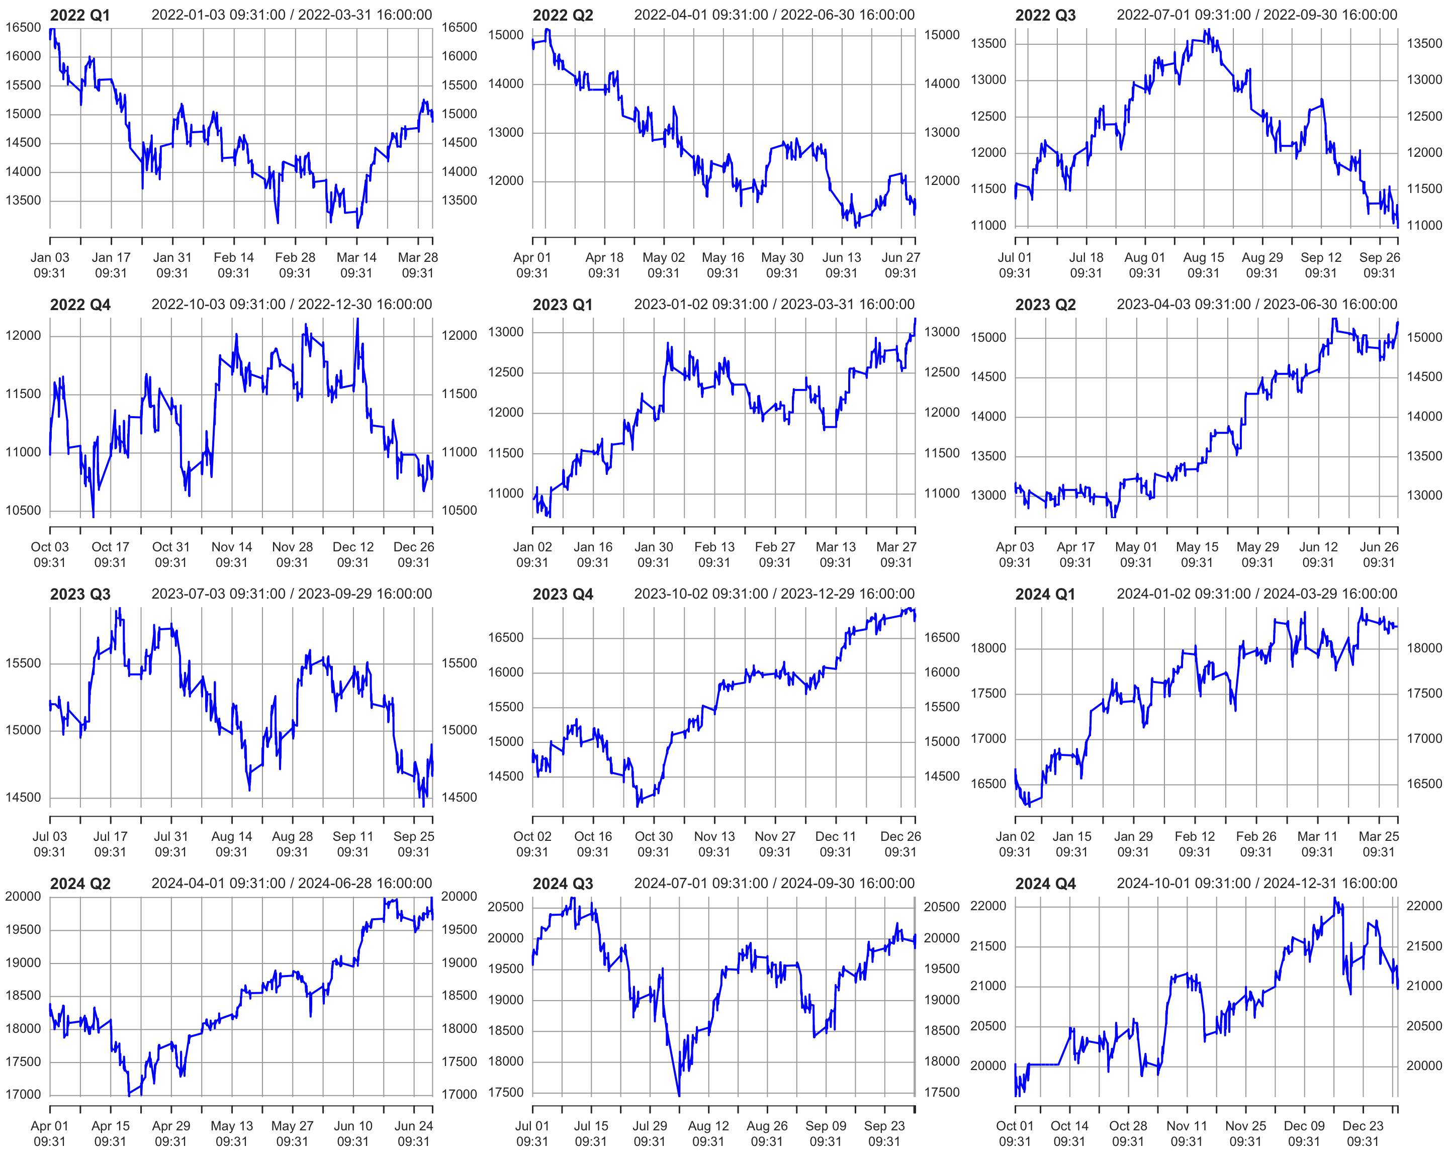

# Reset the layout to default  
par(mfrow = c(1, 1))

# Strategies based on 2022 Q1

data1_2022_Q1["T09:31/T09:35",] <- NA # Remove data between 09:31 and 09:35 by setting it to NA  
data1_2022_Q1["T15:56/T16:00",] <- NA # Remove data between 15:56 and 16:00 by setting it to NA

## Single EMA of ‘NQ’ with a 120-period window

data1_2022_Q1$ema_120 <- EMA(na.locf(data1_2022_Q1$NQ,   
 na.rm = FALSE),  
 120) # Calculate the 120-period EMA of 'NQ' after filling missing values using the last observation carried forward

data1_2022_Q1$ema_120[is.na(data1_2022_Q1$NQ)] <- NA # Set EMA values to NA where the original 'NQ' values are missing

data1_2022_Q1$position_ema_120 <- ifelse(lag.xts(data1_2022_Q1$NQ) >   
 lag.xts(data1_2022_Q1$ema_120), 1, -1) # Generate trading positions: 1 if 'NQ' is above its lagged EMA, -1 otherwise

# Set trading positions to 0 outside the active trading window (before 09:40:00 or after 15:50:00)  
data1_2022_Q1$position_ema_120[times(times_data_2022_Q1) <= times("9:40:00") |   
 times(times_data_2022_Q1) > times("15:50:00")] <- 0

# Fill missing positions with the most recent non-missing value (Last Observation Carried Forward)  
data1_2022_Q1$position_ema_120 <- na.locf(data1_2022_Q1$position_ema_120,  
 na.rm = FALSE)

### Gross profit for Single EMA

# Calculate gross profit based on the position (ema_120), the change in 'NQ' prices, and a factor of 20  
data1_2022_Q1$gross_profit_ema_120 <- data1_2022_Q1$position_ema_120 * diff.xts(data1_2022_Q1$NQ) * 20

# Set any missing values in 'gross_profit_ema_120' to 0  
data1_2022_Q1$gross_profit_ema_120[is.na(data1_2022_Q1$gross_profit_ema_120)] <- 0  
chartSeries(cumsum(data1_2022_Q1$gross_profit_ema_120),  
 name = "Cumulative gross Profit of EMA_120")

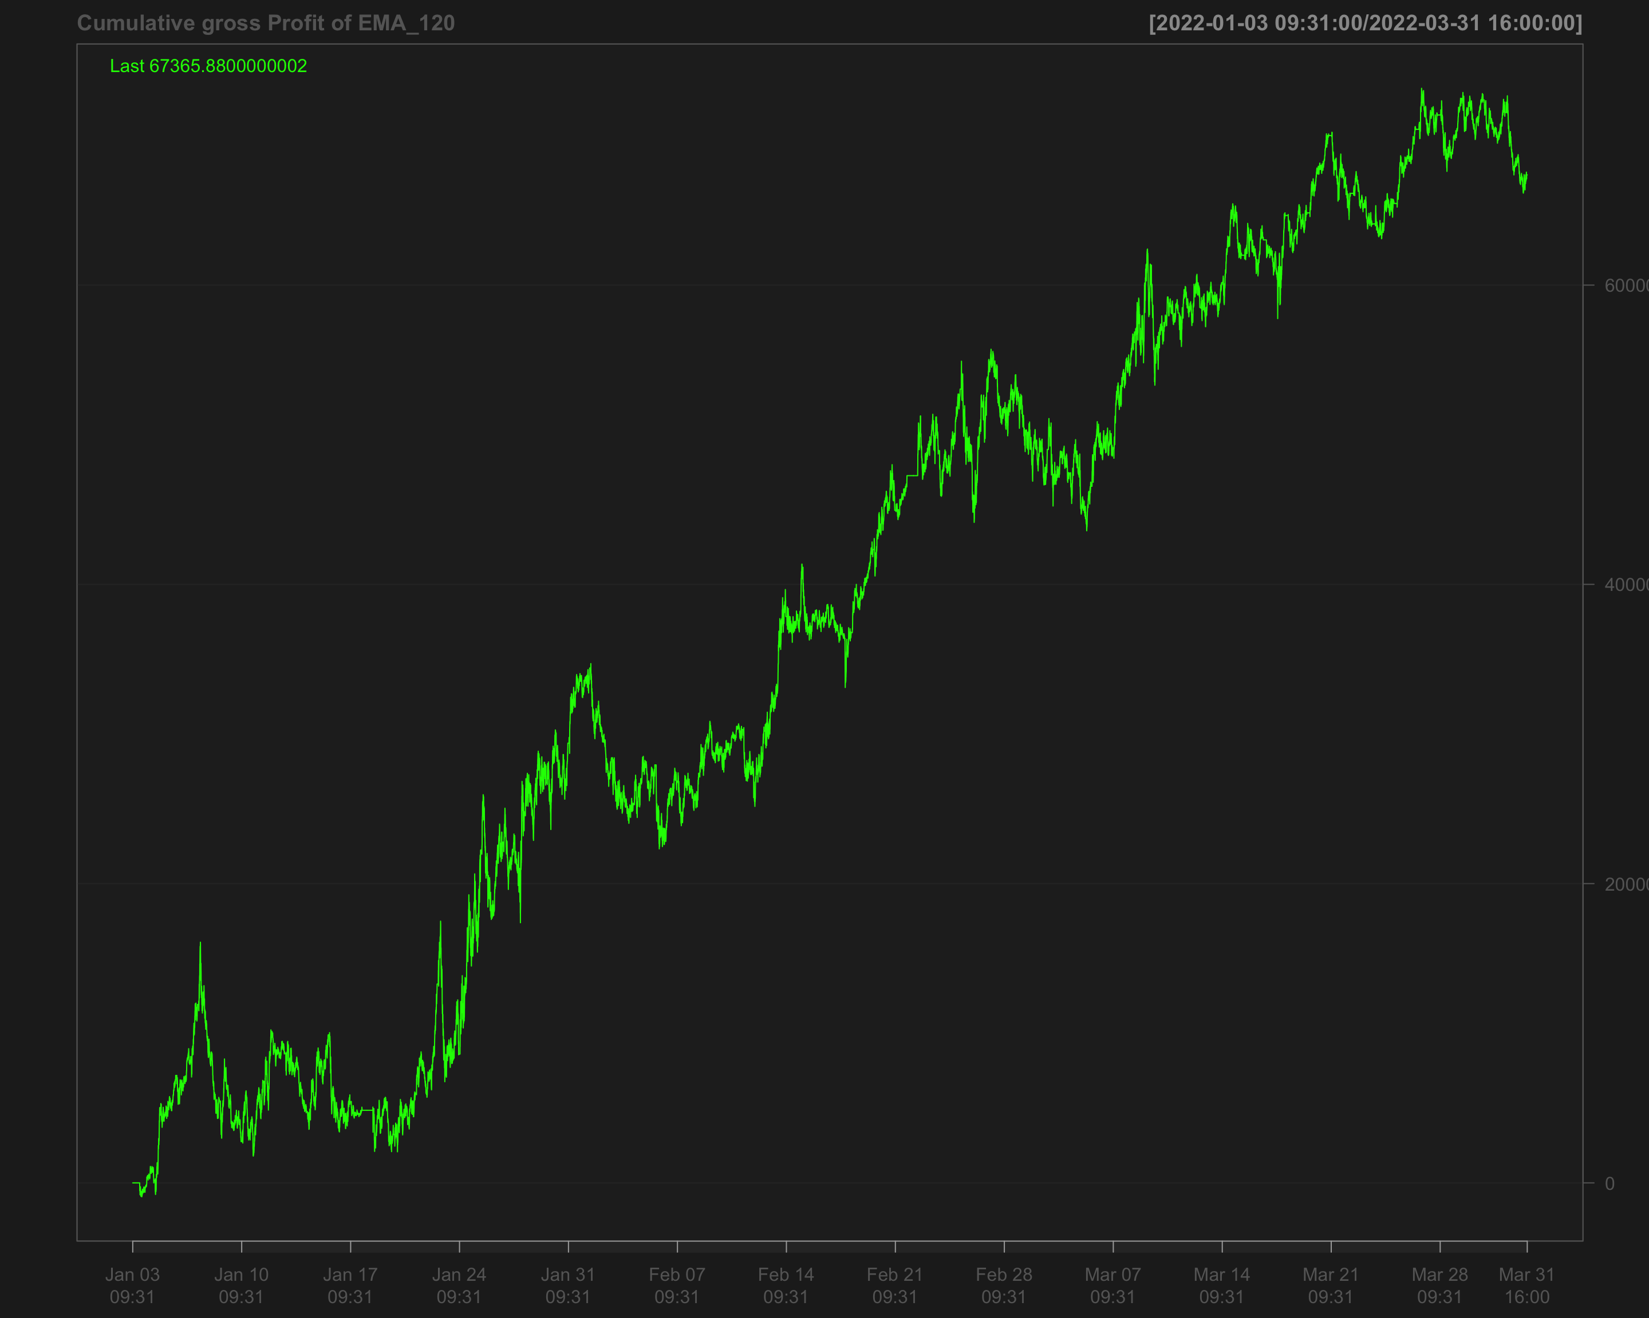

# Identify transactions by calculating the absolute change in position (every time the position changes)  
data1_2022_Q1$ntrans_ema_120 <- abs(diff.xts(data1_2022_Q1$position_ema_120))

# Set the first transaction value to 0, as there's no previous position to compare  
data1_2022_Q1$ntrans_ema_120[1] <- 0

### Net profit for EMA 120

# Calculate net profit by subtracting transaction costs (based on the number of transactions and a cost factor of 12) from the gross profit  
data1_2022_Q1$net_profit_ema_120 <- data1_2022_Q1$gross_profit_ema_120 - data1_2022_Q1$ntrans_ema_120 * 12

# Plot the cumulative sum of the net profit to visualize the overall performance over time  
chartSeries(cumsum(data1_2022_Q1$net_profit_ema_120),   
 name = "Cumulative Net Profit for EMA 120 Strategy")

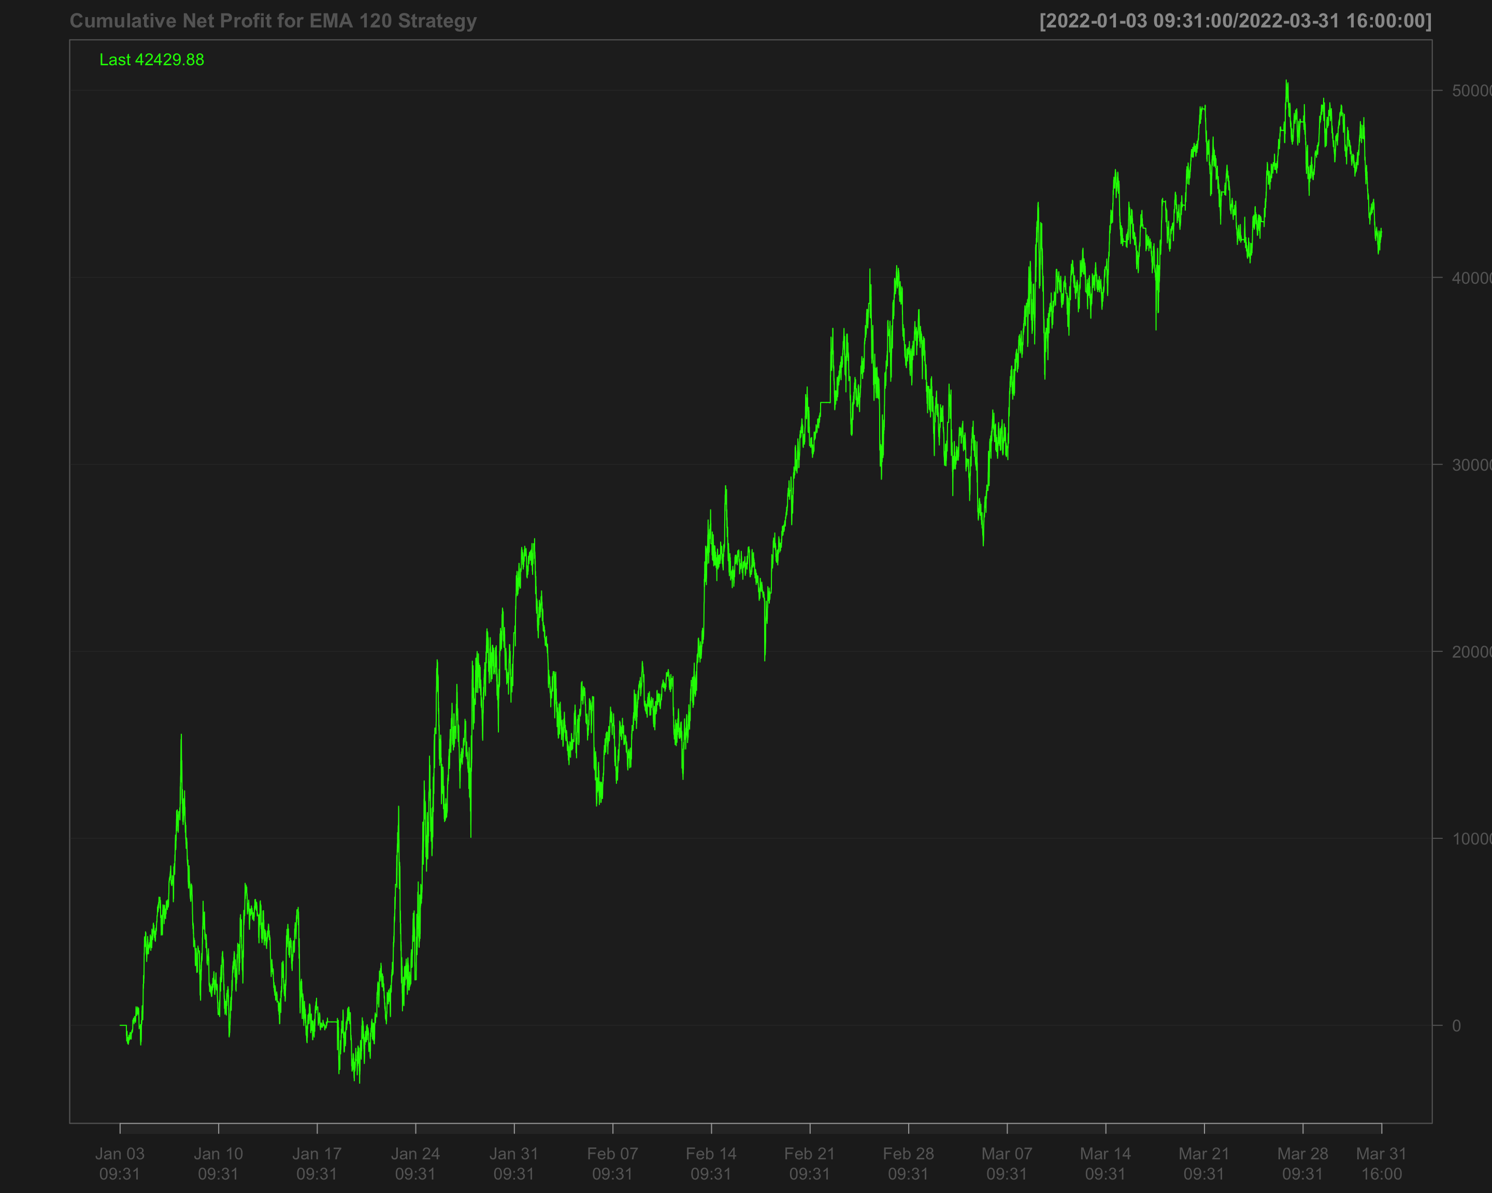

## Volatility breakout strategy using EMA 60 and SD 120

# Calculate the 60-period rolling mean of 'NQ' after filling missing values using the last observation carried forward  
data1_2022_Q1$mean_60 <- roll_mean(na.locf(data1_2022_Q1$NQ, na.rm = FALSE), 60)

# Calculate the 120-period rolling standard deviation of 'NQ' after filling missing values using the last observation carried forward  
data1_2022_Q1$sd_120 <- roll_sd(na.locf(data1_2022_Q1$NQ, na.rm = FALSE), 120)

# Measure the execution time for calculating the position based on a strategy using the 'positionVB' function  
system.time(  
 data1_2022_Q1$position_sd_ema <-   
 positionVB(signal = data1_2022_Q1$NQ,  
 upper = data1_2022_Q1$mean_60 + 1.5 * data1_2022_Q1$sd_120, # Upper bound based on 60-period mean and 1.5 times 120-period SD  
 lower = data1_2022_Q1$mean_60 - 1.5 * data1_2022_Q1$sd_120, # Lower bound based on 60-period mean and 1.5 times 120-period SD  
 times_data = times_data_2022_Q1, # Column with times  
 time_lower = "09:40:00", # Start time for trading  
 time_upper = "15:50:00", # Exit time for all positions  
 strategy = "mom" # Momentum strategy  
 )  
)

# Fill missing position values with the most recent non-missing value (Last Observation Carried Forward)  
data1_2022_Q1$position_sd_ema <- na.locf(data1_2022_Q1$position_sd_ema,  
 na.rm = FALSE)

### Gross profit of volatility breakout strategy

# Calculate gross profit for the strategy by multiplying position with the change in 'NQ' prices and a factor of 20  
data1_2022_Q1$gross_profit_sd_ema <- data1_2022_Q1$position_sd_ema * diff.xts(data1_2022_Q1$NQ) * 20

# Replace any missing values in the gross profit column with 0  
data1_2022_Q1$gross_profit_sd_ema[is.na(data1_2022_Q1$gross_profit_sd_ema)] <- 0  
chartSeries(cumsum(data1_2022_Q1$gross_profit_sd_ema),  
 name = "Cumulative gross Profit of (EMA 60 + SD 120)")

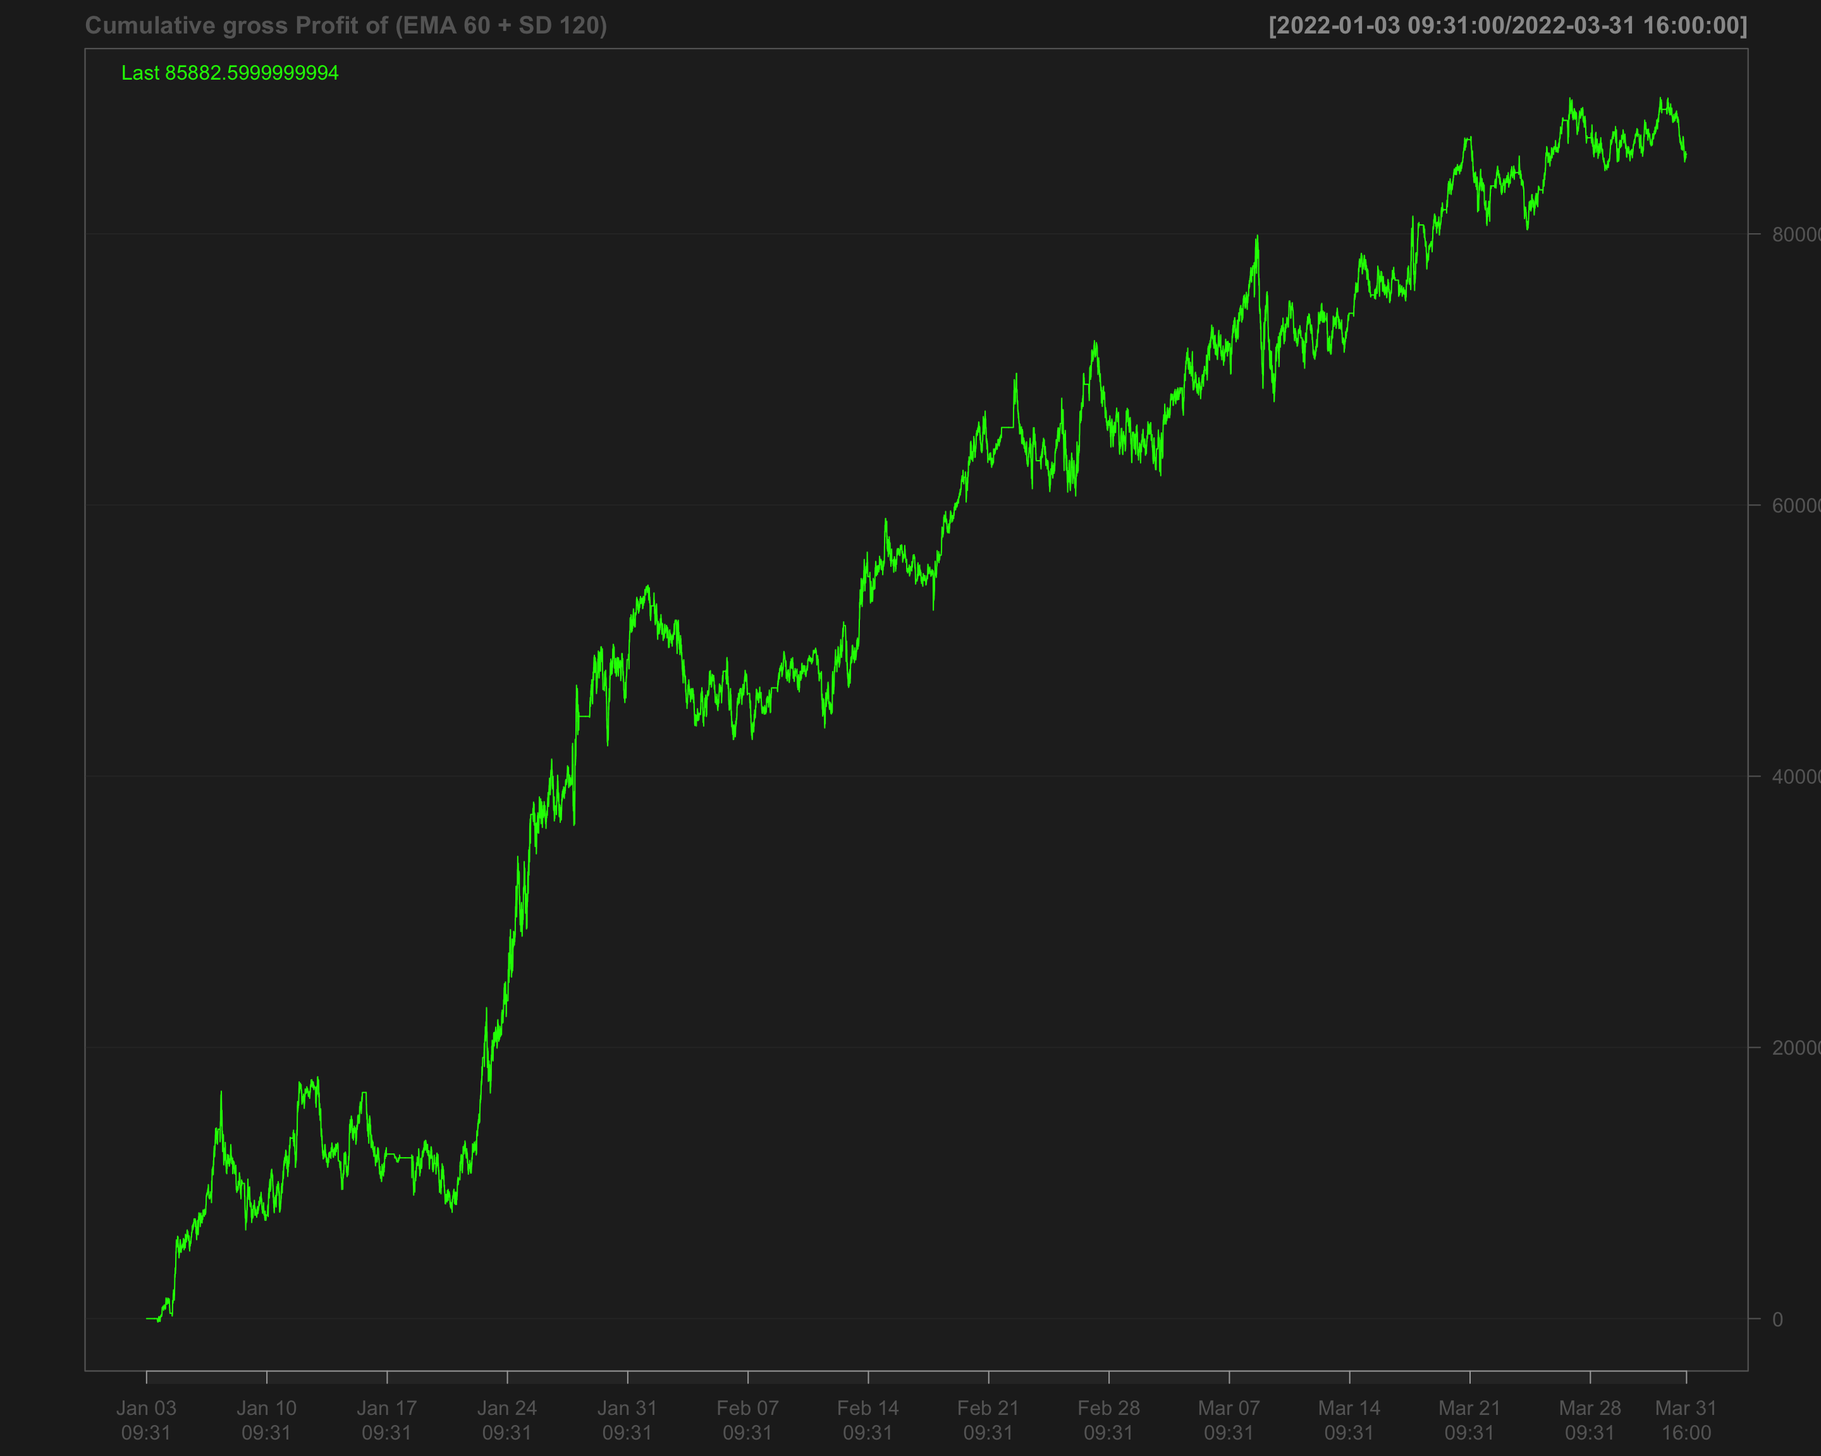

# Identify transactions by calculating the absolute change in position ('position_sd_ema')  
data1_2022_Q1$ntrans_sd_ema <- abs(diff.xts(data1_2022_Q1$position_sd_ema))

# Set the first transaction value to 0, as there's no previous position to compare  
data1_2022_Q1$ntrans_sd_ema[1] <- 0

### Net profit of volatility breakout strategy

# Calculate net profit by subtracting transaction costs (based on the number of transactions and a cost factor of 12) from the gross profit  
data1_2022_Q1$net_profit_sd_ema <- data1_2022_Q1$gross_profit_sd_ema - data1_2022_Q1$ntrans_sd_ema * 12

# Plot the cumulative net profit over time using a chart, based on the 'net_profit_sd_ema' column  
chartSeries(cumsum(data1_2022_Q1$net_profit_sd_ema),   
 name = "Cumulative Net Profit for (EMA 60 + SD 120)")

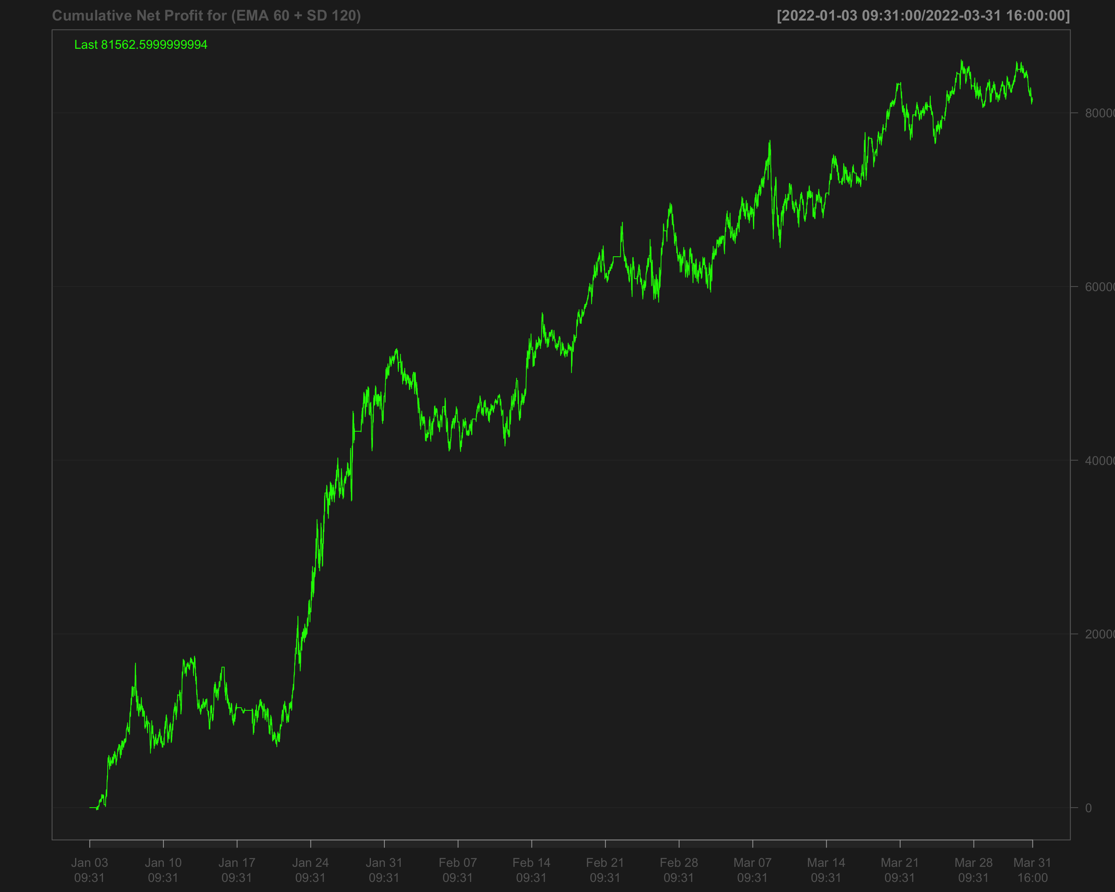

# Strategies based on 2022 Q2

data1_2022_Q2["T09:31/T09:35",] <- NA # Remove data between 09:31 and 09:35 by setting it to NA  
data1_2022_Q2["T15:56/T16:00",] <- NA # Remove data between 15:56 and 16:00 by setting it to NA

## Single EMA of ‘NQ’ with a 120-period window

data1_2022_Q2$ema_120 <- EMA(na.locf(data1_2022_Q2$NQ,   
 na.rm = FALSE),  
 120) # Calculate the 120-period EMA of 'NQ' after filling missing values using the last observation carried forward

data1_2022_Q2$ema_120[is.na(data1_2022_Q2$NQ)] <- NA # Set EMA values to NA where the original 'NQ' values are missing

data1_2022_Q2$position_ema_120 <- ifelse(lag.xts(data1_2022_Q2$NQ) >   
 lag.xts(data1_2022_Q2$ema_120), 1, -1) # Generate trading positions: 1 if 'NQ' is above its lagged EMA, -1 otherwise

# Set trading positions to 0 outside the active trading window (before 09:40:00 or after 15:50:00)  
data1_2022_Q2$position_ema_120[times(times_data_2022_Q2) <= times("9:40:00") |   
 times(times_data_2022_Q2) > times("15:50:00")] <- 0

# Fill missing positions with the most recent non-missing value (Last Observation Carried Forward)  
data1_2022_Q2$position_ema_120 <- na.locf(data1_2022_Q2$position_ema_120,  
 na.rm = FALSE)

### Gross profit for Single EMA

# Calculate gross profit based on the position (ema_120), the change in 'NQ' prices, and a factor of 20  
data1_2022_Q2$gross_profit_ema_120 <- data1_2022_Q2$position_ema_120 * diff.xts(data1_2022_Q2$NQ) * 20

# Set any missing values in 'gross_profit_ema_120' to 0  
data1_2022_Q2$gross_profit_ema_120[is.na(data1_2022_Q2$gross_profit_ema_120)] <- 0  
chartSeries(cumsum(data1_2022_Q2$gross_profit_ema_120),  
 name = "Cumulative gross profit of EMA_120")

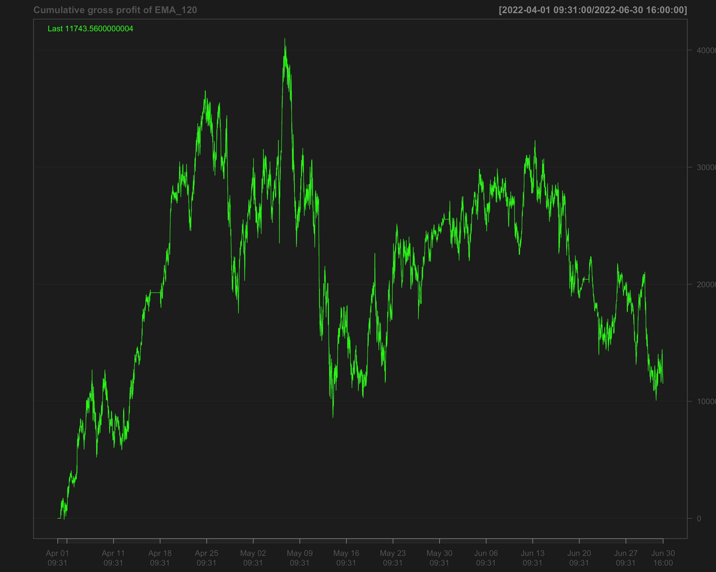

# Identify transactions by calculating the absolute change in position (every time the position changes)  
data1_2022_Q2$ntrans_ema_120 <- abs(diff.xts(data1_2022_Q2$position_ema_120))

# Set the first transaction value to 0, as there's no previous position to compare  
data1_2022_Q2$ntrans_ema_120[1] <- 0

### Net profit for EMA 120

# Calculate net profit by subtracting transaction costs (based on the number of transactions and a cost factor of 12) from the gross profit  
data1_2022_Q2$net_profit_ema_120 <- data1_2022_Q2$gross_profit_ema_120 - data1_2022_Q2$ntrans_ema_120 * 12

# Plot the cumulative sum of the net profit to visualize the overall performance over time  
chartSeries(cumsum(data1_2022_Q2$net_profit_ema_120),   
 name = "Cumulative Net Profit for EMA 120")

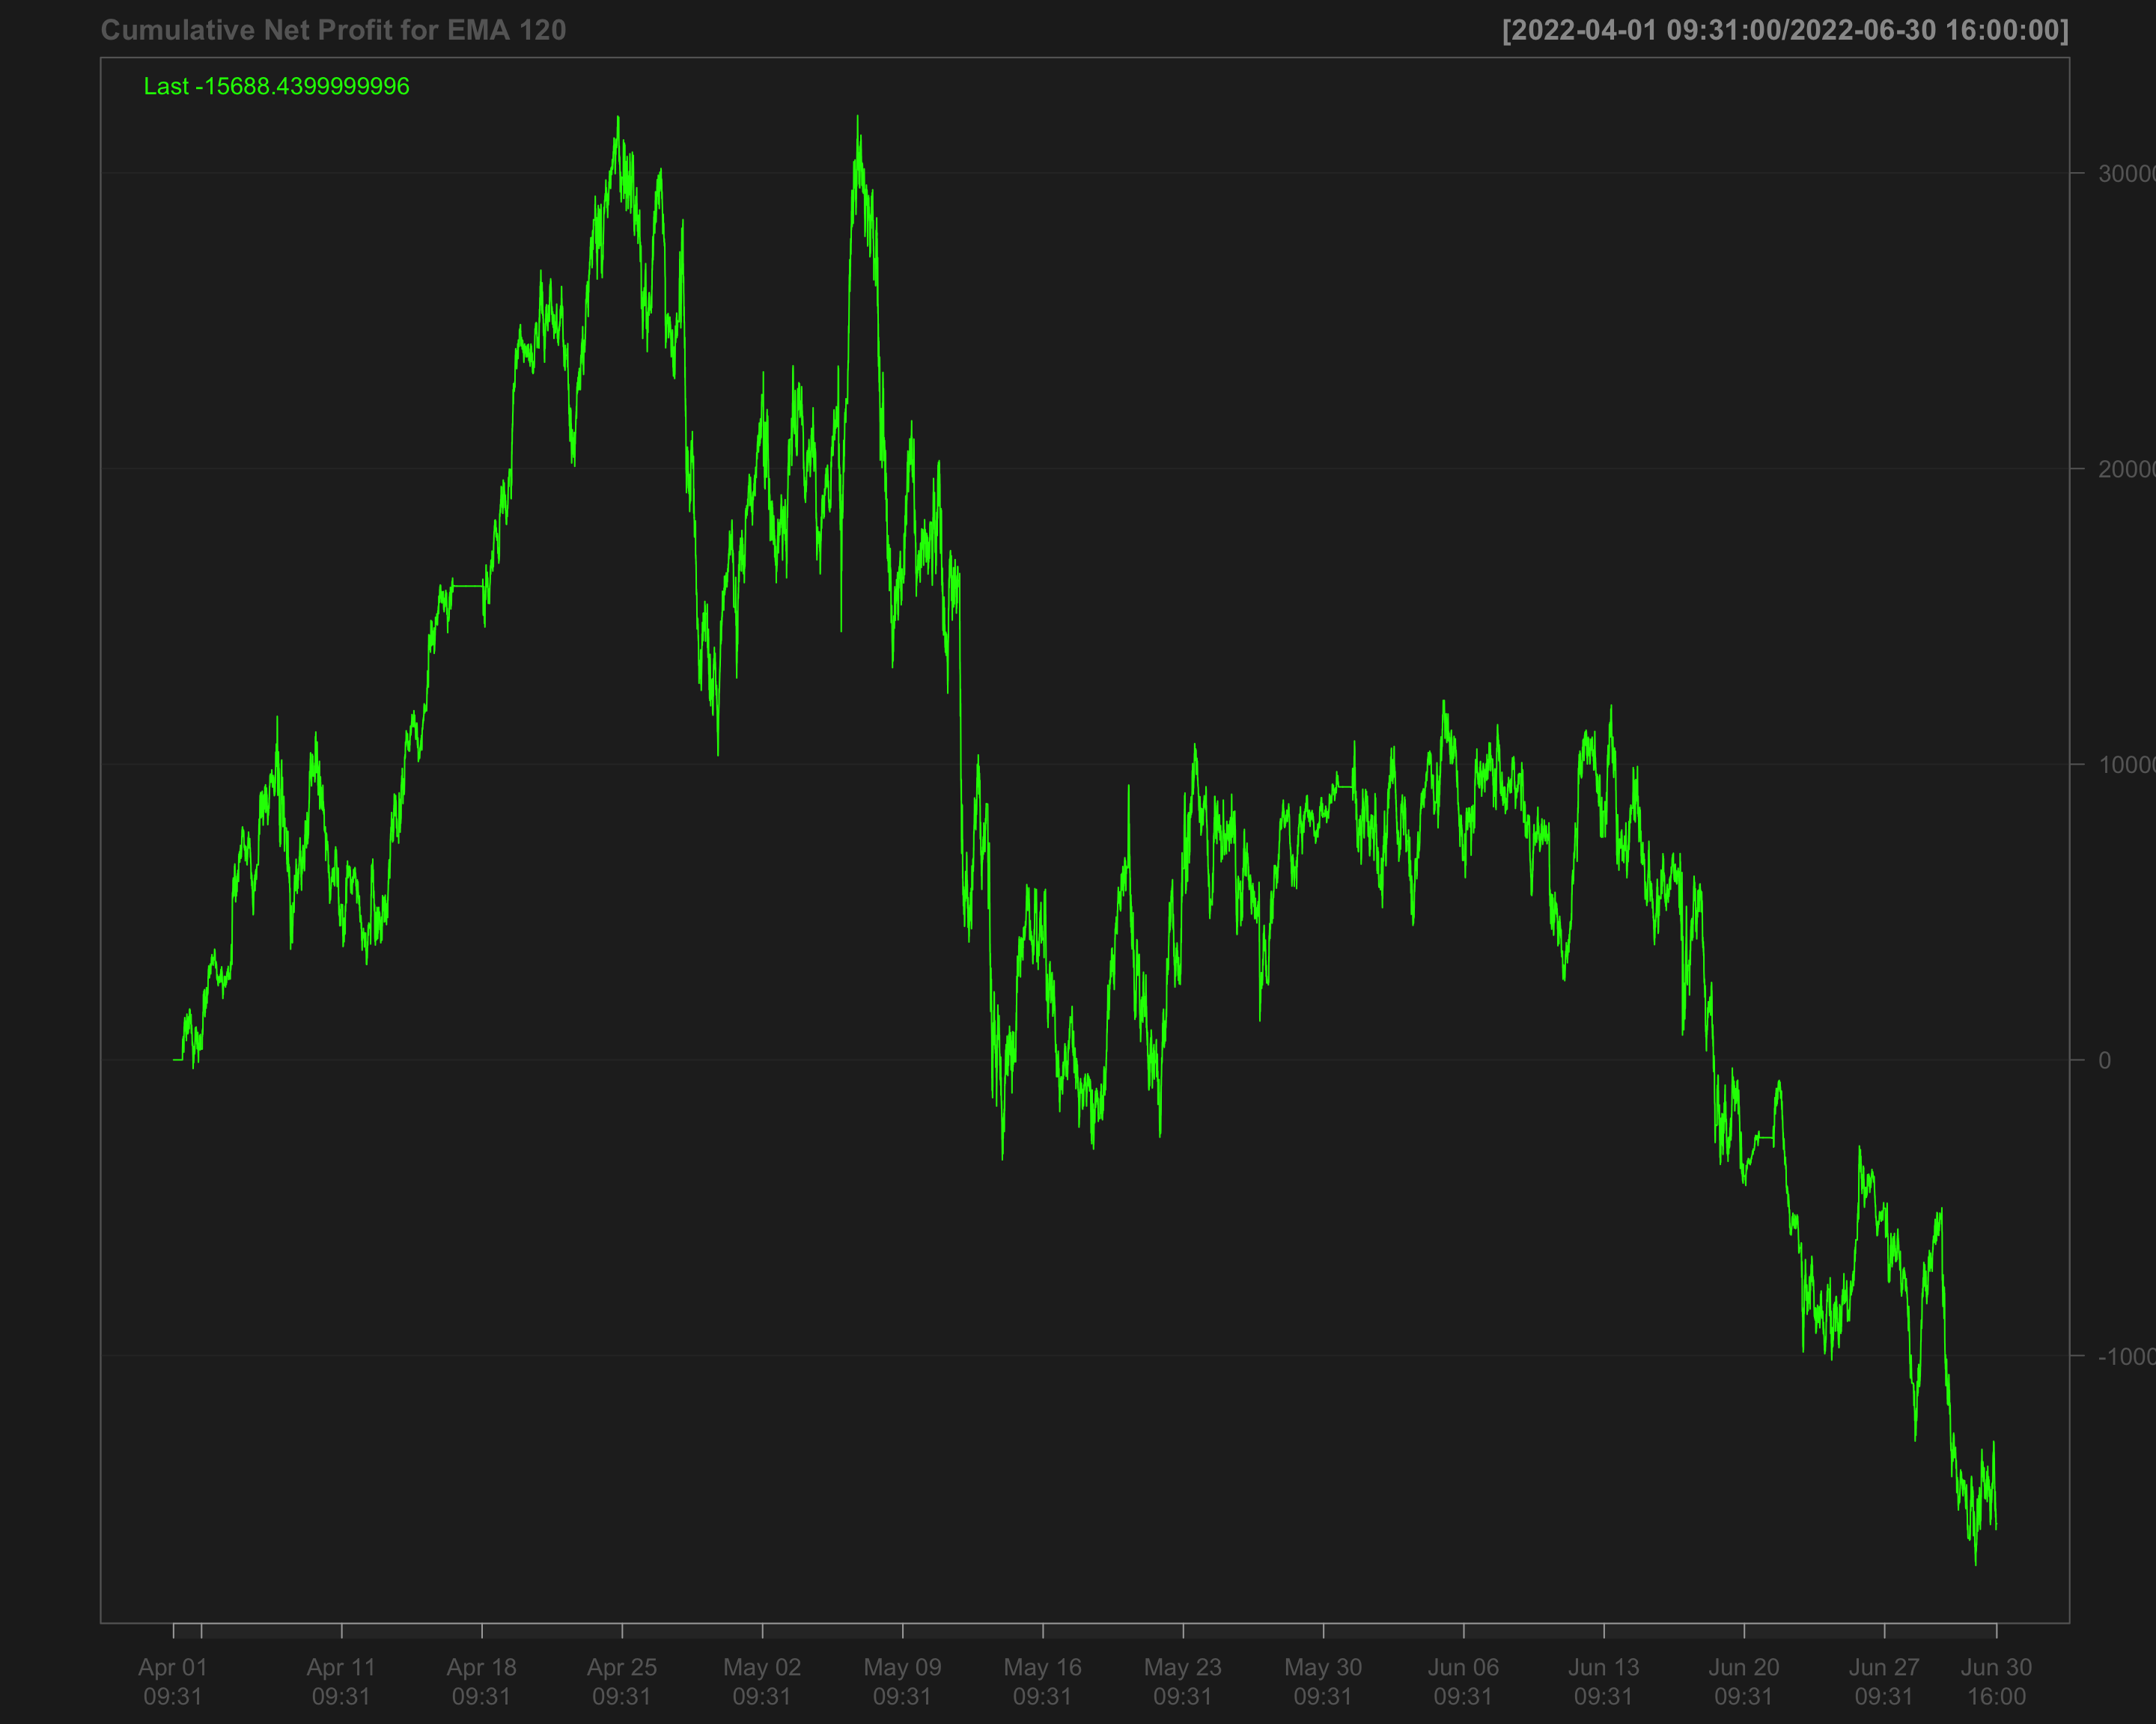

## Volatility breakout strategy using EMA 60 and SD 120

# Calculate the 60-period rolling mean of 'NQ' after filling missing values using the last observation carried forward  
data1_2022_Q2$mean_60 <- roll_mean(na.locf(data1_2022_Q2$NQ, na.rm = FALSE), 60)

# Calculate the 120-period rolling standard deviation of 'NQ' after filling missing values using the last observation carried forward  
data1_2022_Q2$sd_120 <- roll_sd(na.locf(data1_2022_Q2$NQ, na.rm = FALSE), 120)

# Measure the execution time for calculating the position based on a strategy using the 'positionVB' function  
system.time(  
 data1_2022_Q2$position_sd_ema <-   
 positionVB(signal = data1_2022_Q2$NQ,  
 upper = data1_2022_Q2$mean_60 + 1.5 * data1_2022_Q2$sd_120, # Upper bound based on 60-period mean and 1.5 times 120-period SD  
 lower = data1_2022_Q2$mean_60 - 1.5 * data1_2022_Q2$sd_120, # Lower bound based on 60-period mean and 1.5 times 120-period SD  
 times_data = times_data_2022_Q2, # Column with times  
 time_lower = "09:40:00", # Start time for trading  
 time_upper = "15:50:00", # Exit time for all positions  
 strategy = "mom" # Momentum strategy  
 )  
)

# Fill missing position values with the most recent non-missing value (Last Observation Carried Forward)  
data1_2022_Q2$position_sd_ema <- na.locf(data1_2022_Q2$position_sd_ema,  
 na.rm = FALSE)

### Gross profit of volatility breakout strategy

# Calculate gross profit for the strategy by multiplying position with the change in 'NQ' prices and a factor of 20  
data1_2022_Q2$gross_profit_sd_ema <- data1_2022_Q2$position_sd_ema * diff.xts(data1_2022_Q2$NQ) * 20

# Replace any missing values in the gross profit column with 0  
data1_2022_Q2$gross_profit_sd_ema[is.na(data1_2022_Q2$gross_profit_sd_ema)] <- 0  
chartSeries(cumsum(data1_2022_Q2$gross_profit_sd_ema),  
 name = "Cumulative gross profit of (EMA 60 + SD 120)")

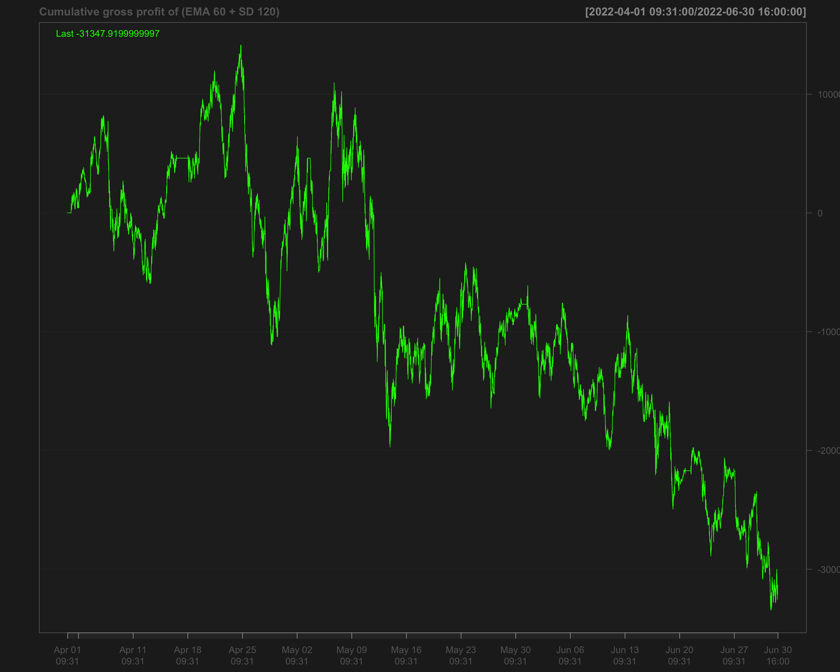

# Identify transactions by calculating the absolute change in position ('position_sd_ema')  
data1_2022_Q2$ntrans_sd_ema <- abs(diff.xts(data1_2022_Q2$position_sd_ema))

# Set the first transaction value to 0, as there's no previous position to compare  
data1_2022_Q2$ntrans_sd_ema[1] <- 0

### Net profit of volatility breakout strategy

# Calculate net profit by subtracting transaction costs (based on the number of transactions and a cost factor of 12) from the gross profit  
data1_2022_Q2$net_profit_sd_ema <- data1_2022_Q2$gross_profit_sd_ema - data1_2022_Q2$ntrans_sd_ema * 12

# Plot the cumulative net profit over time using a chart, based on the 'net_profit_sd_ema' column  
chartSeries(cumsum(data1_2022_Q2$net_profit_sd_ema),   
 name = "Cumulative Net Profit for (EMA 60 + SD 120)")

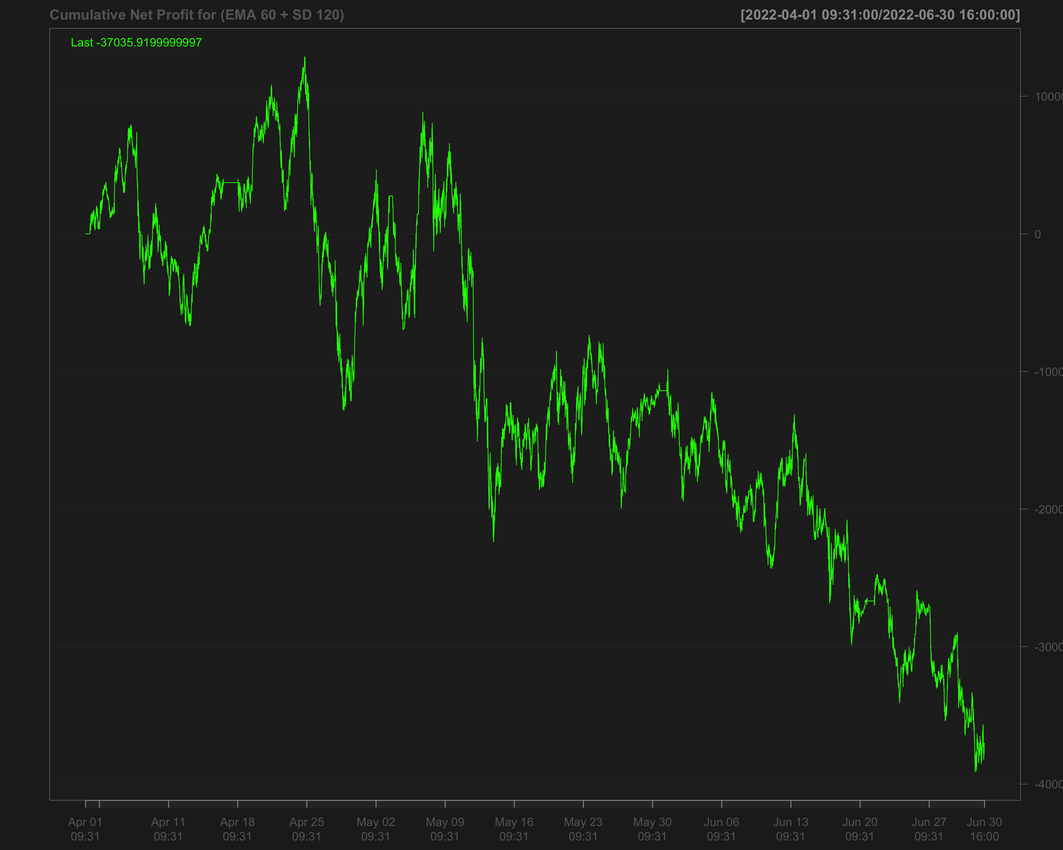

# Strategies based on 2022 Q3

data1_2022_Q3["T09:31/T09:35",] <- NA # Remove data between 09:31 and 09:35 by setting it to NA  
data1_2022_Q3["T15:56/T16:00",] <- NA # Remove data between 15:56 and 16:00 by setting it to NA

## Single EMA of ‘NQ’ with a 120-period window

data1_2022_Q3$ema_120 <- EMA(na.locf(data1_2022_Q3$NQ,   
 na.rm = FALSE),  
 120) # Calculate the 120-period EMA of 'NQ' after filling missing values using the last observation carried forward

data1_2022_Q3$ema_120[is.na(data1_2022_Q3$NQ)] <- NA # Set EMA values to NA where the original 'NQ' values are missing

data1_2022_Q3$position_ema_120 <- ifelse(lag.xts(data1_2022_Q3$NQ) >   
 lag.xts(data1_2022_Q3$ema_120), 1, -1) # Generate trading positions: 1 if 'NQ' is above its lagged EMA, -1 otherwise

# Set trading positions to 0 outside the active trading window (before 09:40:00 or after 15:50:00)  
data1_2022_Q3$position_ema_120[times(times_data_2022_Q3) <= times("9:40:00") |   
 times(times_data_2022_Q3) > times("15:50:00")] <- 0

# Fill missing positions with the most recent non-missing value (Last Observation Carried Forward)  
data1_2022_Q3$position_ema_120 <- na.locf(data1_2022_Q3$position_ema_120,  
 na.rm = FALSE)

### Gross profit for Single EMA

# Calculate gross profit based on the position (ema_120), the change in 'NQ' prices, and a factor of 20  
data1_2022_Q3$gross_profit_ema_120 <- data1_2022_Q3$position_ema_120 * diff.xts(data1_2022_Q3$NQ) * 20

# Set any missing values in 'gross_profit_ema_120' to 0  
data1_2022_Q3$gross_profit_ema_120[is.na(data1_2022_Q3$gross_profit_ema_120)] <- 0  
chartSeries(cumsum(data1_2022_Q3$gross_profit_ema_120),  
 name = "Cumulative gross profit of EMA_120")

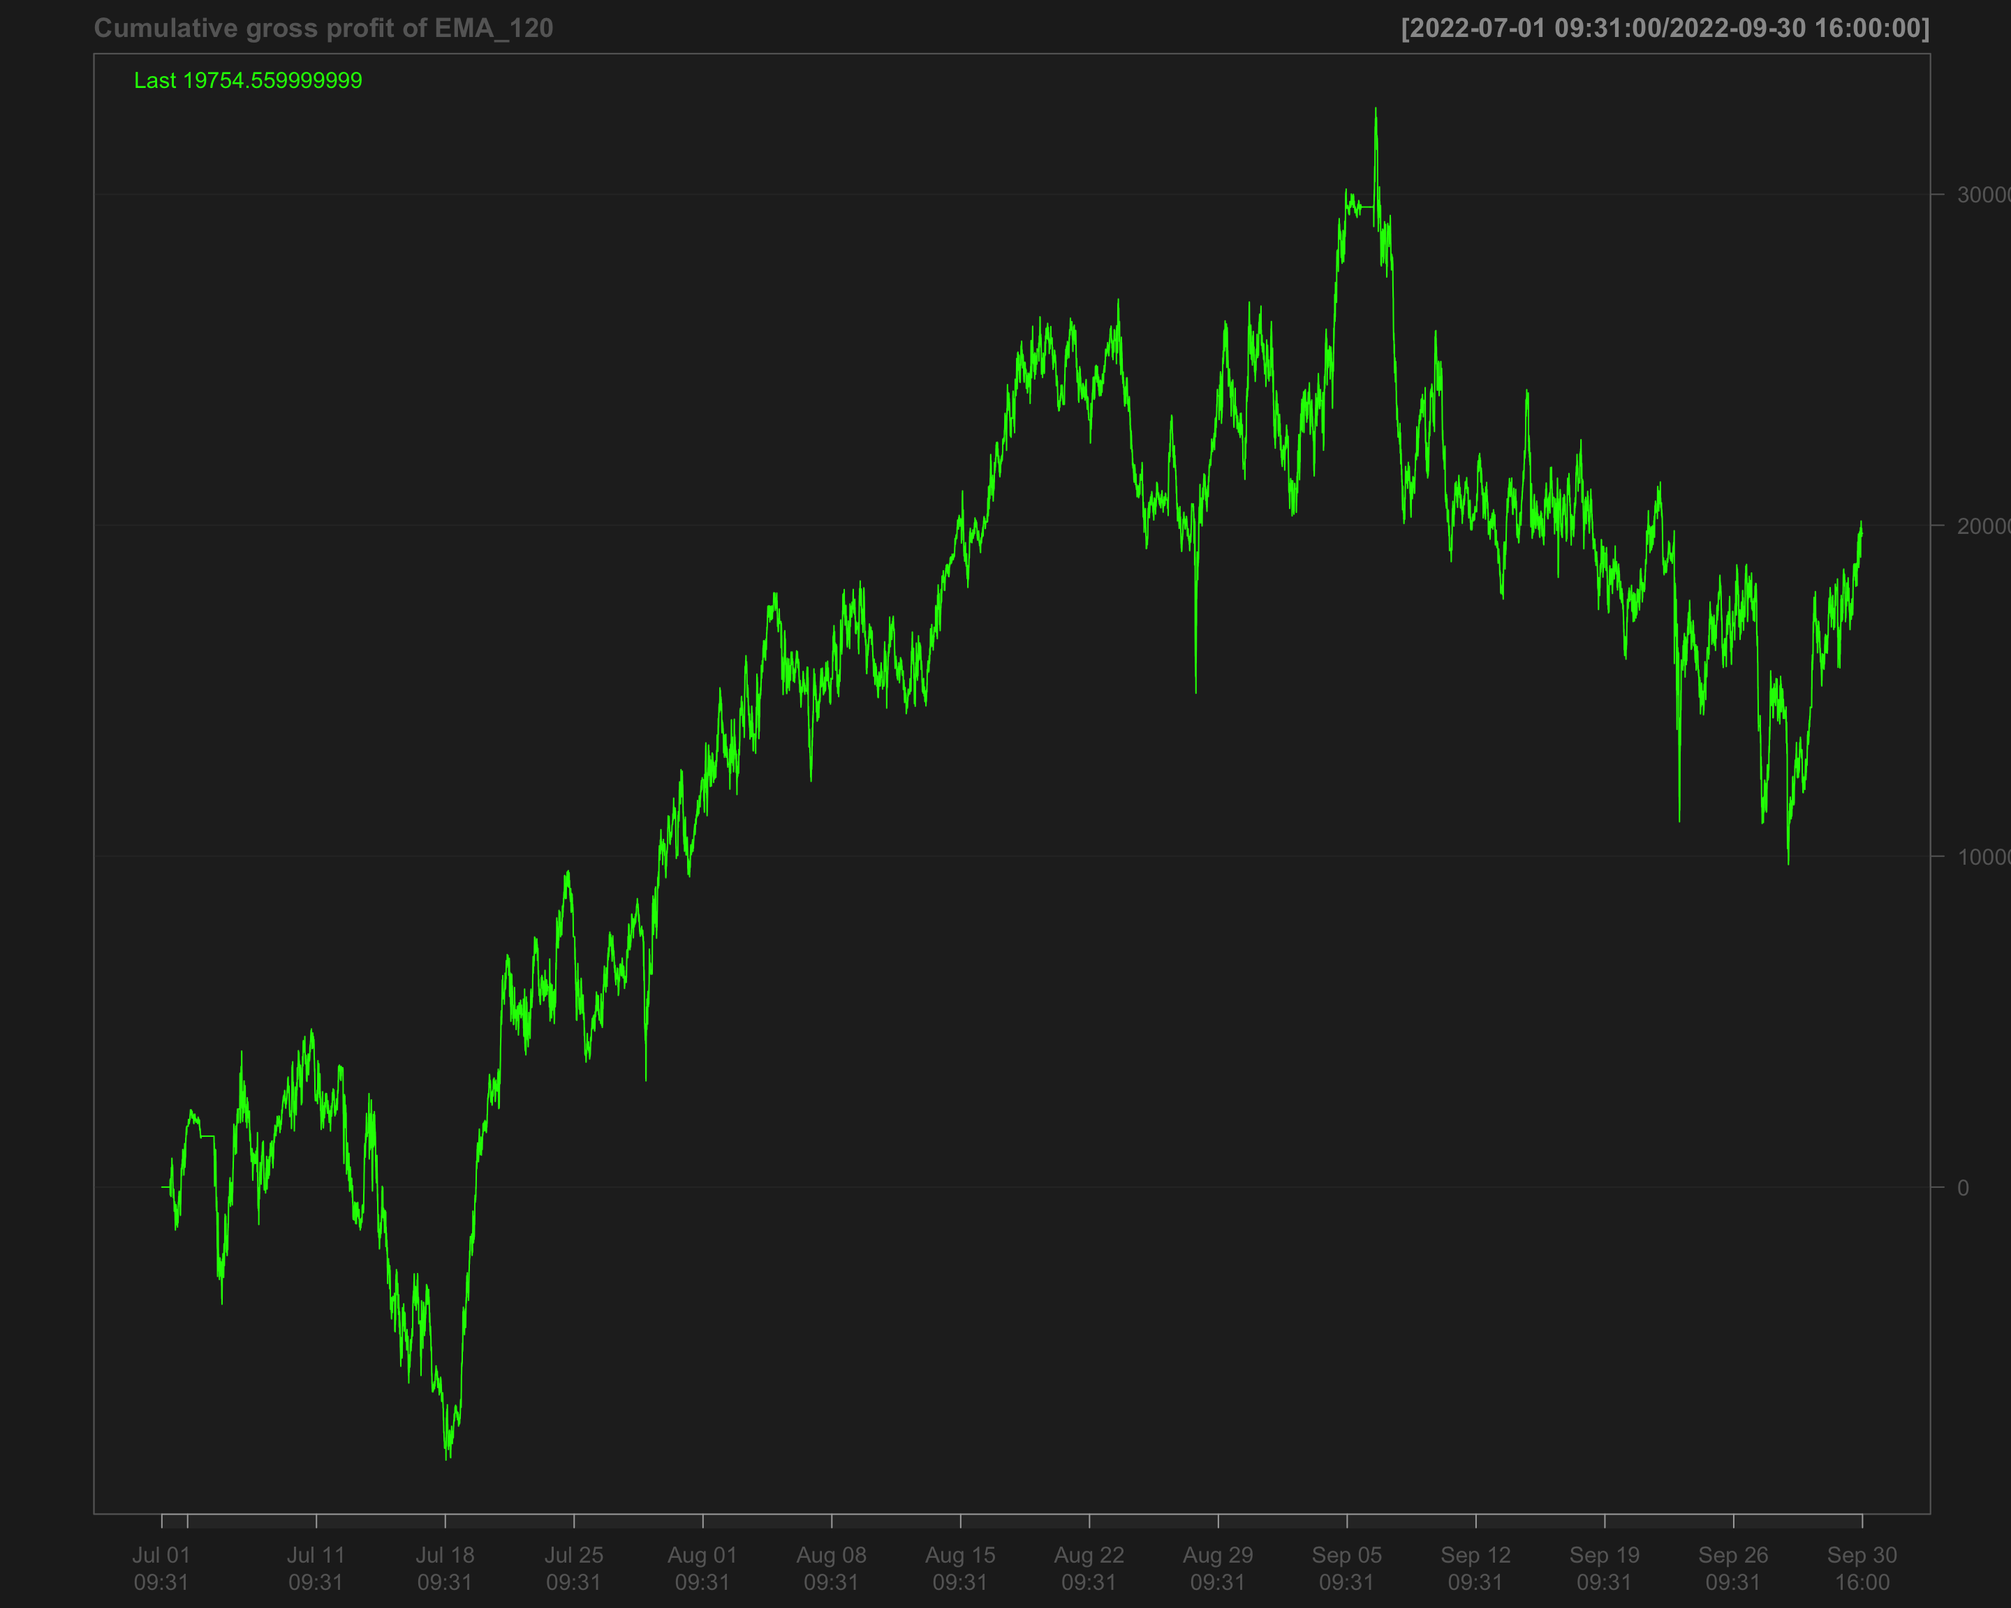

# Identify transactions by calculating the absolute change in position (every time the position changes)  
data1_2022_Q3$ntrans_ema_120 <- abs(diff.xts(data1_2022_Q3$position_ema_120))

# Set the first transaction value to 0, as there's no previous position to compare  
data1_2022_Q3$ntrans_ema_120[1] <- 0

### Net profit for EMA 120

# Calculate net profit by subtracting transaction costs (based on the number of transactions and a cost factor of 12) from the gross profit  
data1_2022_Q3$net_profit_ema_120 <- data1_2022_Q3$gross_profit_ema_120 - data1_2022_Q3$ntrans_ema_120 * 12

# Plot the cumulative sum of the net profit to visualize the overall performance over time  
chartSeries(cumsum(data1_2022_Q3$net_profit_ema_120),   
 name = "Cumulative Net Profit for EMA 120 Strategy")

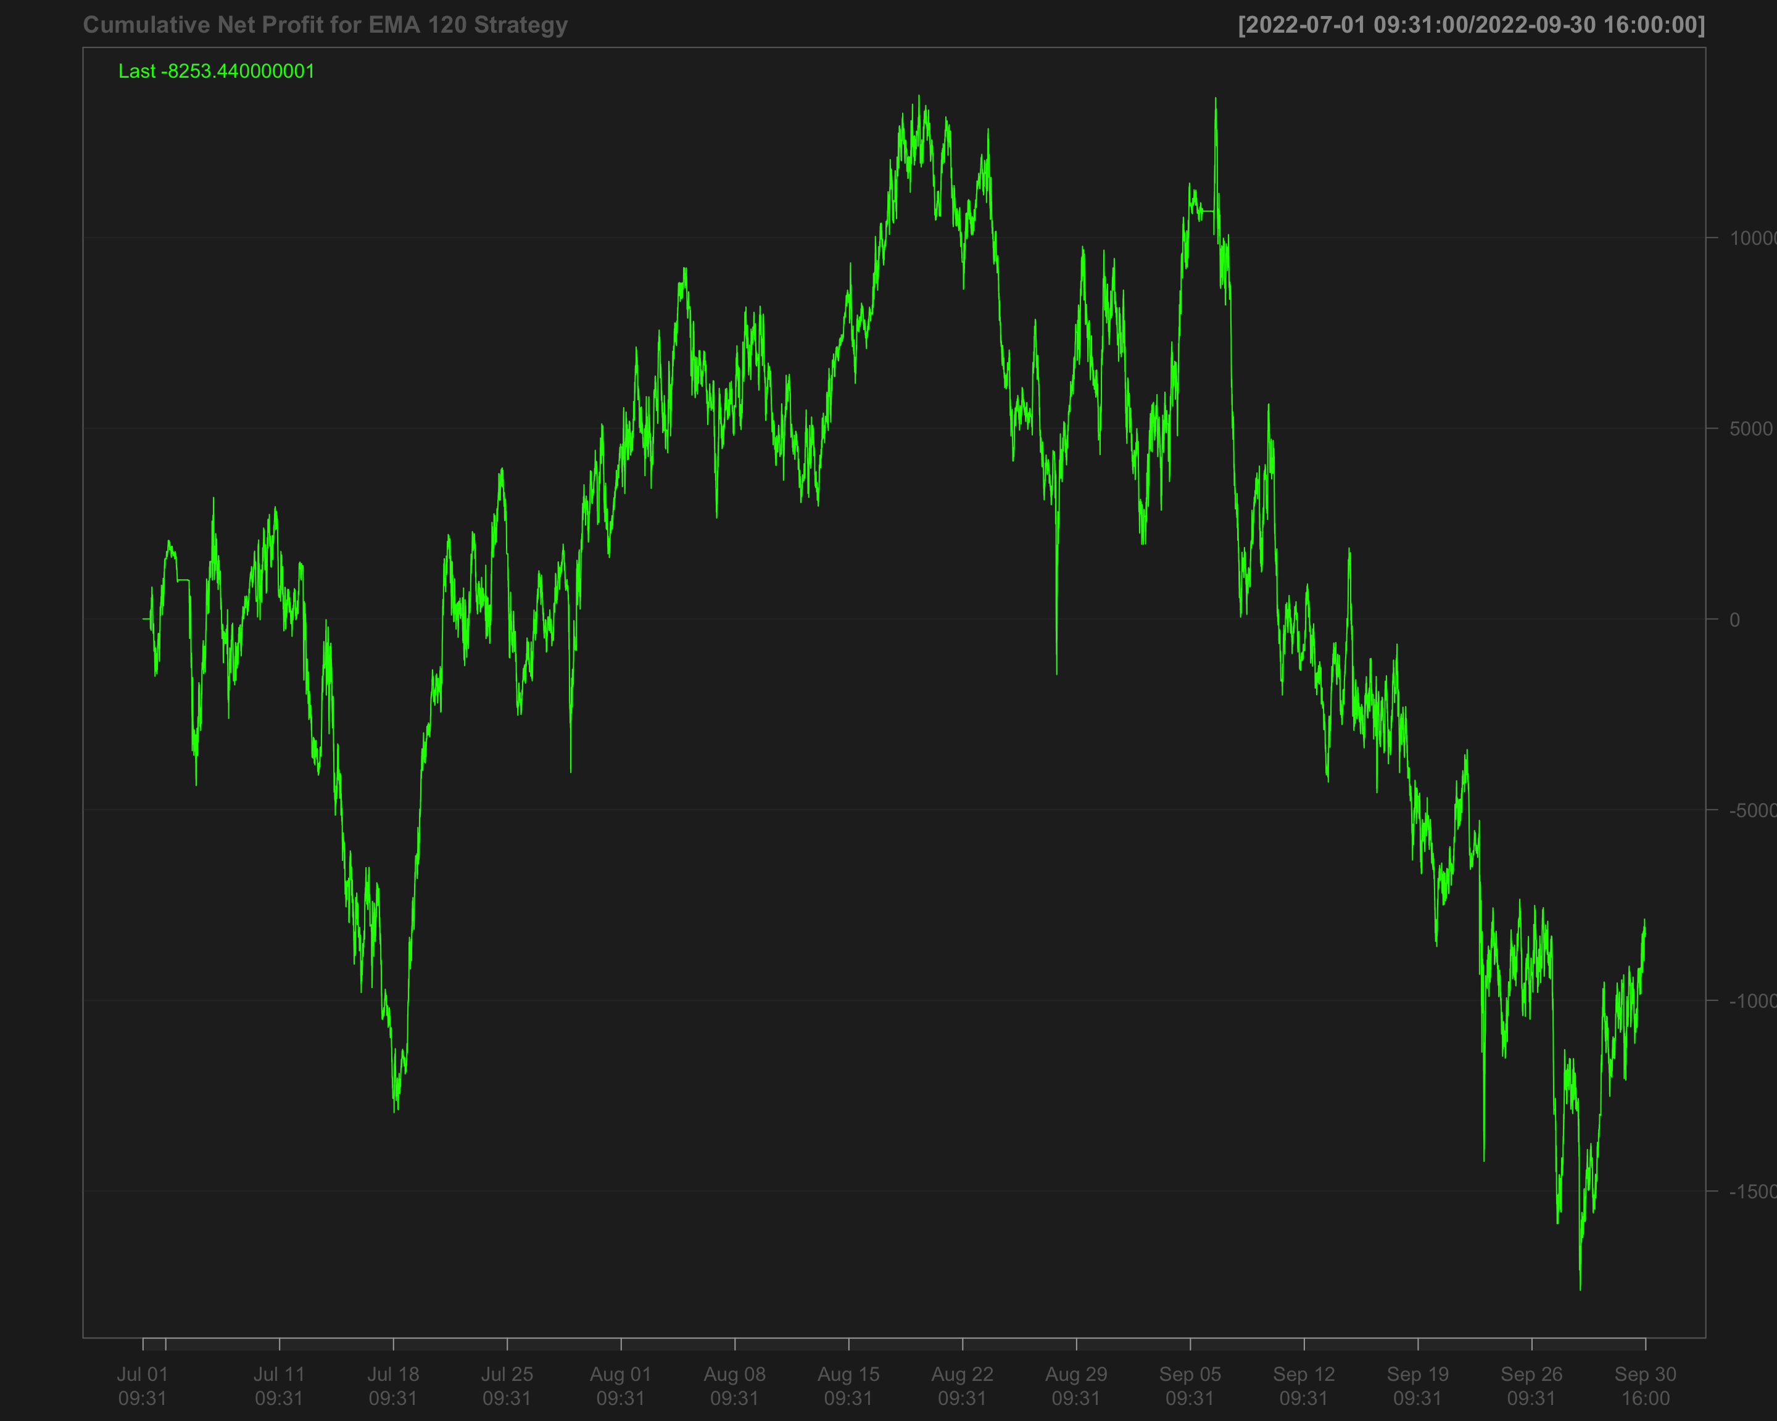

## Volatility breakout strategy using EMA 60 and SD 120

# Calculate the 60-period rolling mean of 'NQ' after filling missing values using the last observation carried forward  
data1_2022_Q3$mean_60 <- roll_mean(na.locf(data1_2022_Q3$NQ, na.rm = FALSE), 60)

# Calculate the 120-period rolling standard deviation of 'NQ' after filling missing values using the last observation carried forward  
data1_2022_Q3$sd_120 <- roll_sd(na.locf(data1_2022_Q3$NQ, na.rm = FALSE), 120)

# Measure the execution time for calculating the position based on a strategy using the 'positionVB' function  
system.time(  
 data1_2022_Q3$position_sd_ema <-   
 positionVB(signal = data1_2022_Q3$NQ,  
 upper = data1_2022_Q3$mean_60 + 1.5 * data1_2022_Q3$sd_120, # Upper bound based on 60-period mean and 1.5 times 120-period SD  
 lower = data1_2022_Q3$mean_60 - 1.5 * data1_2022_Q3$sd_120, # Lower bound based on 60-period mean and 1.5 times 120-period SD  
 times_data = times_data_2022_Q3, # Column with times  
 time_lower = "09:40:00", # Start time for trading  
 time_upper = "15:50:00", # Exit time for all positions  
 strategy = "mom" # Momentum strategy  
 )  
)

# Fill missing position values with the most recent non-missing value (Last Observation Carried Forward)  
data1_2022_Q3$position_sd_ema <- na.locf(data1_2022_Q3$position_sd_ema,  
 na.rm = FALSE)

### Gross profit of volatility breakout strategy

# Calculate gross profit for the strategy by multiplying position with the change in 'NQ' prices and a factor of 20  
data1_2022_Q3$gross_profit_sd_ema <- data1_2022_Q3$position_sd_ema * diff.xts(data1_2022_Q3$NQ) * 20

# Replace any missing values in the gross profit column with 0  
data1_2022_Q3$gross_profit_sd_ema[is.na(data1_2022_Q3$gross_profit_sd_ema)] <- 0  
chartSeries(cumsum(data1_2022_Q3$gross_profit_sd_ema),  
 name = "Cumulative gross profit of (EMA 60 + SD 120)")

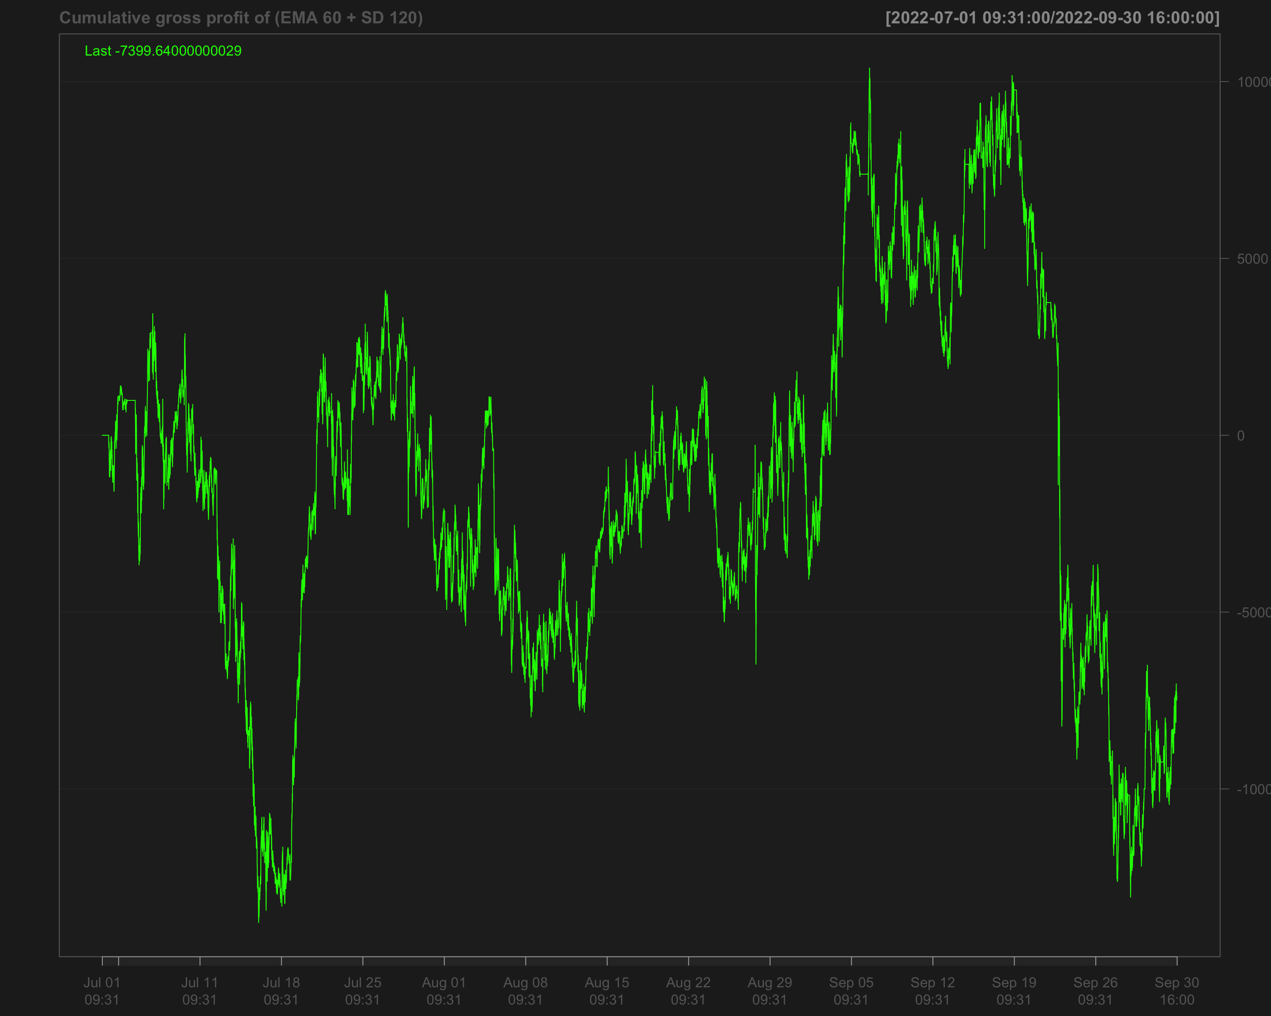

# Identify transactions by calculating the absolute change in position ('position_sd_ema')  
data1_2022_Q3$ntrans_sd_ema <- abs(diff.xts(data1_2022_Q3$position_sd_ema))

# Set the first transaction value to 0, as there's no previous position to compare  
data1_2022_Q3$ntrans_sd_ema[1] <- 0

### Net profit of volatility breakout strategy

# Calculate net profit by subtracting transaction costs (based on the number of transactions and a cost factor of 12) from the gross profit  
data1_2022_Q3$net_profit_sd_ema <- data1_2022_Q3$gross_profit_sd_ema - data1_2022_Q3$ntrans_sd_ema * 12

# Plot the cumulative net profit over time using a chart, based on the 'net_profit_sd_ema' column  
chartSeries(cumsum(data1_2022_Q3$net_profit_sd_ema),   
 name = "Cumulative Net Profit for (EMA 60 + SD 120)")

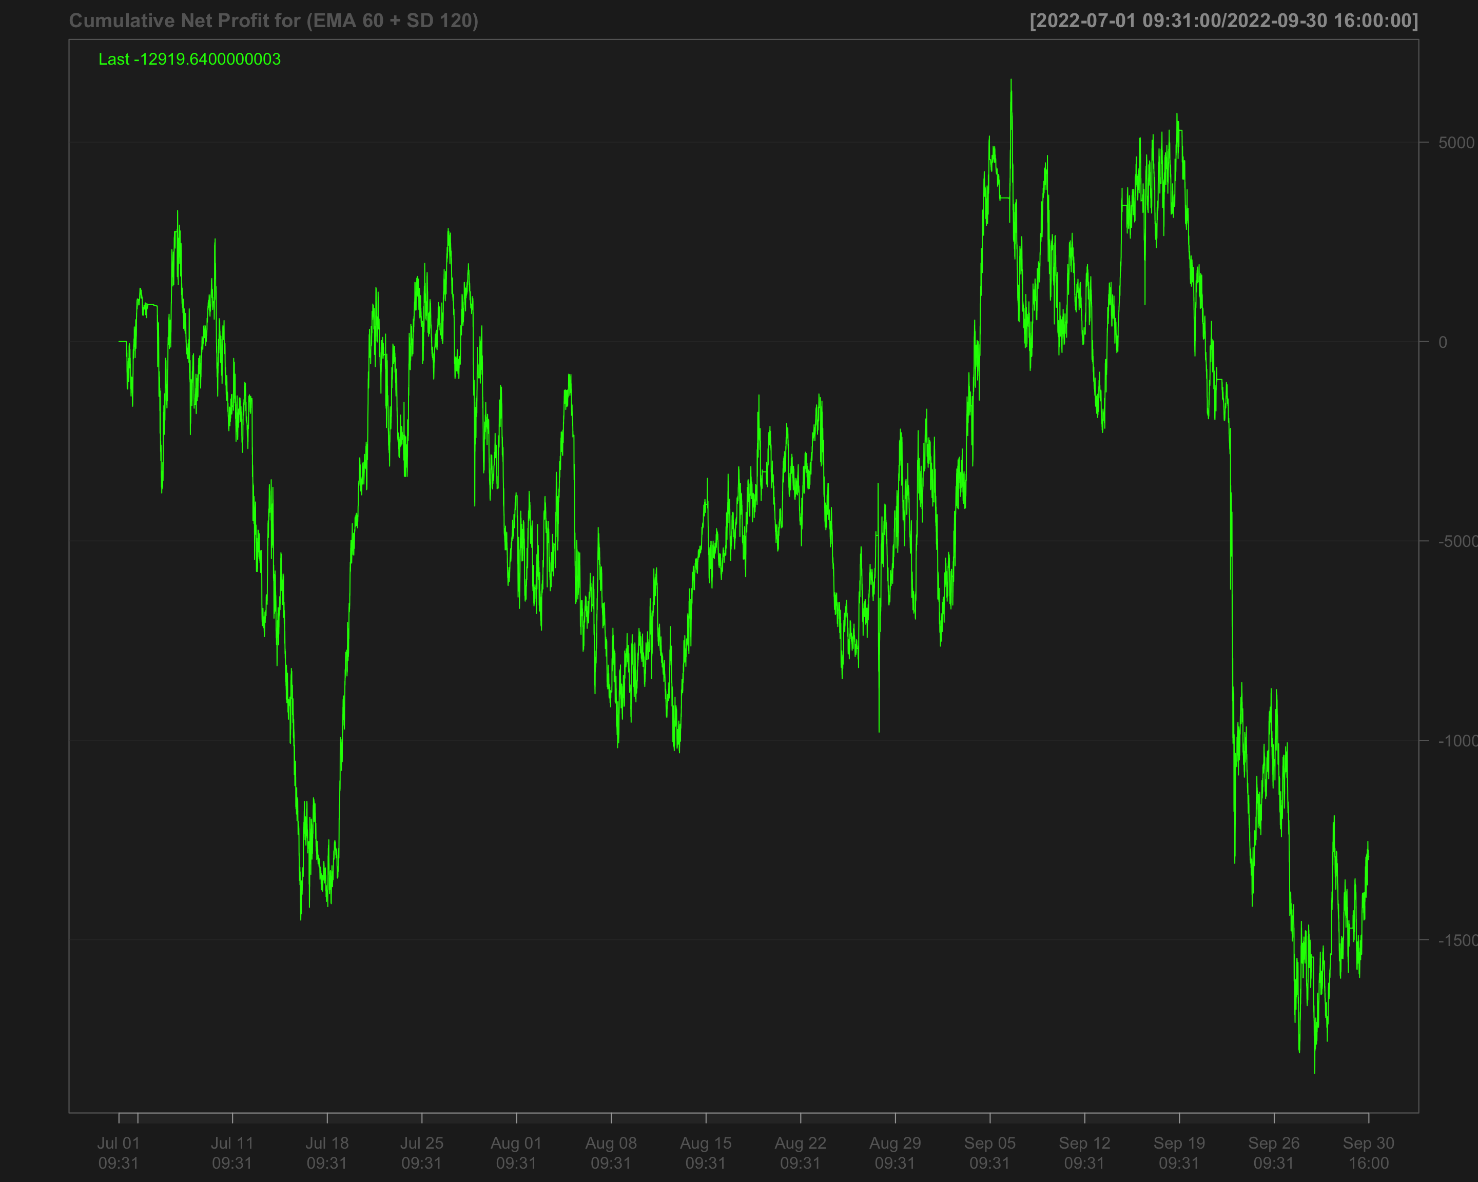

# Strategies based on 2022 Q4

data1_2022_Q4["T09:31/T09:35",] <- NA # Remove data between 09:31 and 09:35 by setting it to NA  
data1_2022_Q4["T15:56/T16:00",] <- NA # Remove data between 15:56 and 16:00 by setting it to NA

## Single EMA of ‘NQ’ with a 120-period window

data1_2022_Q4$ema_120 <- EMA(na.locf(data1_2022_Q4$NQ,   
 na.rm = FALSE),  
 120) # Calculate the 120-period EMA of 'NQ' after filling missing values using the last observation carried forward

data1_2022_Q4$ema_120[is.na(data1_2022_Q4$NQ)] <- NA # Set EMA values to NA where the original 'NQ' values are missing

data1_2022_Q4$position_ema_120 <- ifelse(lag.xts(data1_2022_Q4$NQ) >   
 lag.xts(data1_2022_Q4$ema_120), 1, -1) # Generate trading positions: 1 if 'NQ' is above its lagged EMA, -1 otherwise

# Set trading positions to 0 outside the active trading window (before 09:40:00 or after 15:50:00)  
data1_2022_Q4$position_ema_120[times(times_data_2022_Q4) <= times("9:40:00") |   
 times(times_data_2022_Q4) > times("15:50:00")] <- 0

# Fill missing positions with the most recent non-missing value (Last Observation Carried Forward)  
data1_2022_Q4$position_ema_120 <- na.locf(data1_2022_Q4$position_ema_120,  
 na.rm = FALSE)

### Gross profit for Single EMA

# Calculate gross profit based on the position (ema_120), the change in 'NQ' prices, and a factor of 20  
data1_2022_Q4$gross_profit_ema_120 <- data1_2022_Q4$position_ema_120 * diff.xts(data1_2022_Q4$NQ) * 20

# Set any missing values in 'gross_profit_ema_120' to 0  
data1_2022_Q4$gross_profit_ema_120[is.na(data1_2022_Q4$gross_profit_ema_120)] <- 0  
chartSeries(cumsum(data1_2022_Q4$gross_profit_ema_120),  
 name = "Cumulative gross profit of EMA_120")

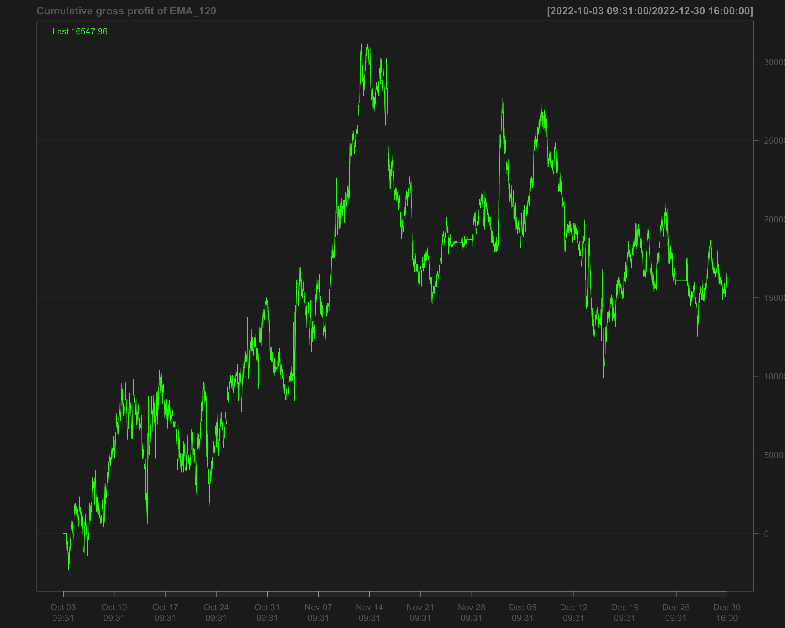

# Identify transactions by calculating the absolute change in position (every time the position changes)  
data1_2022_Q4$ntrans_ema_120 <- abs(diff.xts(data1_2022_Q4$position_ema_120))

# Set the first transaction value to 0, as there's no previous position to compare  
data1_2022_Q4$ntrans_ema_120[1] <- 0

### Net profit for EMA 120

# Calculate net profit by subtracting transaction costs (based on the number of transactions and a cost factor of 12) from the gross profit  
data1_2022_Q4$net_profit_ema_120 <- data1_2022_Q4$gross_profit_ema_120 - data1_2022_Q4$ntrans_ema_120 * 12

# Plot the cumulative sum of the net profit to visualize the overall performance over time  
chartSeries(cumsum(data1_2022_Q4$net_profit_ema_120),   
 name = "Cumulative Net Profit for EMA 120 Strategy")

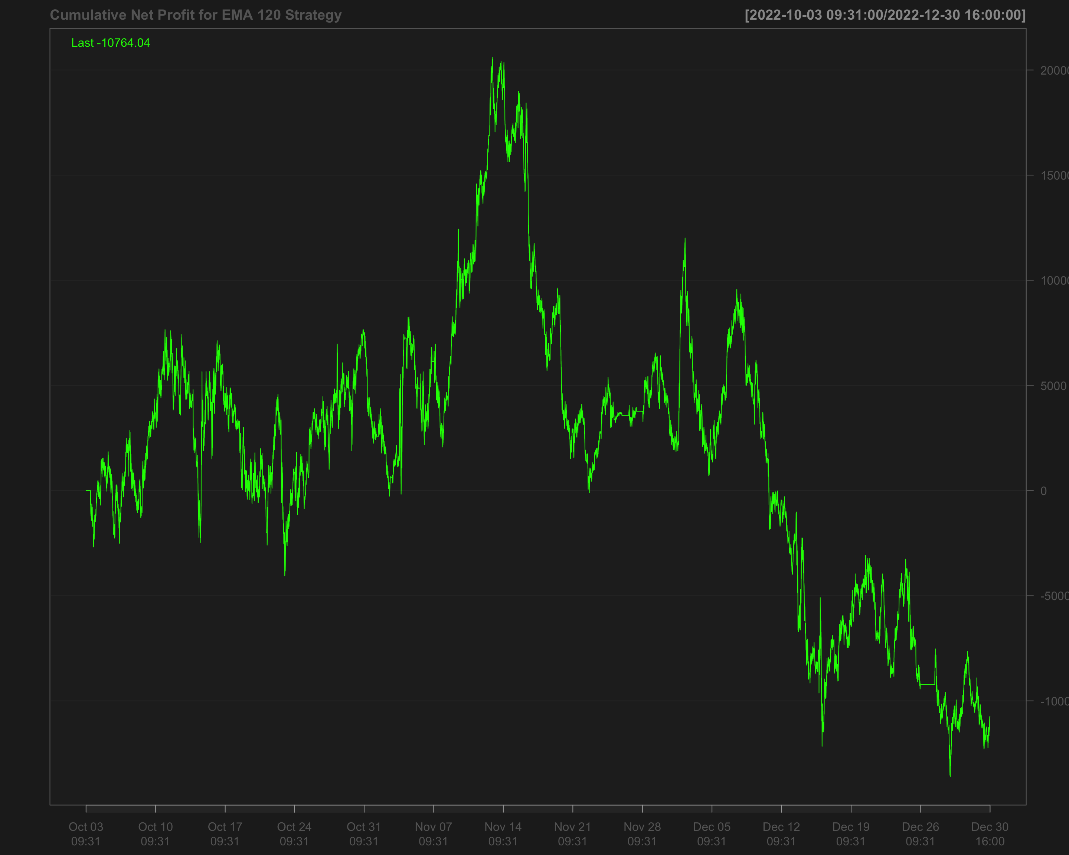

## Volatility breakout strategy using EMA 60 and SD 120

# Calculate the 60-period rolling mean of 'NQ' after filling missing values using the last observation carried forward  
data1_2022_Q4$mean_60 <- roll_mean(na.locf(data1_2022_Q4$NQ, na.rm = FALSE), 60)

# Calculate the 120-period rolling standard deviation of 'NQ' after filling missing values using the last observation carried forward  
data1_2022_Q4$sd_120 <- roll_sd(na.locf(data1_2022_Q4$NQ, na.rm = FALSE), 120)

# Measure the execution time for calculating the position based on a strategy using the 'positionVB' function  
system.time(  
 data1_2022_Q4$position_sd_ema <-   
 positionVB(signal = data1_2022_Q4$NQ,  
 upper = data1_2022_Q4$mean_60 + 1.5 * data1_2022_Q4$sd_120, # Upper bound based on 60-period mean and 1.5 times 120-period SD  
 lower = data1_2022_Q4$mean_60 - 1.5 * data1_2022_Q4$sd_120, # Lower bound based on 60-period mean and 1.5 times 120-period SD  
 times_data = times_data_2022_Q4, # Column with times  
 time_lower = "09:40:00", # Start time for trading  
 time_upper = "15:50:00", # Exit time for all positions  
 strategy = "mom" # Momentum strategy  
 )  
)

# Fill missing position values with the most recent non-missing value (Last Observation Carried Forward)  
data1_2022_Q4$position_sd_ema <- na.locf(data1_2022_Q4$position_sd_ema,  
 na.rm = FALSE)

### Gross profit of volatility breakout strategy

# Calculate gross profit for the strategy by multiplying position with the change in 'NQ' prices and a factor of 20  
data1_2022_Q4$gross_profit_sd_ema <- data1_2022_Q4$position_sd_ema * diff.xts(data1_2022_Q4$NQ) * 20

# Replace any missing values in the gross profit column with 0  
data1_2022_Q4$gross_profit_sd_ema[is.na(data1_2022_Q4$gross_profit_sd_ema)] <- 0  
chartSeries(cumsum(data1_2022_Q4$gross_profit_sd_ema),  
 name = "Cumulative gross profit of (EMA 60 + SD 120)")

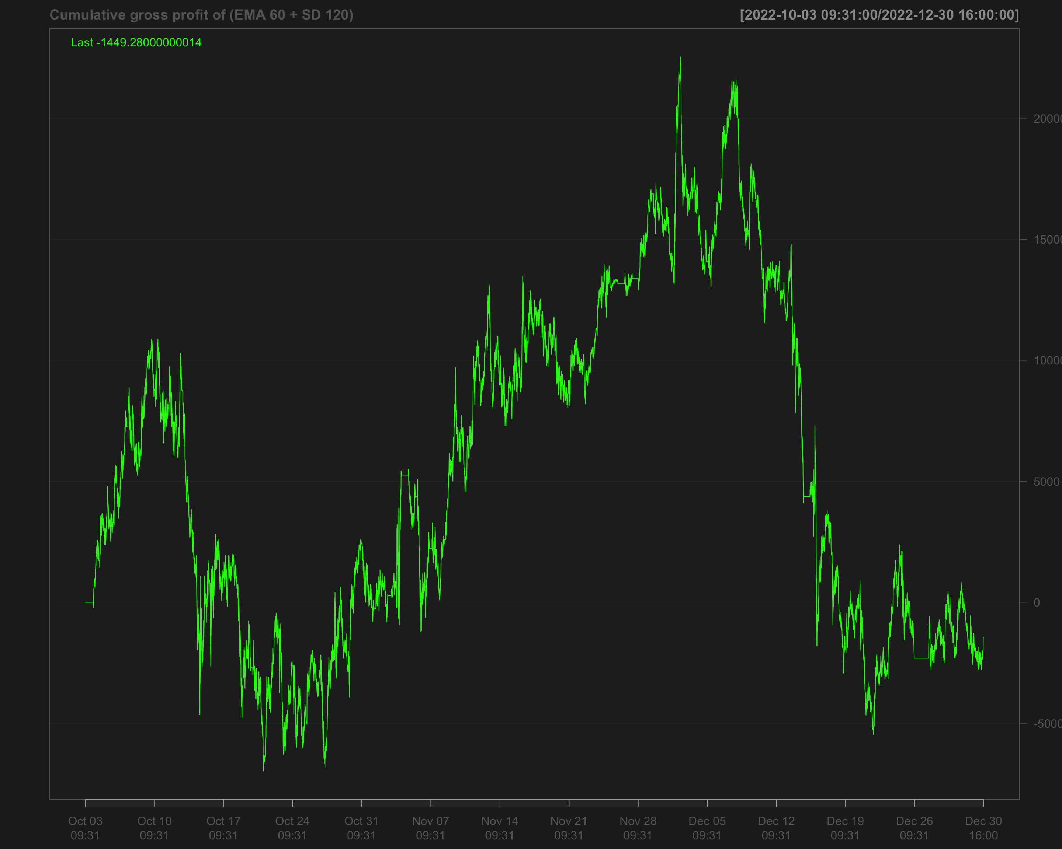

# Identify transactions by calculating the absolute change in position ('position_sd_ema')  
data1_2022_Q4$ntrans_sd_ema <- abs(diff.xts(data1_2022_Q4$position_sd_ema))

# Set the first transaction value to 0, as there's no previous position to compare  
data1_2022_Q4$ntrans_sd_ema[1] <- 0

### Net profit of volatility breakout strategy

# Calculate net profit by subtracting transaction costs (based on the number of transactions and a cost factor of 12) from the gross profit  
data1_2022_Q4$net_profit_sd_ema <- data1_2022_Q4$gross_profit_sd_ema - data1_2022_Q4$ntrans_sd_ema * 12

# Plot the cumulative net profit over time using a chart, based on the 'net_profit_sd_ema' column  
chartSeries(cumsum(data1_2022_Q4$net_profit_sd_ema),   
 name = "Cumulative Net Profit for Volatility Breakout Strategy (EMA 60 + SD 120)")

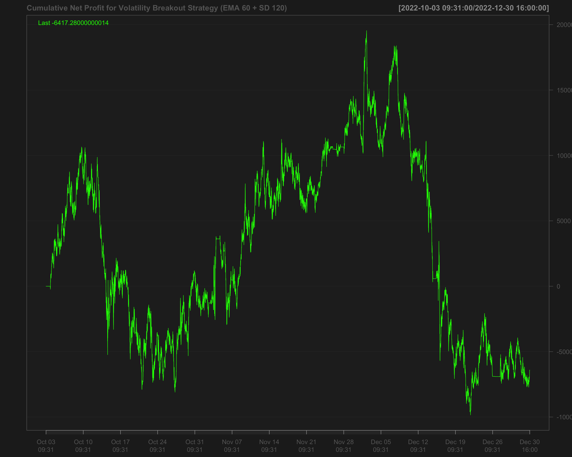

# Strategies based on 2023 Q1

data1_2023_Q1["T09:31/T09:35",] <- NA # Remove data between 09:31 and 09:35 by setting it to NA  
data1_2023_Q1["T15:56/T16:00",] <- NA # Remove data between 15:56 and 16:00 by setting it to NA

## Single EMA of ‘NQ’ with a 120-period window

data1_2023_Q1$ema_120 <- EMA(na.locf(data1_2023_Q1$NQ,   
 na.rm = FALSE),  
 120) # Calculate the 120-period EMA of 'NQ' after filling missing values using the last observation carried forward

data1_2023_Q1$ema_120[is.na(data1_2023_Q1$NQ)] <- NA # Set EMA values to NA where the original 'NQ' values are missing

data1_2023_Q1$position_ema_120 <- ifelse(lag.xts(data1_2023_Q1$NQ) >   
 lag.xts(data1_2023_Q1$ema_120), 1, -1) # Generate trading positions: 1 if 'NQ' is above its lagged EMA, -1 otherwise

# Set trading positions to 0 outside the active trading window (before 09:40:00 or after 15:50:00)  
data1_2023_Q1$position_ema_120[times(times_data_2023_Q1) <= times("9:40:00") |   
 times(times_data_2023_Q1) > times("15:50:00")] <- 0

# Fill missing positions with the most recent non-missing value (Last Observation Carried Forward)  
data1_2023_Q1$position_ema_120 <- na.locf(data1_2023_Q1$position_ema_120,  
 na.rm = FALSE)

### Gross profit for Single EMA

# Calculate gross profit based on the position (ema_120), the change in 'NQ' prices, and a factor of 20  
data1_2023_Q1$gross_profit_ema_120 <- data1_2023_Q1$position_ema_120 * diff.xts(data1_2023_Q1$NQ) * 20

# Set any missing values in 'gross_profit_ema_120' to 0  
data1_2023_Q1$gross_profit_ema_120[is.na(data1_2023_Q1$gross_profit_ema_120)] <- 0  
chartSeries(cumsum(data1_2023_Q1$gross_profit_ema_120),  
 name = "Cumulative gross profit of EMA_120")

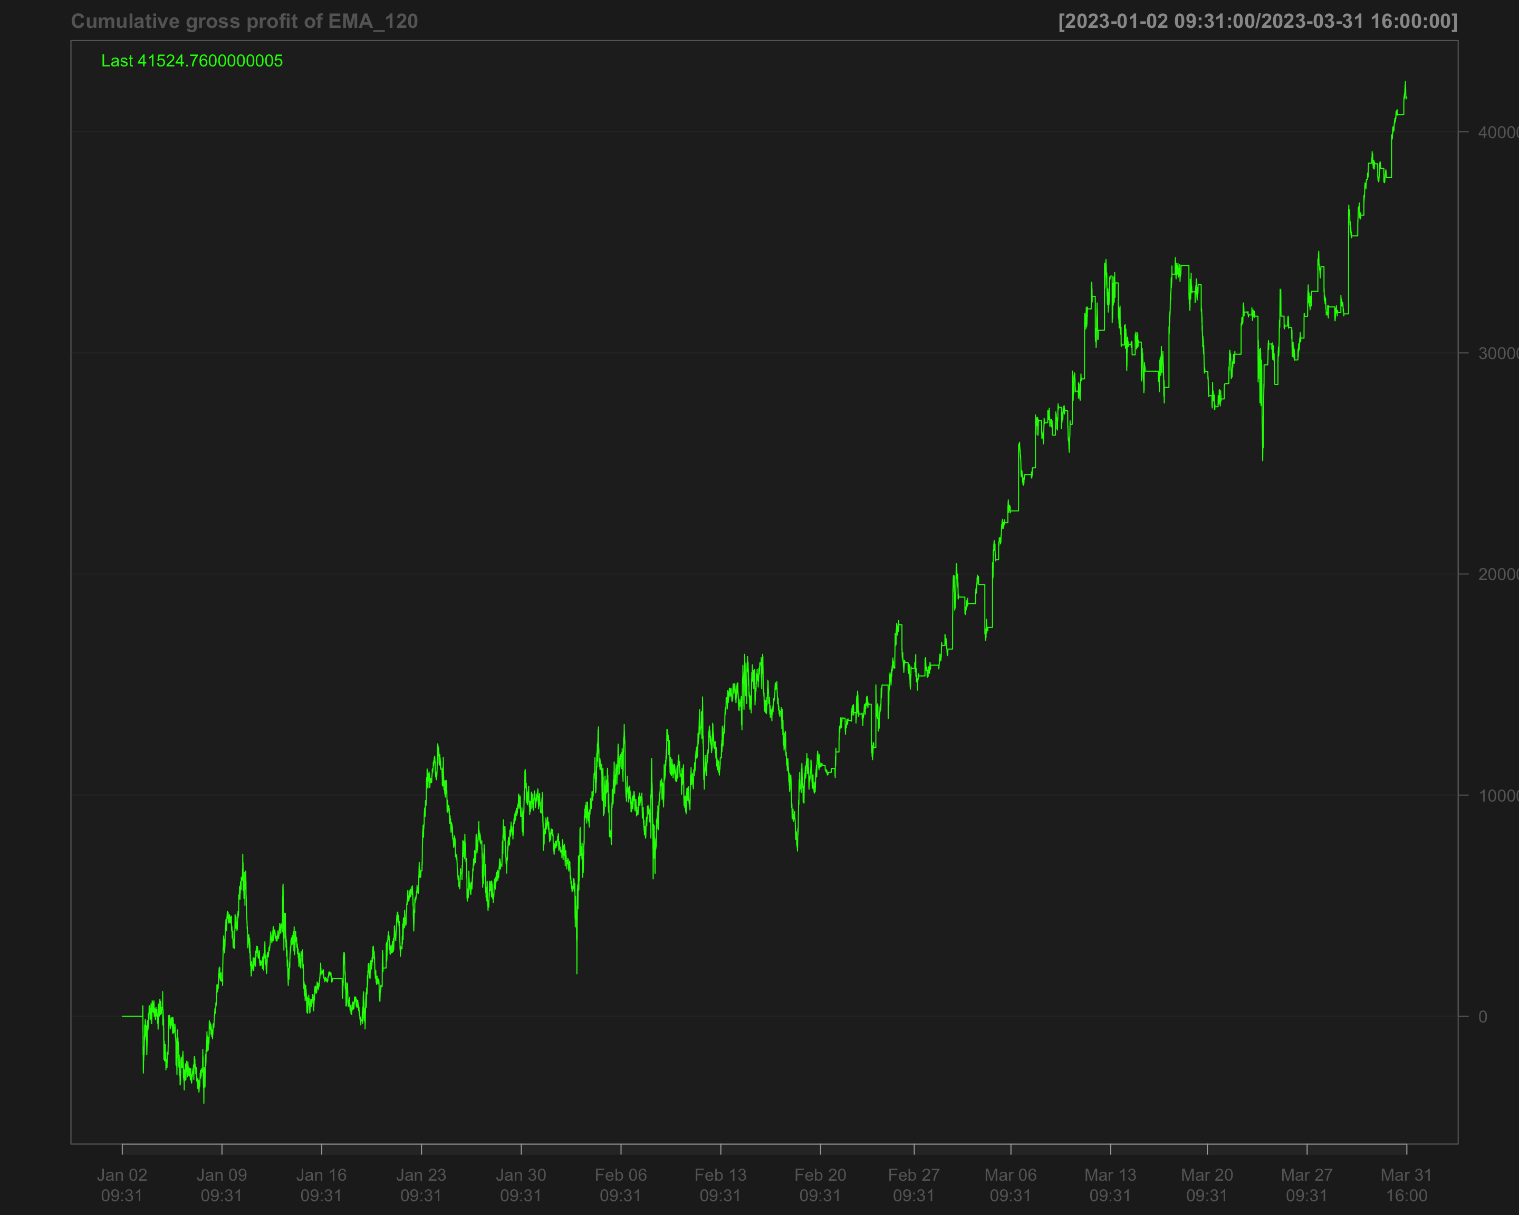

# Identify transactions by calculating the absolute change in position (every time the position changes)  
data1_2023_Q1$ntrans_ema_120 <- abs(diff.xts(data1_2023_Q1$position_ema_120))

# Set the first transaction value to 0, as there's no previous position to compare  
data1_2023_Q1$ntrans_ema_120[1] <- 0

### Net profit for EMA 120

# Calculate net profit by subtracting transaction costs (based on the number of transactions and a cost factor of 12) from the gross profit  
data1_2023_Q1$net_profit_ema_120 <- data1_2023_Q1$gross_profit_ema_120 - data1_2023_Q1$ntrans_ema_120 * 12

# Plot the cumulative sum of the net profit to visualize the overall performance over time  
chartSeries(cumsum(data1_2023_Q1$net_profit_ema_120),   
 name = "Cumulative Net Profit for EMA 120 Strategy")

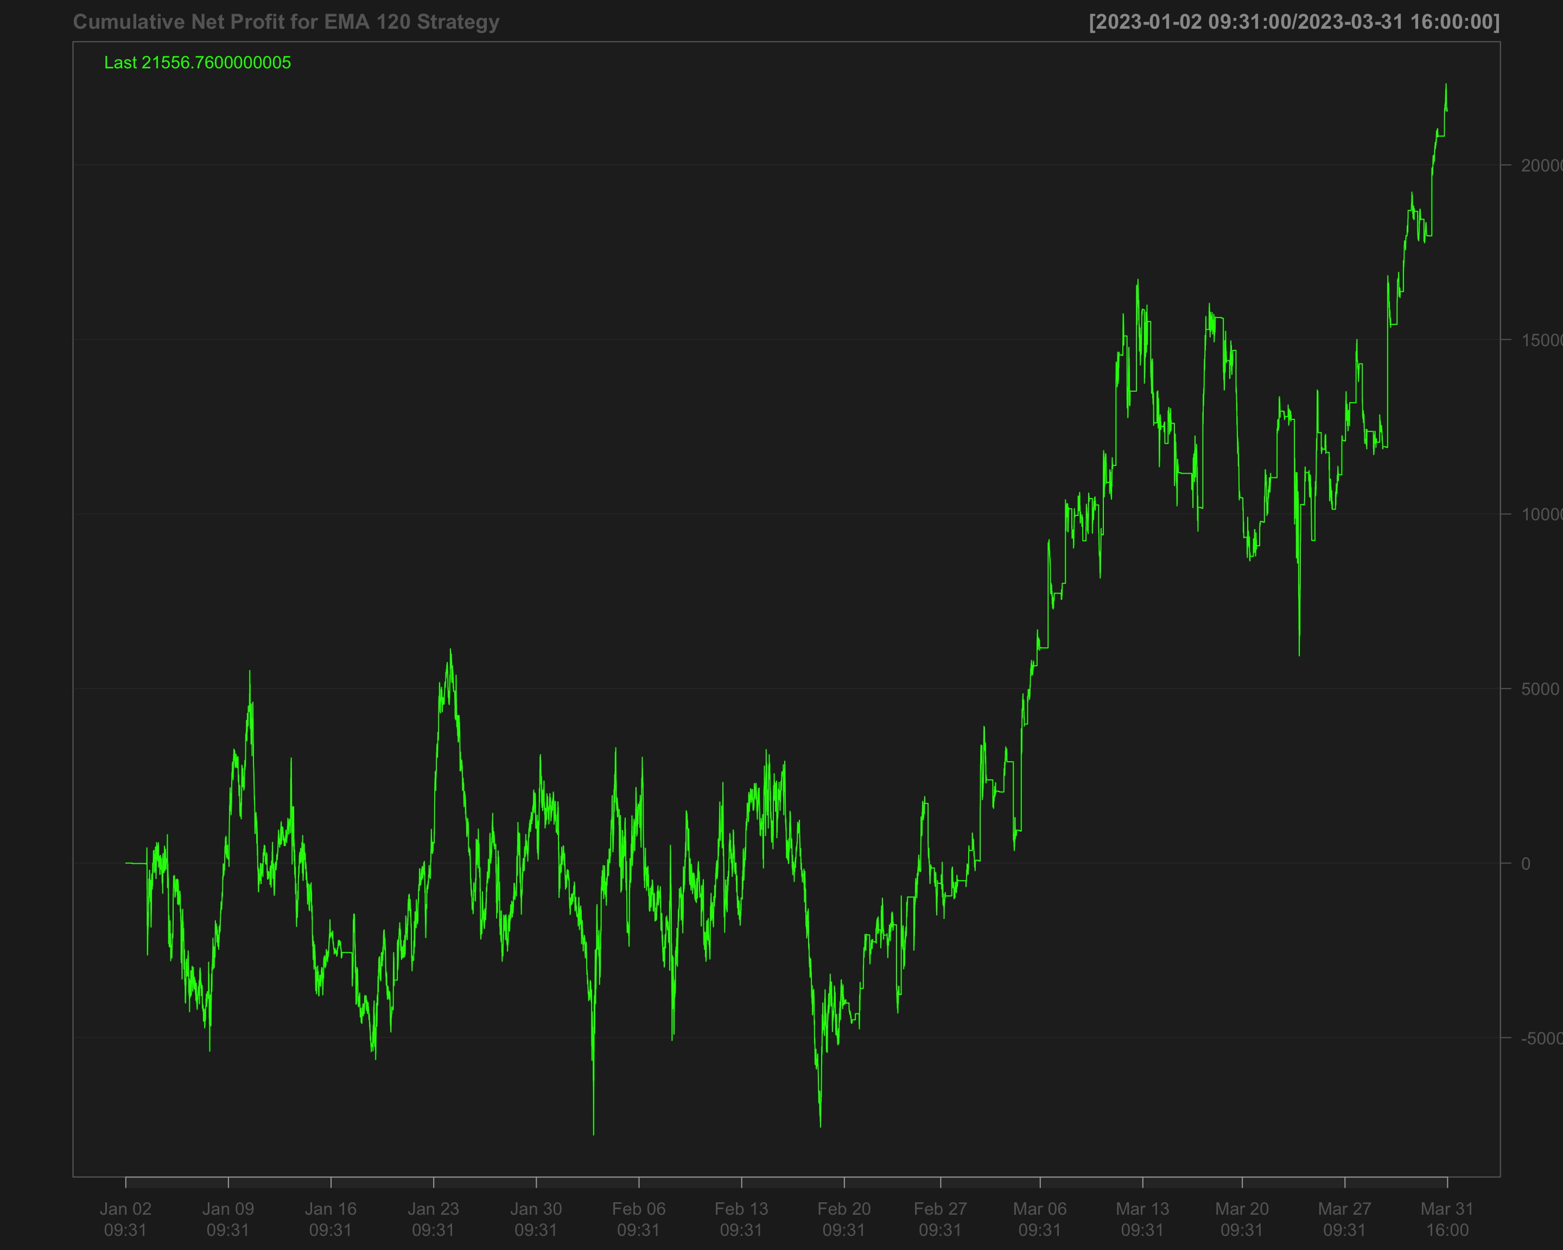

## Volatility breakout strategy using EMA 60 and SD 120

# Calculate the 60-period rolling mean of 'NQ' after filling missing values using the last observation carried forward  
data1_2023_Q1$mean_60 <- roll_mean(na.locf(data1_2023_Q1$NQ, na.rm = FALSE), 60)

# Calculate the 120-period rolling standard deviation of 'NQ' after filling missing values using the last observation carried forward  
data1_2023_Q1$sd_120 <- roll_sd(na.locf(data1_2023_Q1$NQ, na.rm = FALSE), 120)

# Measure the execution time for calculating the position based on a strategy using the 'positionVB' function  
system.time(  
 data1_2023_Q1$position_sd_ema <-   
 positionVB(signal = data1_2023_Q1$NQ,  
 upper = data1_2023_Q1$mean_60 + 1.5 * data1_2023_Q1$sd_120, # Upper bound based on 60-period mean and 1.5 times 120-period SD  
 lower = data1_2023_Q1$mean_60 - 1.5 * data1_2023_Q1$sd_120, # Lower bound based on 60-period mean and 1.5 times 120-period SD  
 times_data = times_data_2023_Q1, # Column with times  
 time_lower = "09:40:00", # Start time for trading  
 time_upper = "15:50:00", # Exit time for all positions  
 strategy = "mom" # Momentum strategy  
 )  
)

# Fill missing position values with the most recent non-missing value (Last Observation Carried Forward)  
data1_2023_Q1$position_sd_ema <- na.locf(data1_2023_Q1$position_sd_ema,  
 na.rm = FALSE)

### Gross profit of volatility breakout strategy

# Calculate gross profit for the strategy by multiplying position with the change in 'NQ' prices and a factor of 20  
data1_2023_Q1$gross_profit_sd_ema <- data1_2023_Q1$position_sd_ema * diff.xts(data1_2023_Q1$NQ) * 20

# Replace any missing values in the gross profit column with 0  
data1_2023_Q1$gross_profit_sd_ema[is.na(data1_2023_Q1$gross_profit_sd_ema)] <- 0  
chartSeries(cumsum(data1_2023_Q1$gross_profit_sd_ema),  
 name = "Cumulative gross profit of (EMA 60 + SD 120)")

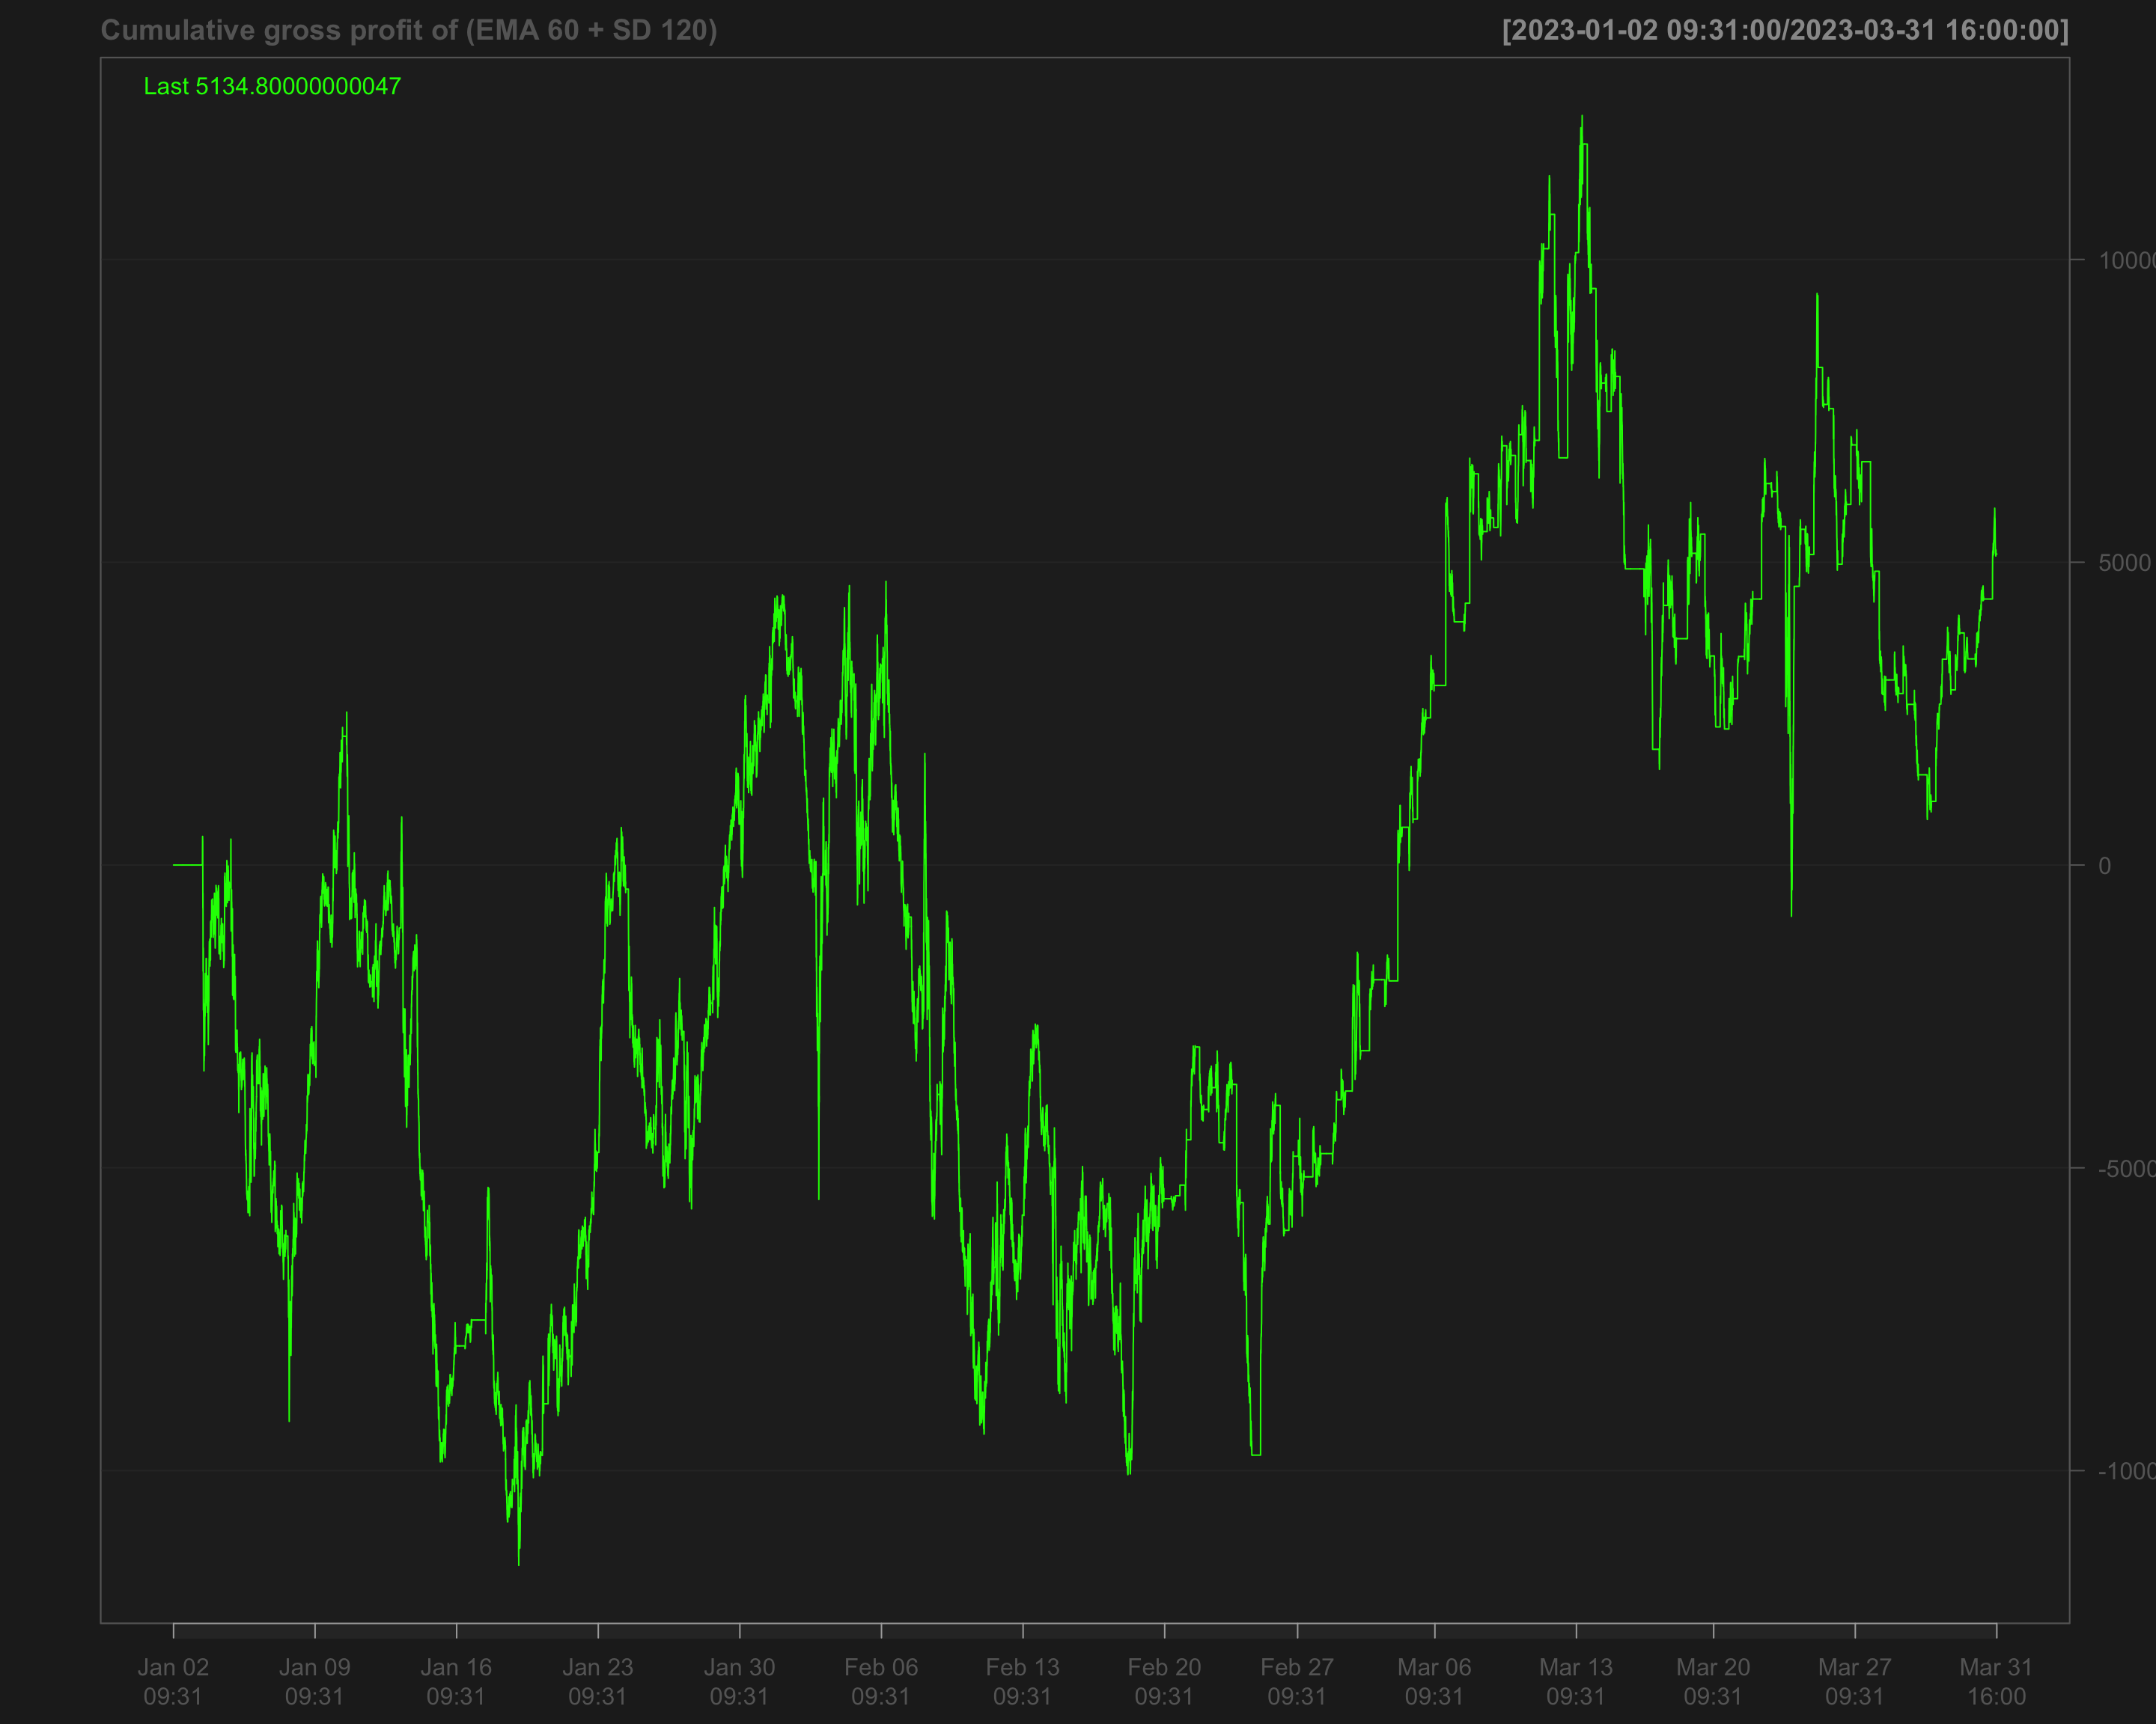

# Identify transactions by calculating the absolute change in position ('position_sd_ema')  
data1_2023_Q1$ntrans_sd_ema <- abs(diff.xts(data1_2023_Q1$position_sd_ema))

# Set the first transaction value to 0, as there's no previous position to compare  
data1_2023_Q1$ntrans_sd_ema[1] <- 0

### Net profit of volatility breakout strategy

# Calculate net profit by subtracting transaction costs (based on the number of transactions and a cost factor of 12) from the gross profit  
data1_2023_Q1$net_profit_sd_ema <- data1_2023_Q1$gross_profit_sd_ema - data1_2023_Q1$ntrans_sd_ema * 12

# Plot the cumulative net profit over time using a chart, based on the 'net_profit_sd_ema' column  
chartSeries(cumsum(data1_2023_Q1$net_profit_sd_ema),   
 name = "Cumulative Net Profit for (EMA 60 + SD 120)")

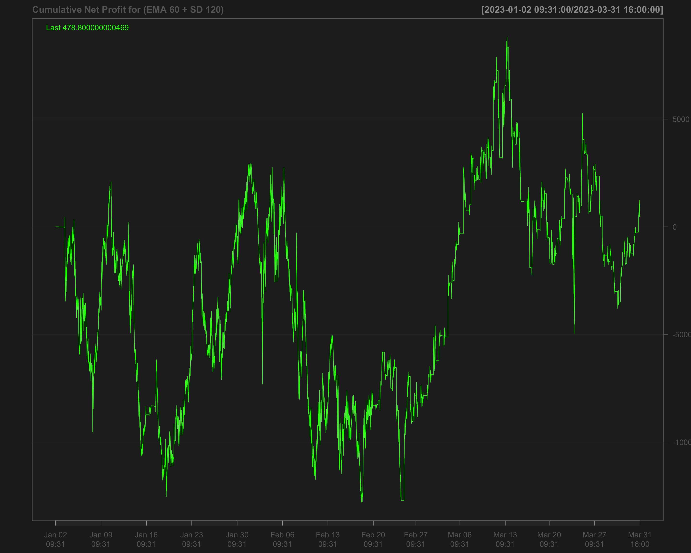

# Strategies based on 2023 Q2

data1_2023_Q2["T09:31/T09:35",] <- NA # Remove data between 09:31 and 09:35 by setting it to NA  
data1_2023_Q2["T15:56/T16:00",] <- NA # Remove data between 15:56 and 16:00 by setting it to NA

## Single EMA of ‘NQ’ with a 120-period window

data1_2023_Q2$ema_120 <- EMA(na.locf(data1_2023_Q2$NQ,   
 na.rm = FALSE),  
 120) # Calculate the 120-period EMA of 'NQ' after filling missing values using the last observation carried forward

data1_2023_Q2$ema_120[is.na(data1_2023_Q2$NQ)] <- NA # Set EMA values to NA where the original 'NQ' values are missing

data1_2023_Q2$position_ema_120 <- ifelse(lag.xts(data1_2023_Q2$NQ) >   
 lag.xts(data1_2023_Q2$ema_120), 1, -1) # Generate trading positions: 1 if 'NQ' is above its lagged EMA, -1 otherwise

# Set trading positions to 0 outside the active trading window (before 09:40:00 or after 15:50:00)  
data1_2023_Q2$position_ema_120[times(times_data_2023_Q2) <= times("9:40:00") |   
 times(times_data_2023_Q2) > times("15:50:00")] <- 0

# Fill missing positions with the most recent non-missing value (Last Observation Carried Forward)  
data1_2023_Q2$position_ema_120 <- na.locf(data1_2023_Q2$position_ema_120,  
 na.rm = FALSE)

### Gross profit for Single EMA

# Calculate gross profit based on the position (ema_120), the change in 'NQ' prices, and a factor of 20  
data1_2023_Q2$gross_profit_ema_120 <- data1_2023_Q2$position_ema_120 * diff.xts(data1_2023_Q2$NQ) * 20

# Set any missing values in 'gross_profit_ema_120' to 0  
data1_2023_Q2$gross_profit_ema_120[is.na(data1_2023_Q2$gross_profit_ema_120)] <- 0  
chartSeries(cumsum(data1_2023_Q2$gross_profit_ema_120),  
 name = "Cumulative gross profit of EMA_120")

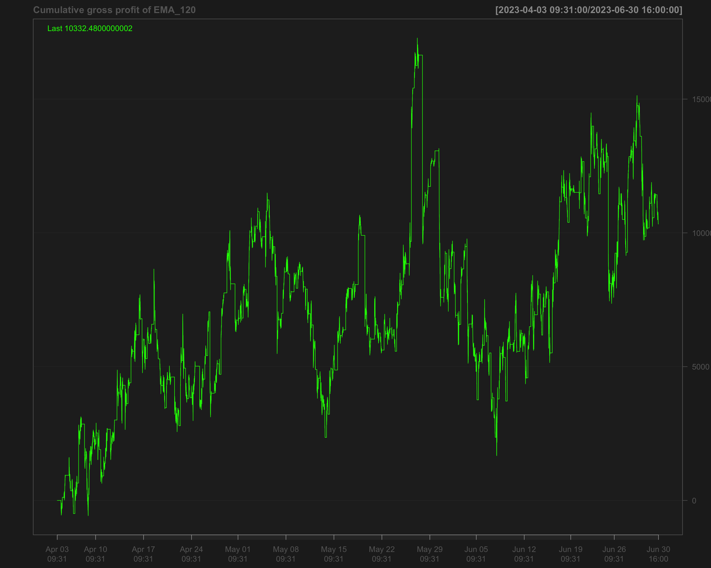

# Identify transactions by calculating the absolute change in position (every time the position changes)  
data1_2023_Q2$ntrans_ema_120 <- abs(diff.xts(data1_2023_Q2$position_ema_120))

# Set the first transaction value to 0, as there's no previous position to compare  
data1_2023_Q2$ntrans_ema_120[1] <- 0

### Net profit for EMA 120

# Calculate net profit by subtracting transaction costs (based on the number of transactions and a cost factor of 12) from the gross profit  
data1_2023_Q2$net_profit_ema_120 <- data1_2023_Q2$gross_profit_ema_120 - data1_2023_Q2$ntrans_ema_120 * 12

# Plot the cumulative sum of the net profit to visualize the overall performance over time  
chartSeries(cumsum(data1_2023_Q2$net_profit_ema_120),   
 name = "Cumulative Net Profit for EMA 120 Strategy")

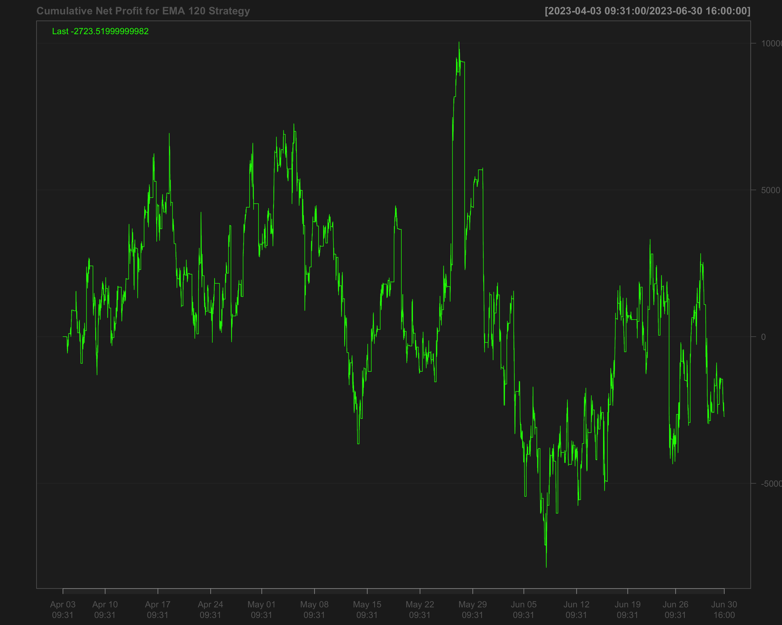

## Volatility breakout strategy using EMA 60 and SD 120

# Calculate the 60-period rolling mean of 'NQ' after filling missing values using the last observation carried forward  
data1_2023_Q2$mean_60 <- roll_mean(na.locf(data1_2023_Q2$NQ, na.rm = FALSE), 60)

# Calculate the 120-period rolling standard deviation of 'NQ' after filling missing values using the last observation carried forward  
data1_2023_Q2$sd_120 <- roll_sd(na.locf(data1_2023_Q2$NQ, na.rm = FALSE), 120)

# Measure the execution time for calculating the position based on a strategy using the 'positionVB' function  
system.time(  
 data1_2023_Q2$position_sd_ema <-   
 positionVB(signal = data1_2023_Q2$NQ,  
 upper = data1_2023_Q2$mean_60 + 1.5 * data1_2023_Q2$sd_120, # Upper bound based on 60-period mean and 1.5 times 120-period SD  
 lower = data1_2023_Q2$mean_60 - 1.5 * data1_2023_Q2$sd_120, # Lower bound based on 60-period mean and 1.5 times 120-period SD  
 times_data = times_data_2023_Q2, # Column with times  
 time_lower = "09:40:00", # Start time for trading  
 time_upper = "15:50:00", # Exit time for all positions  
 strategy = "mom" # Momentum strategy  
 )  
)

# Fill missing position values with the most recent non-missing value (Last Observation Carried Forward)  
data1_2023_Q2$position_sd_ema <- na.locf(data1_2023_Q2$position_sd_ema,  
 na.rm = FALSE)

### Gross profit of volatility breakout strategy

# Calculate gross profit for the strategy by multiplying position with the change in 'NQ' prices and a factor of 20  
data1_2023_Q2$gross_profit_sd_ema <- data1_2023_Q2$position_sd_ema * diff.xts(data1_2023_Q2$NQ) * 20

# Replace any missing values in the gross profit column with 0  
data1_2023_Q2$gross_profit_sd_ema[is.na(data1_2023_Q2$gross_profit_sd_ema)] <- 0  
chartSeries(cumsum(data1_2023_Q2$gross_profit_sd_ema),  
 name = "Cumulative gross profit of (EMA 60 + SD 120)")

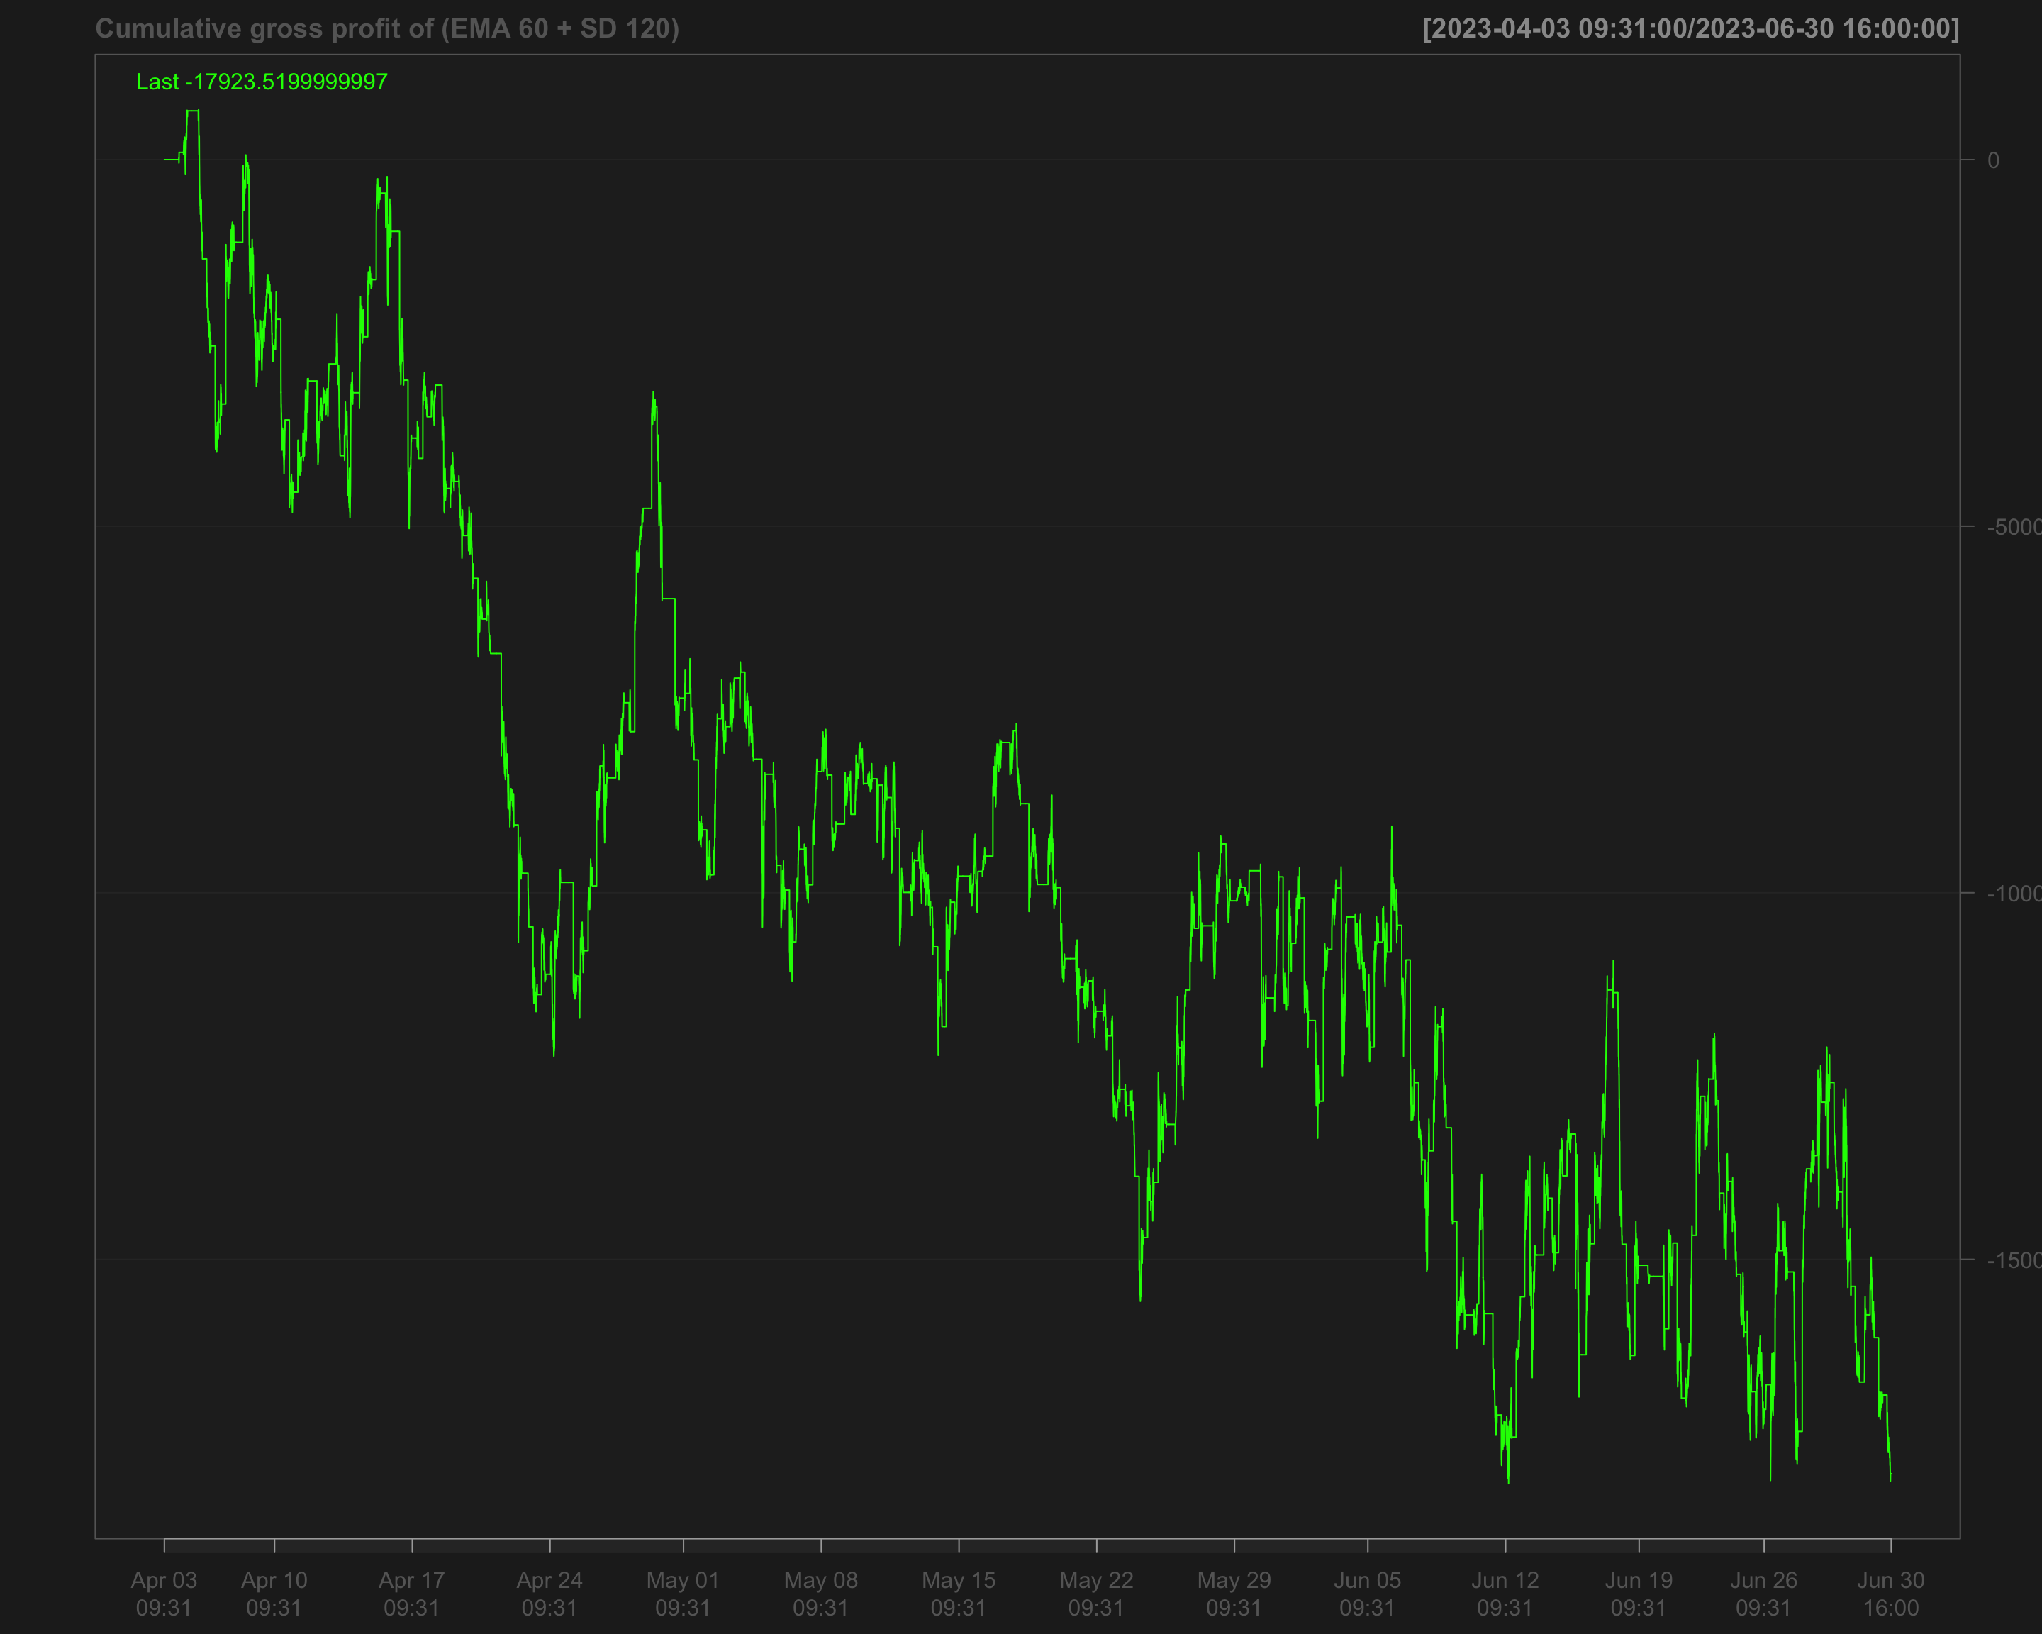

# Identify transactions by calculating the absolute change in position ('position_sd_ema')  
data1_2023_Q2$ntrans_sd_ema <- abs(diff.xts(data1_2023_Q2$position_sd_ema))

# Set the first transaction value to 0, as there's no previous position to compare  
data1_2023_Q2$ntrans_sd_ema[1] <- 0

### Net profit of volatility breakout strategy

# Calculate net profit by subtracting transaction costs (based on the number of transactions and a cost factor of 12) from the gross profit  
data1_2023_Q2$net_profit_sd_ema <- data1_2023_Q2$gross_profit_sd_ema - data1_2023_Q2$ntrans_sd_ema * 12

# Plot the cumulative net profit over time using a chart, based on the 'net_profit_sd_ema' column  
chartSeries(cumsum(data1_2023_Q2$net_profit_sd_ema),   
 name = "Cumulative Net Profit for (EMA 60 + SD 120)")

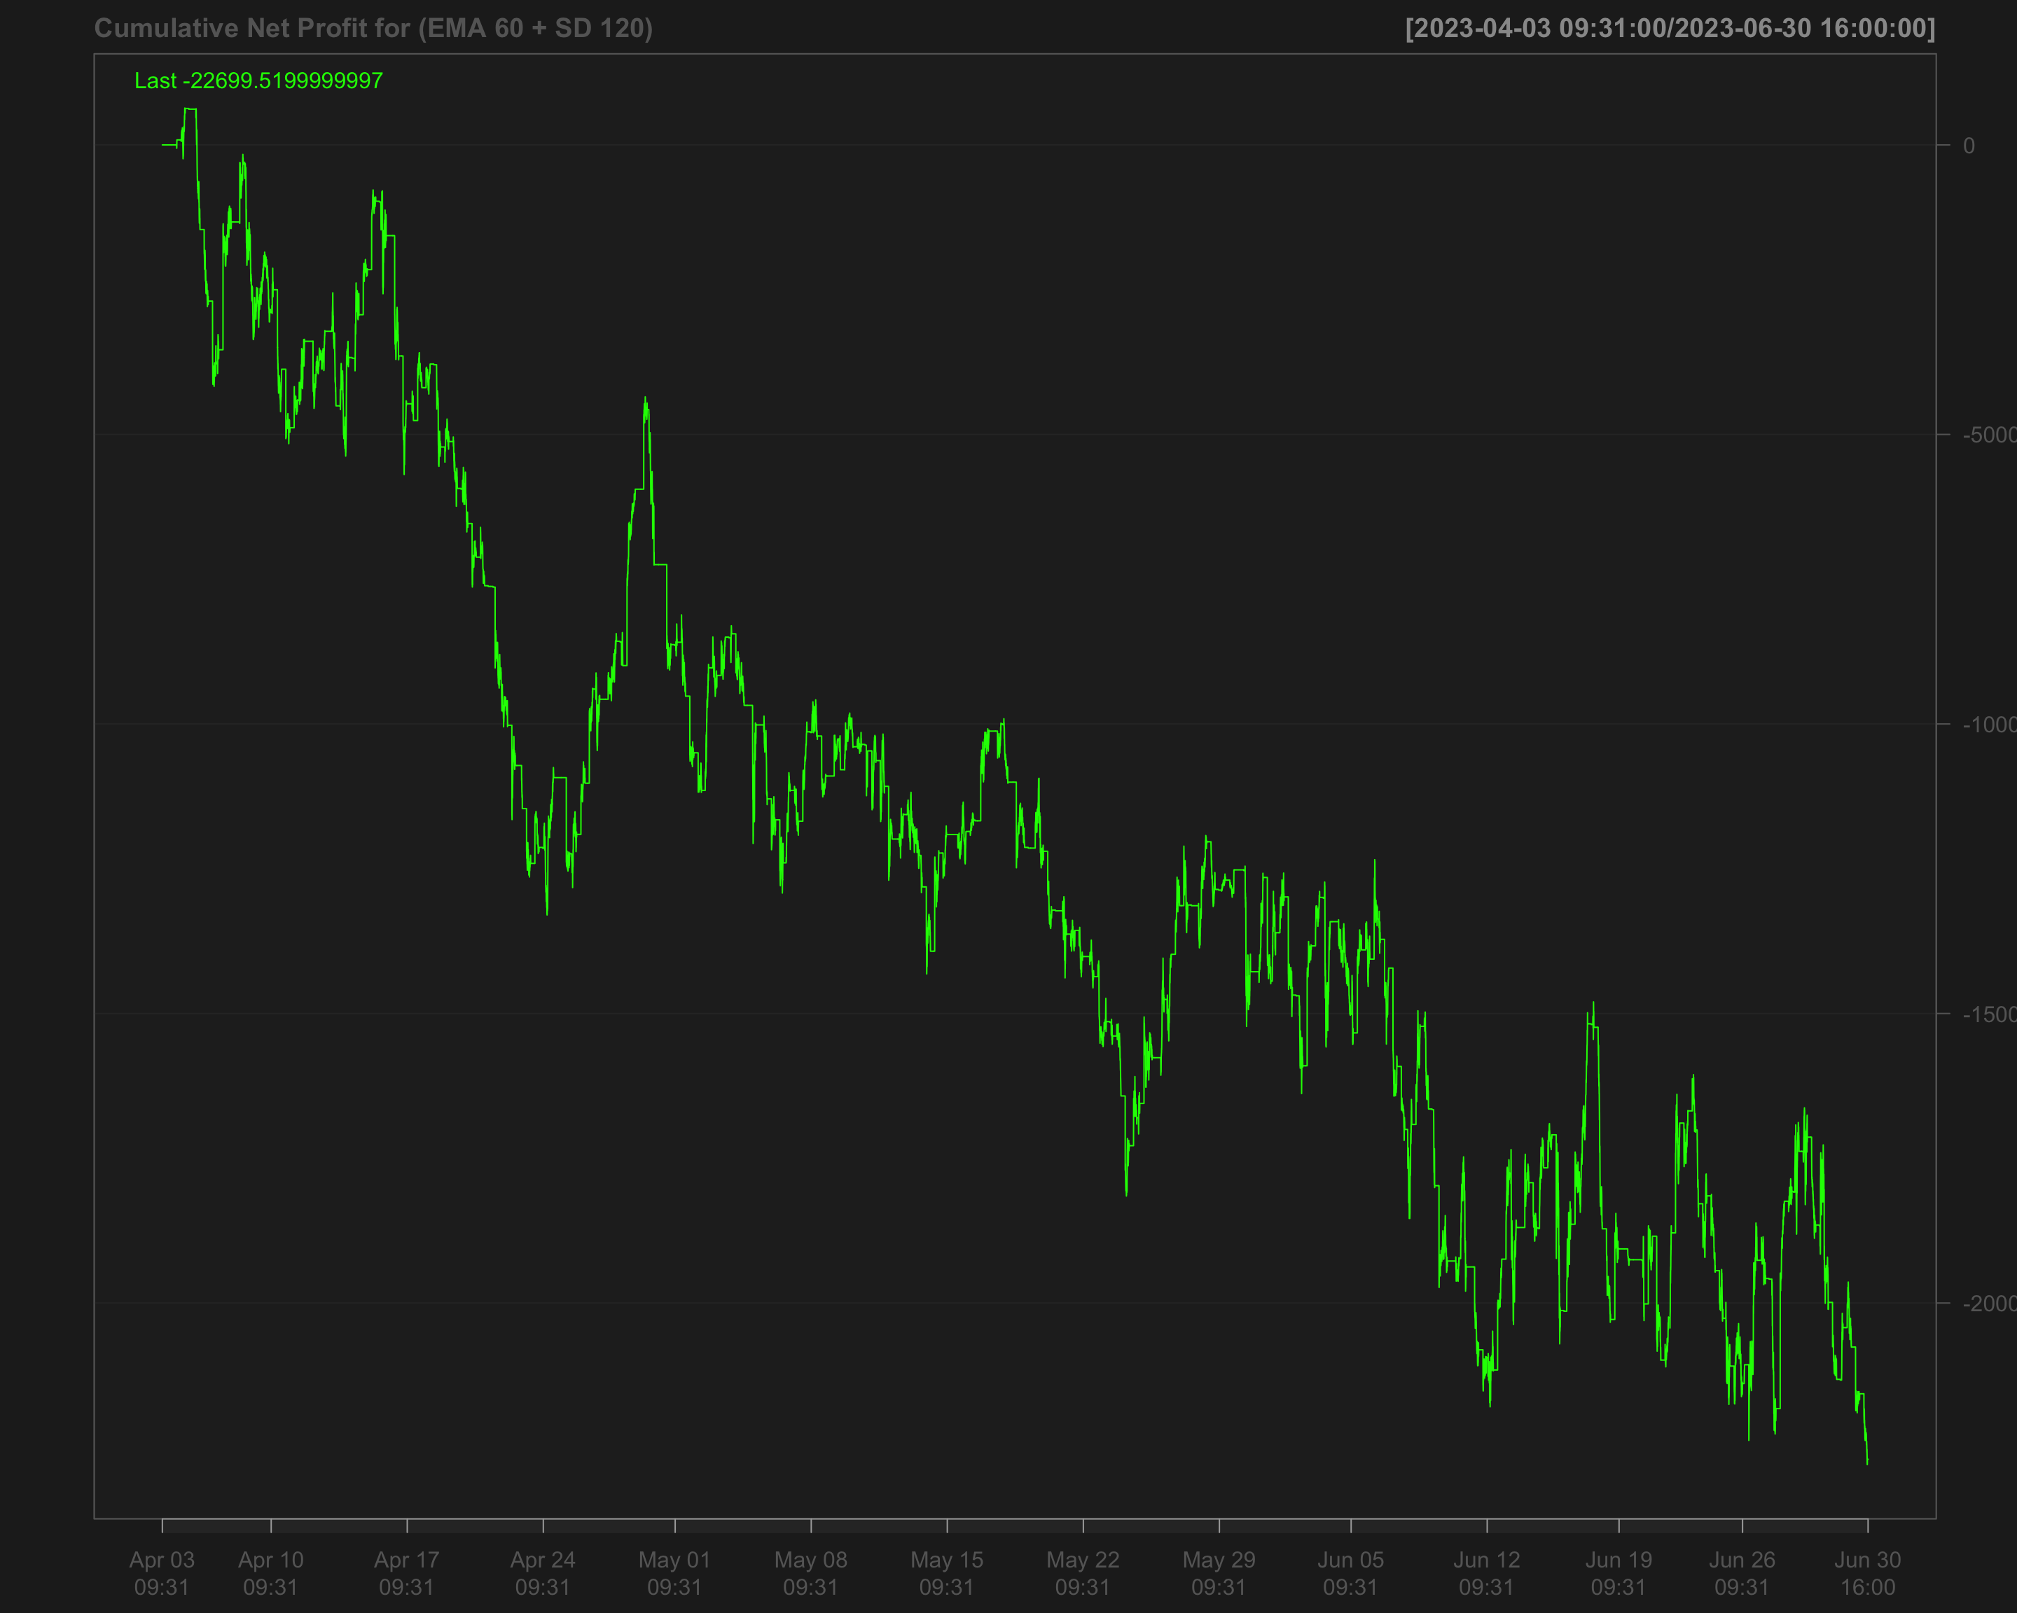

# Strategies based on 2023 Q3

data1_2023_Q3["T09:31/T09:35",] <- NA # Remove data between 09:31 and 09:35 by setting it to NA  
data1_2023_Q3["T15:56/T16:00",] <- NA # Remove data between 15:56 and 16:00 by setting it to NA

## Single EMA of ‘NQ’ with a 120-period window

data1_2023_Q3$ema_120 <- EMA(na.locf(data1_2023_Q3$NQ,   
 na.rm = FALSE),  
 120) # Calculate the 120-period EMA of 'NQ' after filling missing values using the last observation carried forward

data1_2023_Q3$ema_120[is.na(data1_2023_Q3$NQ)] <- NA # Set EMA values to NA where the original 'NQ' values are missing

data1_2023_Q3$position_ema_120 <- ifelse(lag.xts(data1_2023_Q3$NQ) >   
 lag.xts(data1_2023_Q3$ema_120), 1, -1) # Generate trading positions: 1 if 'NQ' is above its lagged EMA, -1 otherwise

# Set trading positions to 0 outside the active trading window (before 09:40:00 or after 15:50:00)  
data1_2023_Q3$position_ema_120[times(times_data_2023_Q3) <= times("9:40:00") |   
 times(times_data_2023_Q3) > times("15:50:00")] <- 0

# Fill missing positions with the most recent non-missing value (Last Observation Carried Forward)  
data1_2023_Q3$position_ema_120 <- na.locf(data1_2023_Q3$position_ema_120,  
 na.rm = FALSE)

### Gross profit for Single EMA

# Calculate gross profit based on the position (ema_120), the change in 'NQ' prices, and a factor of 20  
data1_2023_Q3$gross_profit_ema_120 <- data1_2023_Q3$position_ema_120 * diff.xts(data1_2023_Q3$NQ) * 20

# Set any missing values in 'gross_profit_ema_120' to 0  
data1_2023_Q3$gross_profit_ema_120[is.na(data1_2023_Q3$gross_profit_ema_120)] <- 0  
chartSeries(cumsum(data1_2023_Q3$gross_profit_ema_120),  
 name = "Cumulative gross profit of EMA_120")

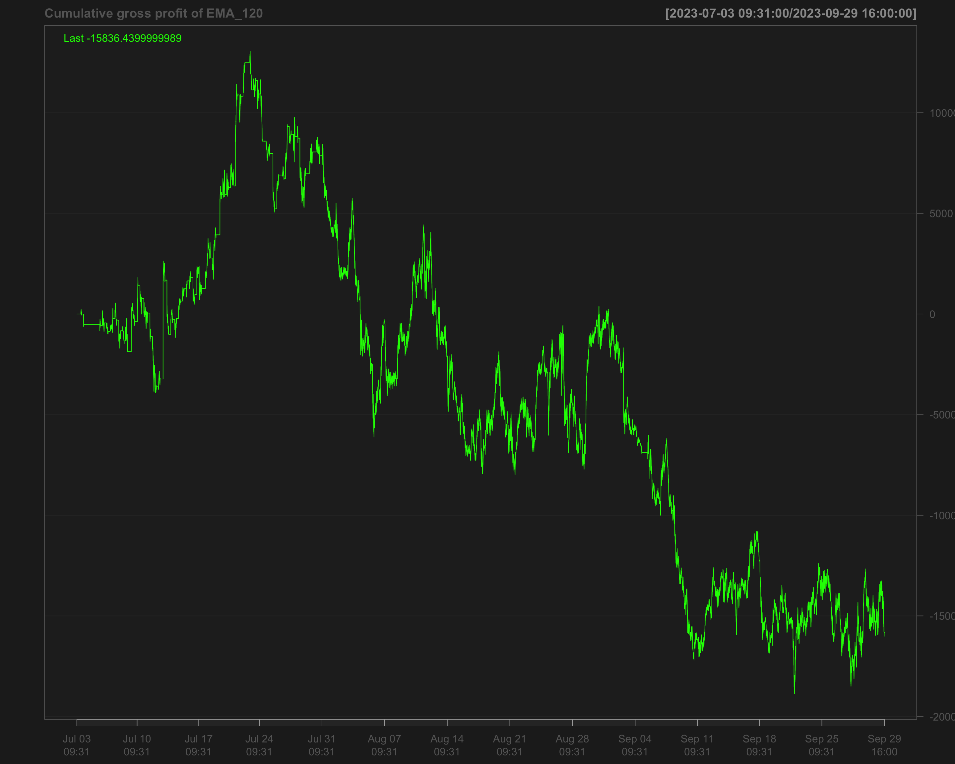

# Identify transactions by calculating the absolute change in position (every time the position changes)  
data1_2023_Q3$ntrans_ema_120 <- abs(diff.xts(data1_2023_Q3$position_ema_120))

# Set the first transaction value to 0, as there's no previous position to compare  
data1_2023_Q3$ntrans_ema_120[1] <- 0

### Net profit for EMA 120

# Calculate net profit by subtracting transaction costs (based on the number of transactions and a cost factor of 12) from the gross profit  
data1_2023_Q3$net_profit_ema_120 <- data1_2023_Q3$gross_profit_ema_120 - data1_2023_Q3$ntrans_ema_120 * 12

# Plot the cumulative sum of the net profit to visualize the overall performance over time  
chartSeries(cumsum(data1_2023_Q3$net_profit_ema_120),   
 name = "Cumulative Net Profit for EMA 120 Strategy")

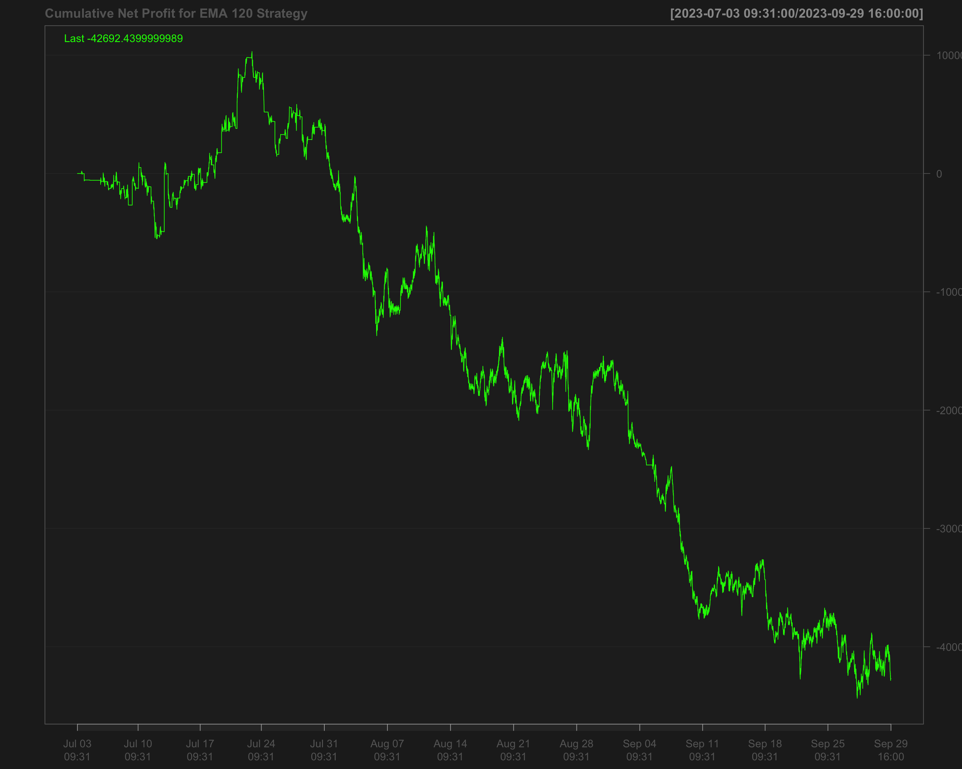

## Volatility breakout strategy using EMA 60 and SD 120

# Calculate the 60-period rolling mean of 'NQ' after filling missing values using the last observation carried forward  
data1_2023_Q3$mean_60 <- roll_mean(na.locf(data1_2023_Q3$NQ, na.rm = FALSE), 60)

# Calculate the 120-period rolling standard deviation of 'NQ' after filling missing values using the last observation carried forward  
data1_2023_Q3$sd_120 <- roll_sd(na.locf(data1_2023_Q3$NQ, na.rm = FALSE), 120)

# Measure the execution time for calculating the position based on a strategy using the 'positionVB' function  
system.time(  
 data1_2023_Q3$position_sd_ema <-   
 positionVB(signal = data1_2023_Q3$NQ,  
 upper = data1_2023_Q3$mean_60 + 1.5 * data1_2023_Q3$sd_120, # Upper bound based on 60-period mean and 1.5 times 120-period SD  
 lower = data1_2023_Q3$mean_60 - 1.5 * data1_2023_Q3$sd_120, # Lower bound based on 60-period mean and 1.5 times 120-period SD  
 times_data = times_data_2023_Q3, # Column with times  
 time_lower = "09:40:00", # Start time for trading  
 time_upper = "15:50:00", # Exit time for all positions  
 strategy = "mom" # Momentum strategy  
 )  
)

# Fill missing position values with the most recent non-missing value (Last Observation Carried Forward)  
data1_2023_Q3$position_sd_ema <- na.locf(data1_2023_Q3$position_sd_ema,  
 na.rm = FALSE)

### Gross profit of volatility breakout strategy

# Calculate gross profit for the strategy by multiplying position with the change in 'NQ' prices and a factor of 20  
data1_2023_Q3$gross_profit_sd_ema <- data1_2023_Q3$position_sd_ema * diff.xts(data1_2023_Q3$NQ) * 20

# Replace any missing values in the gross profit column with 0  
data1_2023_Q3$gross_profit_sd_ema[is.na(data1_2023_Q3$gross_profit_sd_ema)] <- 0  
chartSeries(cumsum(data1_2023_Q3$gross_profit_sd_ema),  
 name = "Cumulative gross profit of (EMA 60 + SD 120)")

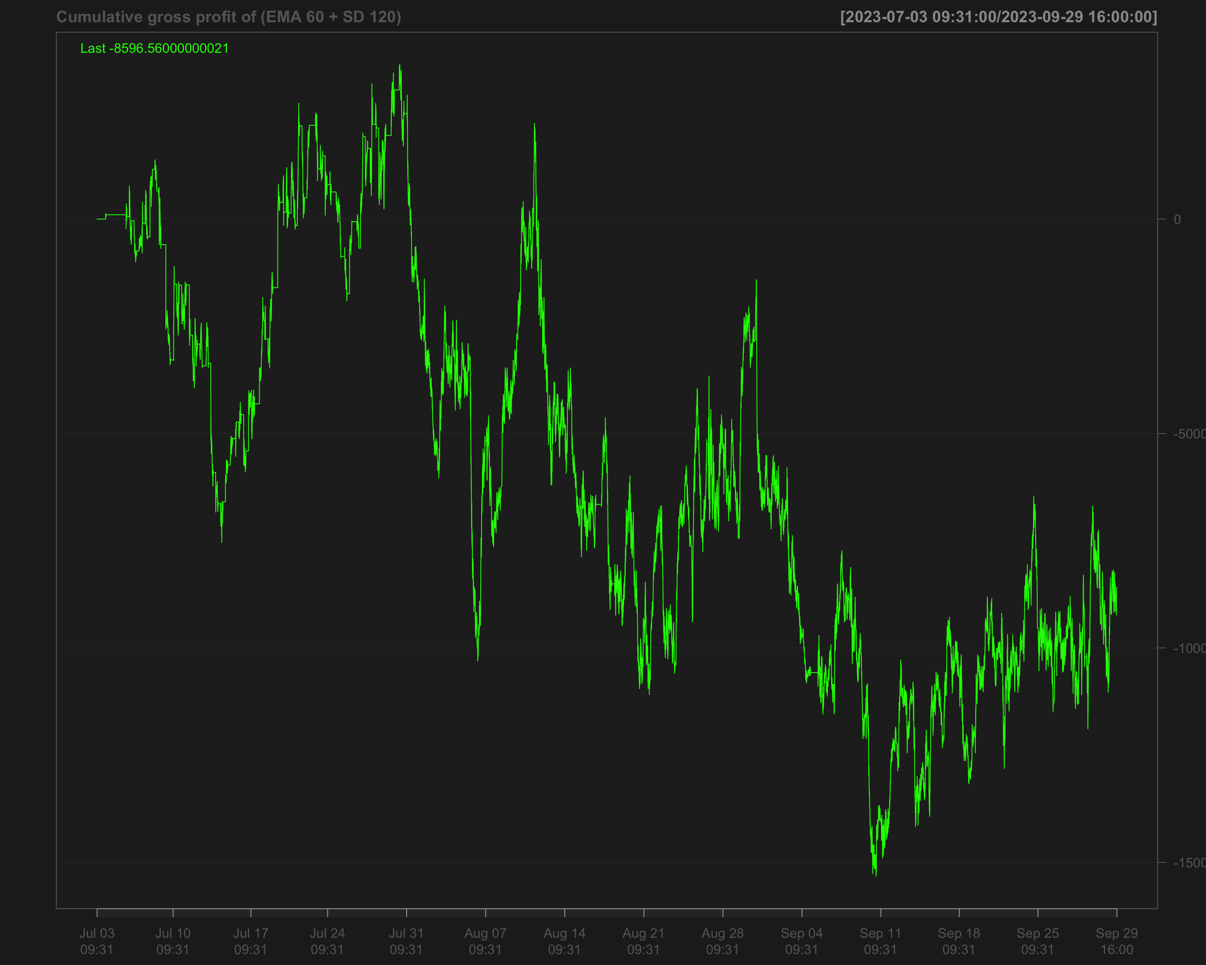

# Identify transactions by calculating the absolute change in position ('position_sd_ema')  
data1_2023_Q3$ntrans_sd_ema <- abs(diff.xts(data1_2023_Q3$position_sd_ema))

# Set the first transaction value to 0, as there's no previous position to compare  
data1_2023_Q3$ntrans_sd_ema[1] <- 0

### Net profit of volatility breakout strategy

# Calculate net profit by subtracting transaction costs (based on the number of transactions and a cost factor of 12) from the gross profit  
data1_2023_Q3$net_profit_sd_ema <- data1_2023_Q3$gross_profit_sd_ema - data1_2023_Q3$ntrans_sd_ema * 12

# Plot the cumulative net profit over time using a chart, based on the 'net_profit_sd_ema' column  
chartSeries(cumsum(data1_2023_Q3$net_profit_sd_ema),   
 name = "Cumulative Net Profit for (EMA 60 + SD 120)")

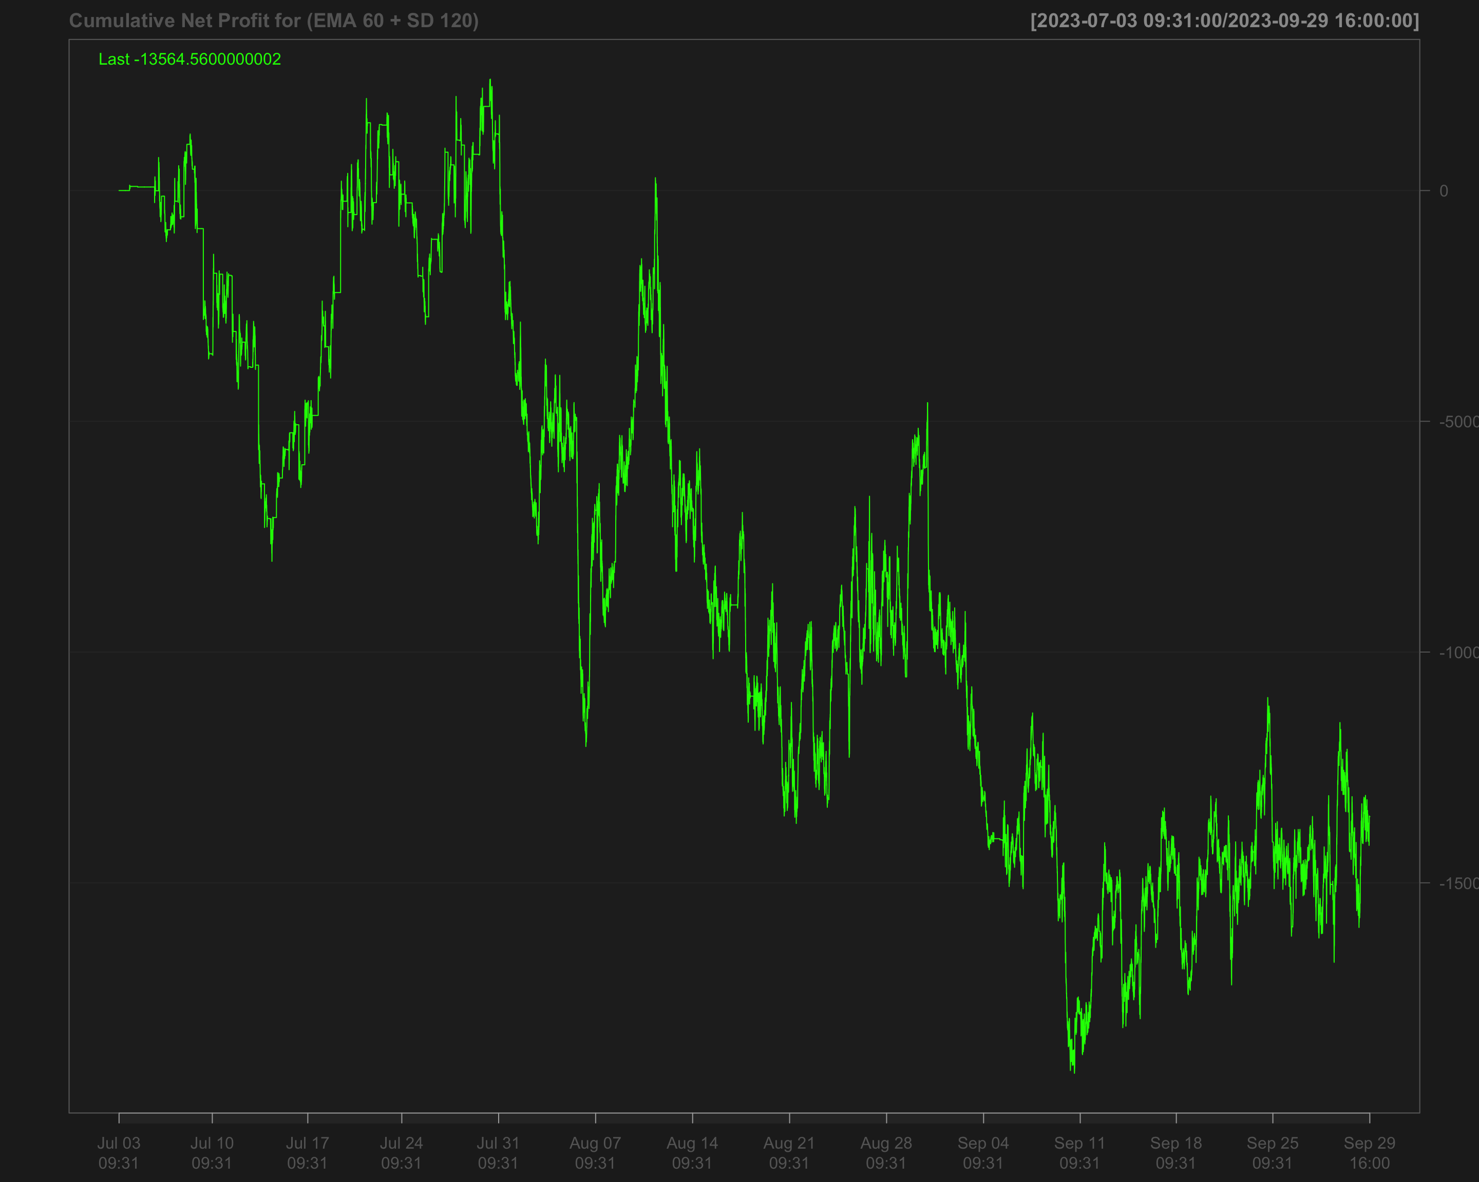

# Strategies based on 2023 Q4

data1_2023_Q4["T09:31/T09:35",] <- NA # Remove data between 09:31 and 09:35 by setting it to NA  
data1_2023_Q4["T15:56/T16:00",] <- NA # Remove data between 15:56 and 16:00 by setting it to NA

## Single EMA of ‘NQ’ with a 120-period window

data1_2023_Q4$ema_120 <- EMA(na.locf(data1_2023_Q4$NQ,   
 na.rm = FALSE),  
 120) # Calculate the 120-period EMA of 'NQ' after filling missing values using the last observation carried forward

data1_2023_Q4$ema_120[is.na(data1_2023_Q4$NQ)] <- NA # Set EMA values to NA where the original 'NQ' values are missing

data1_2023_Q4$position_ema_120 <- ifelse(lag.xts(data1_2023_Q4$NQ) >   
 lag.xts(data1_2023_Q4$ema_120), 1, -1) # Generate trading positions: 1 if 'NQ' is above its lagged EMA, -1 otherwise

# Set trading positions to 0 outside the active trading window (before 09:40:00 or after 15:50:00)  
data1_2023_Q4$position_ema_120[times(times_data_2023_Q2) <= times("9:40:00") |   
 times(times_data_2023_Q2) > times("15:50:00")] <- 0

# Fill missing positions with the most recent non-missing value (Last Observation Carried Forward)  
data1_2023_Q4$position_ema_120 <- na.locf(data1_2023_Q4$position_ema_120,  
 na.rm = FALSE)

### Gross profit for Single EMA

# Calculate gross profit based on the position (ema_120), the change in 'NQ' prices, and a factor of 20  
data1_2023_Q4$gross_profit_ema_120 <- data1_2023_Q4$position_ema_120 * diff.xts(data1_2023_Q4$NQ) * 20

# Set any missing values in 'gross_profit_ema_120' to 0  
data1_2023_Q4$gross_profit_ema_120[is.na(data1_2023_Q4$gross_profit_ema_120)] <- 0  
chartSeries(cumsum(data1_2023_Q4$gross_profit_ema_120),  
 name = "Cumulative gross profit of EMA_120")

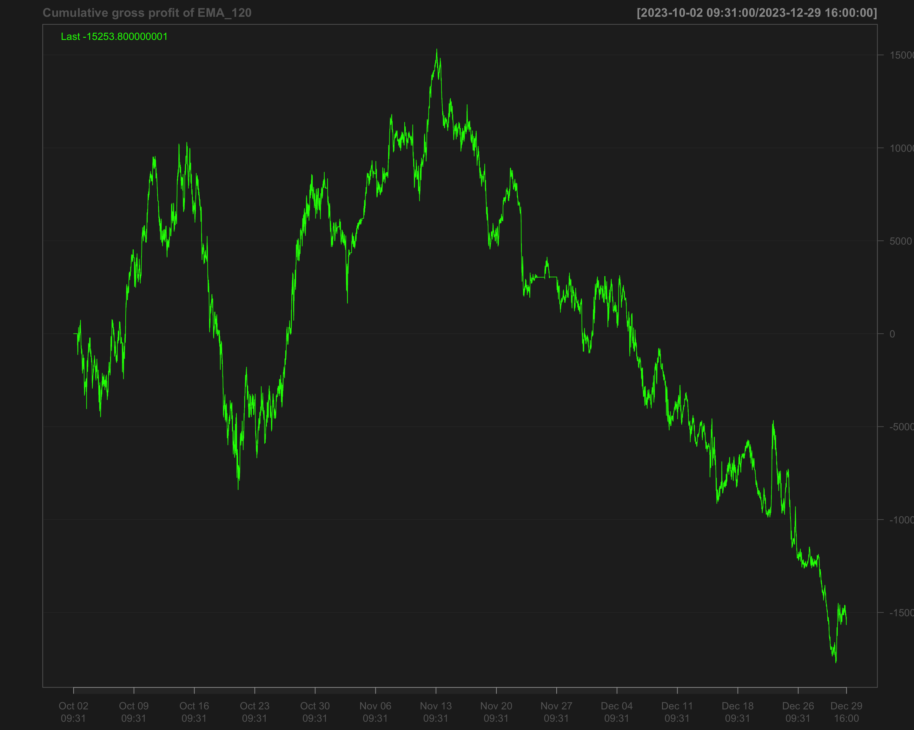

# Identify transactions by calculating the absolute change in position (every time the position changes)  
data1_2023_Q4$ntrans_ema_120 <- abs(diff.xts(data1_2023_Q4$position_ema_120))

# Set the first transaction value to 0, as there's no previous position to compare  
data1_2023_Q4$ntrans_ema_120[1] <- 0

### Net profit for EMA 120

# Calculate net profit by subtracting transaction costs (based on the number of transactions and a cost factor of 12) from the gross profit  
data1_2023_Q4$net_profit_ema_120 <- data1_2023_Q4$gross_profit_ema_120 - data1_2023_Q4$ntrans_ema_120 * 12

# Plot the cumulative sum of the net profit to visualize the overall performance over time  
chartSeries(cumsum(data1_2023_Q4$net_profit_ema_120),   
 name = "Cumulative Net Profit for EMA 120 Strategy")

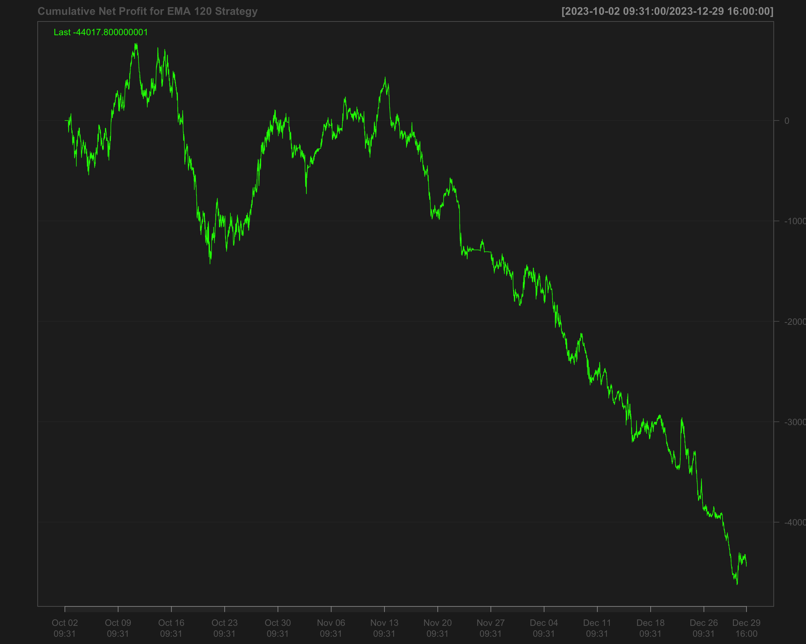

## Volatility breakout strategy using EMA 60 and SD 120

# Calculate the 60-period rolling mean of 'NQ' after filling missing values using the last observation carried forward  
data1_2023_Q4$mean_60 <- roll_mean(na.locf(data1_2023_Q4$NQ, na.rm = FALSE), 60)

# Calculate the 120-period rolling standard deviation of 'NQ' after filling missing values using the last observation carried forward  
data1_2023_Q4$sd_120 <- roll_sd(na.locf(data1_2023_Q4$NQ, na.rm = FALSE), 120)

# Measure the execution time for calculating the position based on a strategy using the 'positionVB' function  
system.time(  
 data1_2023_Q4$position_sd_ema <-   
 positionVB(signal = data1_2023_Q4$NQ,  
 upper = data1_2023_Q4$mean_60 + 1.5 * data1_2023_Q4$sd_120, # Upper bound based on 60-period mean and 1.5 times 120-period SD  
 lower = data1_2023_Q4$mean_60 - 1.5 * data1_2023_Q4$sd_120, # Lower bound based on 60-period mean and 1.5 times 120-period SD  
 times_data = times_data_2023_Q4, # Column with times  
 time_lower = "09:40:00", # Start time for trading  
 time_upper = "15:50:00", # Exit time for all positions  
 strategy = "mom" # Momentum strategy  
 )  
)

# Fill missing position values with the most recent non-missing value (Last Observation Carried Forward)  
data1_2023_Q4$position_sd_ema <- na.locf(data1_2023_Q4$position_sd_ema,  
 na.rm = FALSE)

### Gross profit of volatility breakout strategy

# Calculate gross profit for the strategy by multiplying position with the change in 'NQ' prices and a factor of 20  
data1_2023_Q4$gross_profit_sd_ema <- data1_2023_Q4$position_sd_ema * diff.xts(data1_2023_Q4$NQ) * 20

# Replace any missing values in the gross profit column with 0  
data1_2023_Q4$gross_profit_sd_ema[is.na(data1_2023_Q4$gross_profit_sd_ema)] <- 0  
chartSeries(cumsum(data1_2023_Q4$gross_profit_sd_ema),  
 name = "Cumulative gross profit of (EMA 60 + SD 120)")

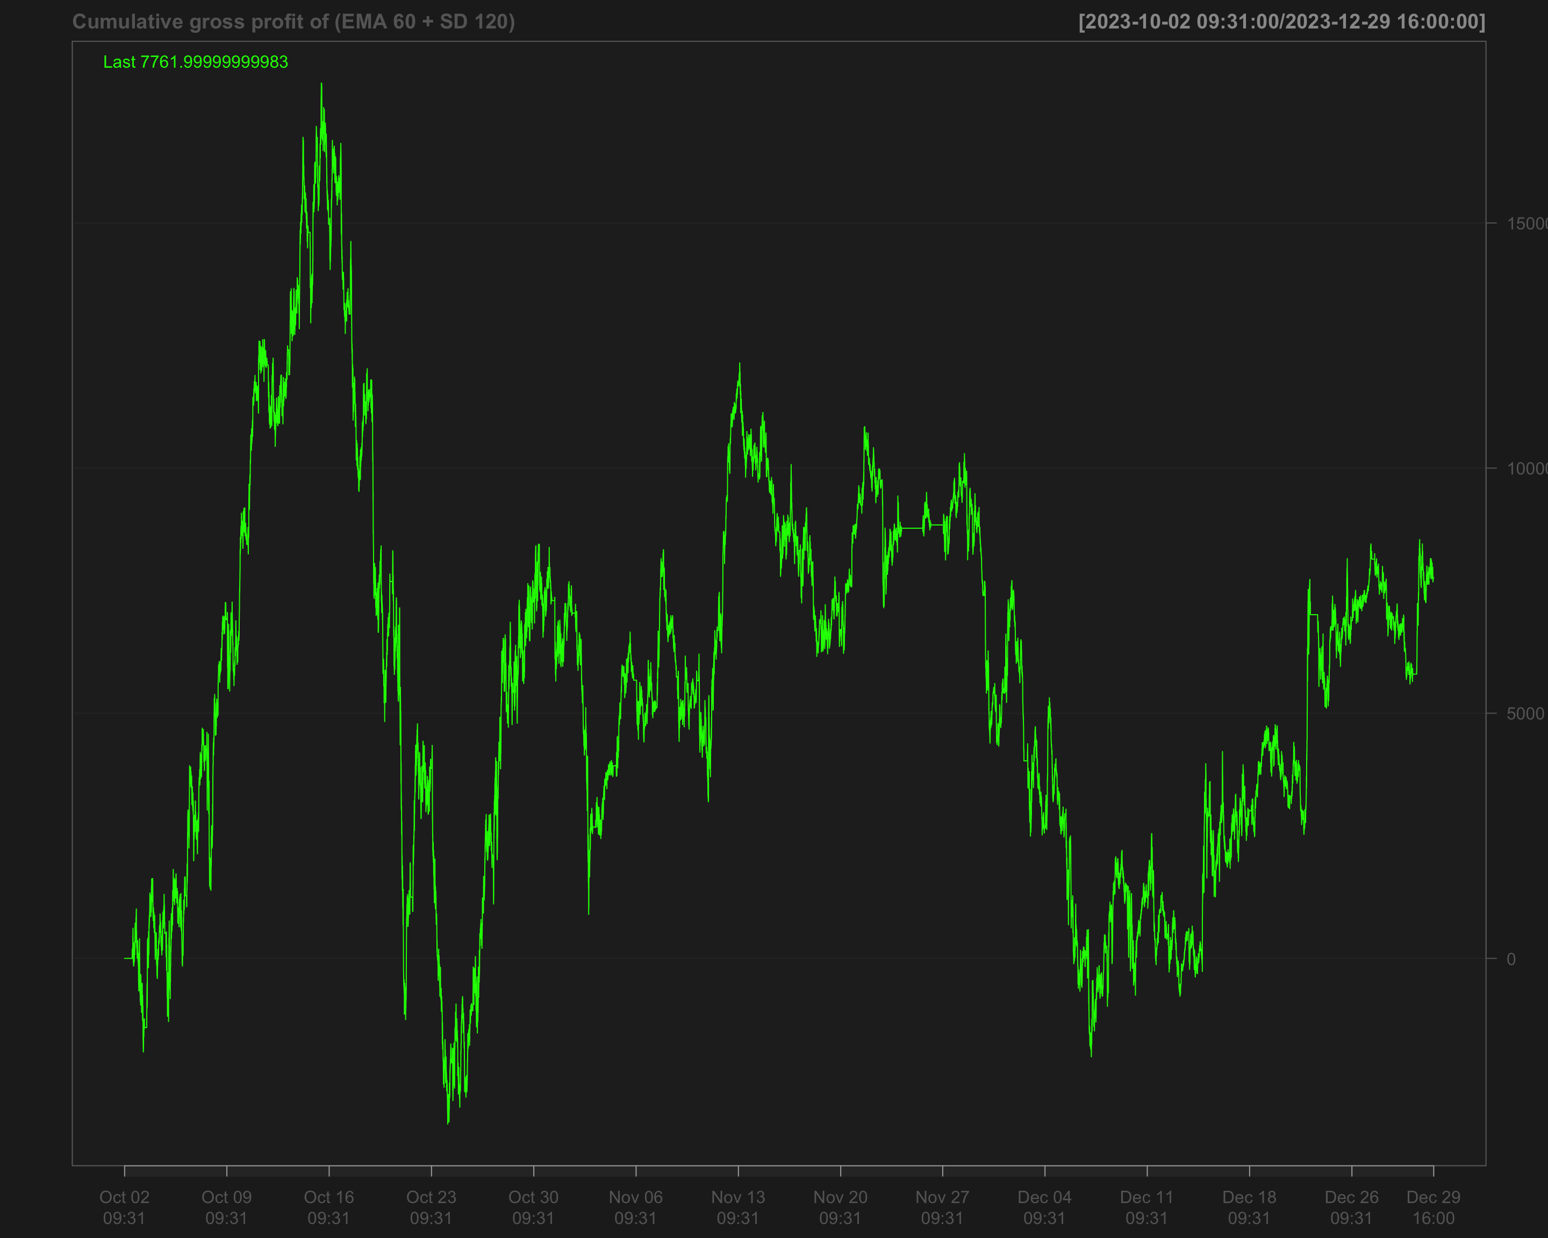

# Identify transactions by calculating the absolute change in position ('position_sd_ema')  
data1_2023_Q4$ntrans_sd_ema <- abs(diff.xts(data1_2023_Q4$position_sd_ema))

# Set the first transaction value to 0, as there's no previous position to compare  
data1_2023_Q4$ntrans_sd_ema[1] <- 0

### Net profit of volatility breakout strategy

# Calculate net profit by subtracting transaction costs (based on the number of transactions and a cost factor of 12) from the gross profit  
data1_2023_Q4$net_profit_sd_ema <- data1_2023_Q4$gross_profit_sd_ema - data1_2023_Q4$ntrans_sd_ema * 12

# Plot the cumulative net profit over time using a chart, based on the 'net_profit_sd_ema' column  
chartSeries(cumsum(data1_2023_Q4$net_profit_sd_ema),   
 name = "Cumulative Net Profit for Volatility Breakout Strategy (EMA 60 + SD 120)")

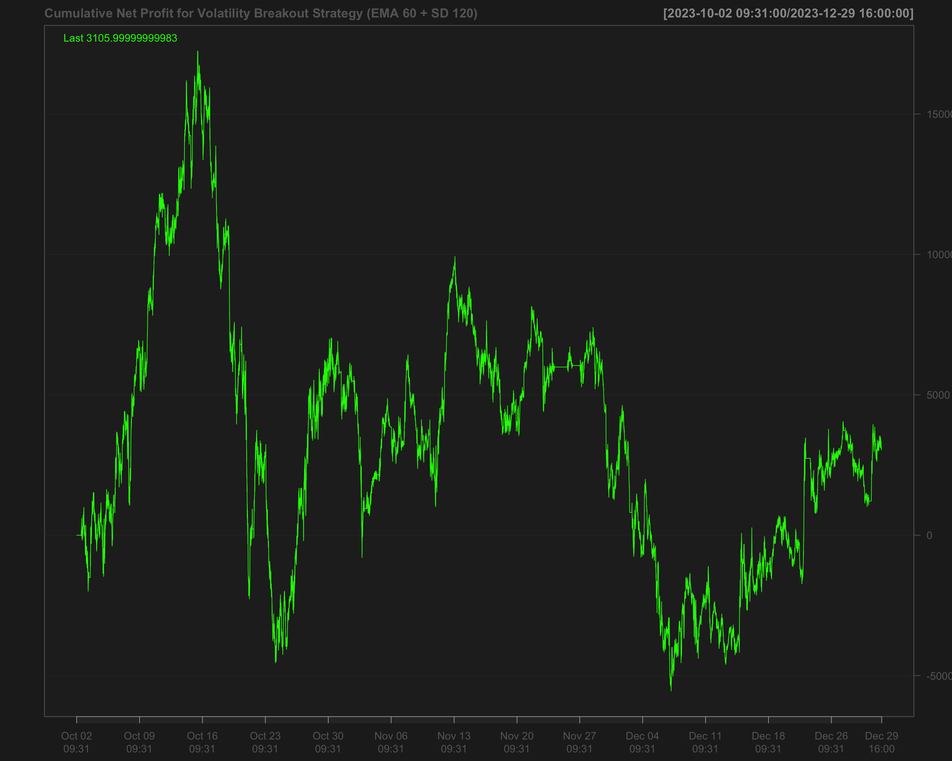

# Strategies based on 2024 Q1

data1_2024_Q1["T09:31/T09:35",] <- NA # Remove data between 09:31 and 09:35 by setting it to NA  
data1_2024_Q1["T15:56/T16:00",] <- NA # Remove data between 15:56 and 16:00 by setting it to NA

## Single EMA of ‘NQ’ with a 120-period window

data1_2024_Q1$ema_120 <- EMA(na.locf(data1_2024_Q1$NQ,   
 na.rm = FALSE),  
 120) # Calculate the 120-period EMA of 'NQ' after filling missing values using the last observation carried forward

data1_2024_Q1$ema_120[is.na(data1_2024_Q1$NQ)] <- NA # Set EMA values to NA where the original 'NQ' values are missing

data1_2024_Q1$position_ema_120 <- ifelse(lag.xts(data1_2024_Q1$NQ) >   
 lag.xts(data1_2024_Q1$ema_120), 1, -1) # Generate trading positions: 1 if 'NQ' is above its lagged EMA, -1 otherwise

# Set trading positions to 0 outside the active trading window (before 09:40:00 or after 15:50:00)  
data1_2024_Q1$position_ema_120[times(times_data_2024_Q1) <= times("9:40:00") |   
 times(times_data_2024_Q1) > times("15:50:00")] <- 0

# Fill missing positions with the most recent non-missing value (Last Observation Carried Forward)  
data1_2024_Q1$position_ema_120 <- na.locf(data1_2024_Q1$position_ema_120,  
 na.rm = FALSE)

### Gross profit for Single EMA

# Calculate gross profit based on the position (ema_120), the change in 'NQ' prices, and a factor of 20  
data1_2024_Q1$gross_profit_ema_120 <- data1_2024_Q1$position_ema_120 * diff.xts(data1_2024_Q1$NQ) * 20

# Set any missing values in 'gross_profit_ema_120' to 0  
data1_2024_Q1$gross_profit_ema_120[is.na(data1_2024_Q1$gross_profit_ema_120)] <- 0  
chartSeries(cumsum(data1_2024_Q1$gross_profit_ema_120),  
 name = "Cumulative gross profit of EMA_120")

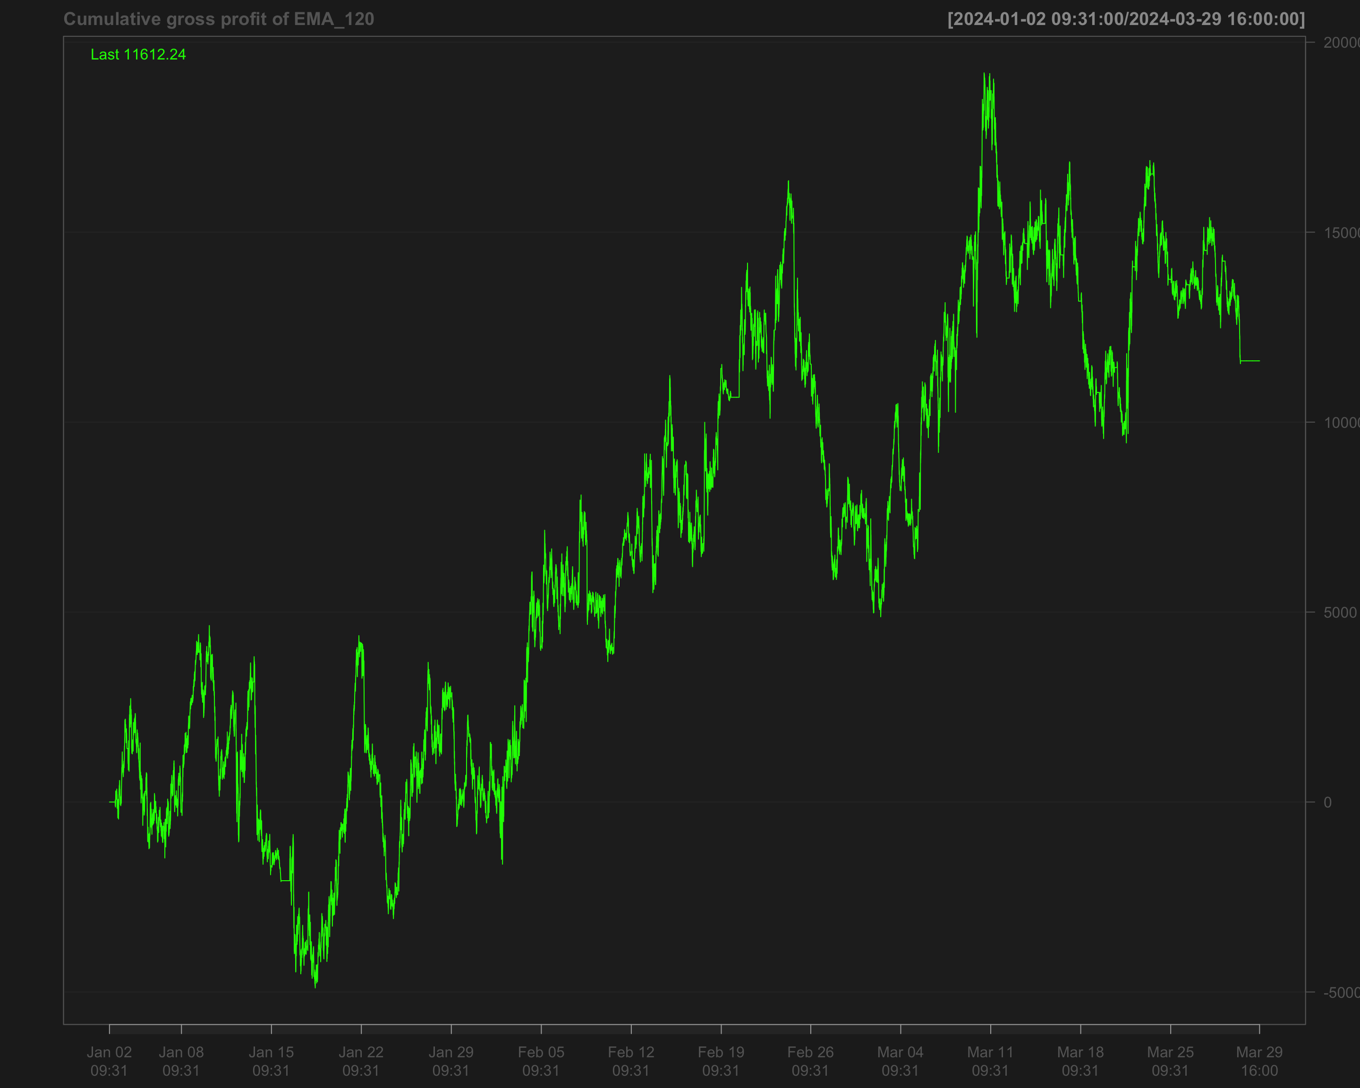

# Identify transactions by calculating the absolute change in position (every time the position changes)  
data1_2024_Q1$ntrans_ema_120 <- abs(diff.xts(data1_2024_Q1$position_ema_120))

# Set the first transaction value to 0, as there's no previous position to compare  
data1_2024_Q1$ntrans_ema_120[1] <- 0

### Net profit for EMA 120

# Calculate net profit by subtracting transaction costs (based on the number of transactions and a cost factor of 12) from the gross profit  
data1_2024_Q1$net_profit_ema_120 <- data1_2024_Q1$gross_profit_ema_120 - data1_2024_Q1$ntrans_ema_120 * 12

# Plot the cumulative sum of the net profit to visualize the overall performance over time  
chartSeries(cumsum(data1_2024_Q1$net_profit_ema_120),   
 name = "Cumulative Net Profit for EMA 120 Strategy")

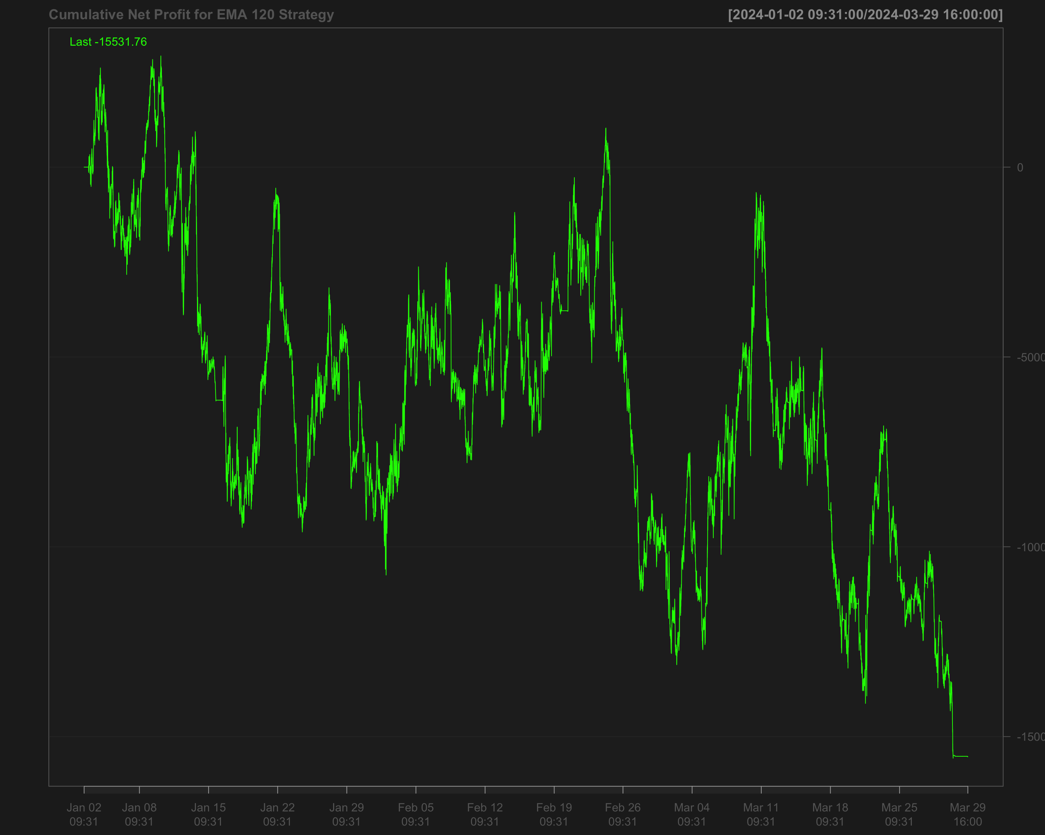

## Volatility breakout strategy using EMA 60 and SD 120

# Calculate the 60-period rolling mean of 'NQ' after filling missing values using the last observation carried forward  
data1_2024_Q1$mean_60 <- roll_mean(na.locf(data1_2024_Q1$NQ, na.rm = FALSE), 60)

# Calculate the 120-period rolling standard deviation of 'NQ' after filling missing values using the last observation carried forward  
data1_2024_Q1$sd_120 <- roll_sd(na.locf(data1_2024_Q1$NQ, na.rm = FALSE), 120)

# Measure the execution time for calculating the position based on a strategy using the 'positionVB' function  
system.time(  
 data1_2024_Q1$position_sd_ema <-   
 positionVB(signal = data1_2024_Q1$NQ,  
 upper = data1_2024_Q1$mean_60 + 1.5 * data1_2024_Q1$sd_120, # Upper bound based on 60-period mean and 1.5 times 120-period SD  
 lower = data1_2024_Q1$mean_60 - 1.5 * data1_2024_Q1$sd_120, # Lower bound based on 60-period mean and 1.5 times 120-period SD  
 times_data = times_data_2024_Q1, # Column with times  
 time_lower = "09:40:00", # Start time for trading  
 time_upper = "15:50:00", # Exit time for all positions  
 strategy = "mom" # Momentum strategy  
 )  
)

# Fill missing position values with the most recent non-missing value (Last Observation Carried Forward)  
data1_2024_Q1$position_sd_ema <- na.locf(data1_2024_Q1$position_sd_ema,  
 na.rm = FALSE)

### Gross profit of volatility breakout strategy

# Calculate gross profit for the strategy by multiplying position with the change in 'NQ' prices and a factor of 20  
data1_2024_Q1$gross_profit_sd_ema <- data1_2024_Q1$position_sd_ema * diff.xts(data1_2024_Q1$NQ) * 20

# Replace any missing values in the gross profit column with 0  
data1_2024_Q1$gross_profit_sd_ema[is.na(data1_2024_Q1$gross_profit_sd_ema)] <- 0  
chartSeries(cumsum(data1_2024_Q1$gross_profit_sd_ema),  
 name = "Cumulative gross profit of (EMA 60 + SD 120)")

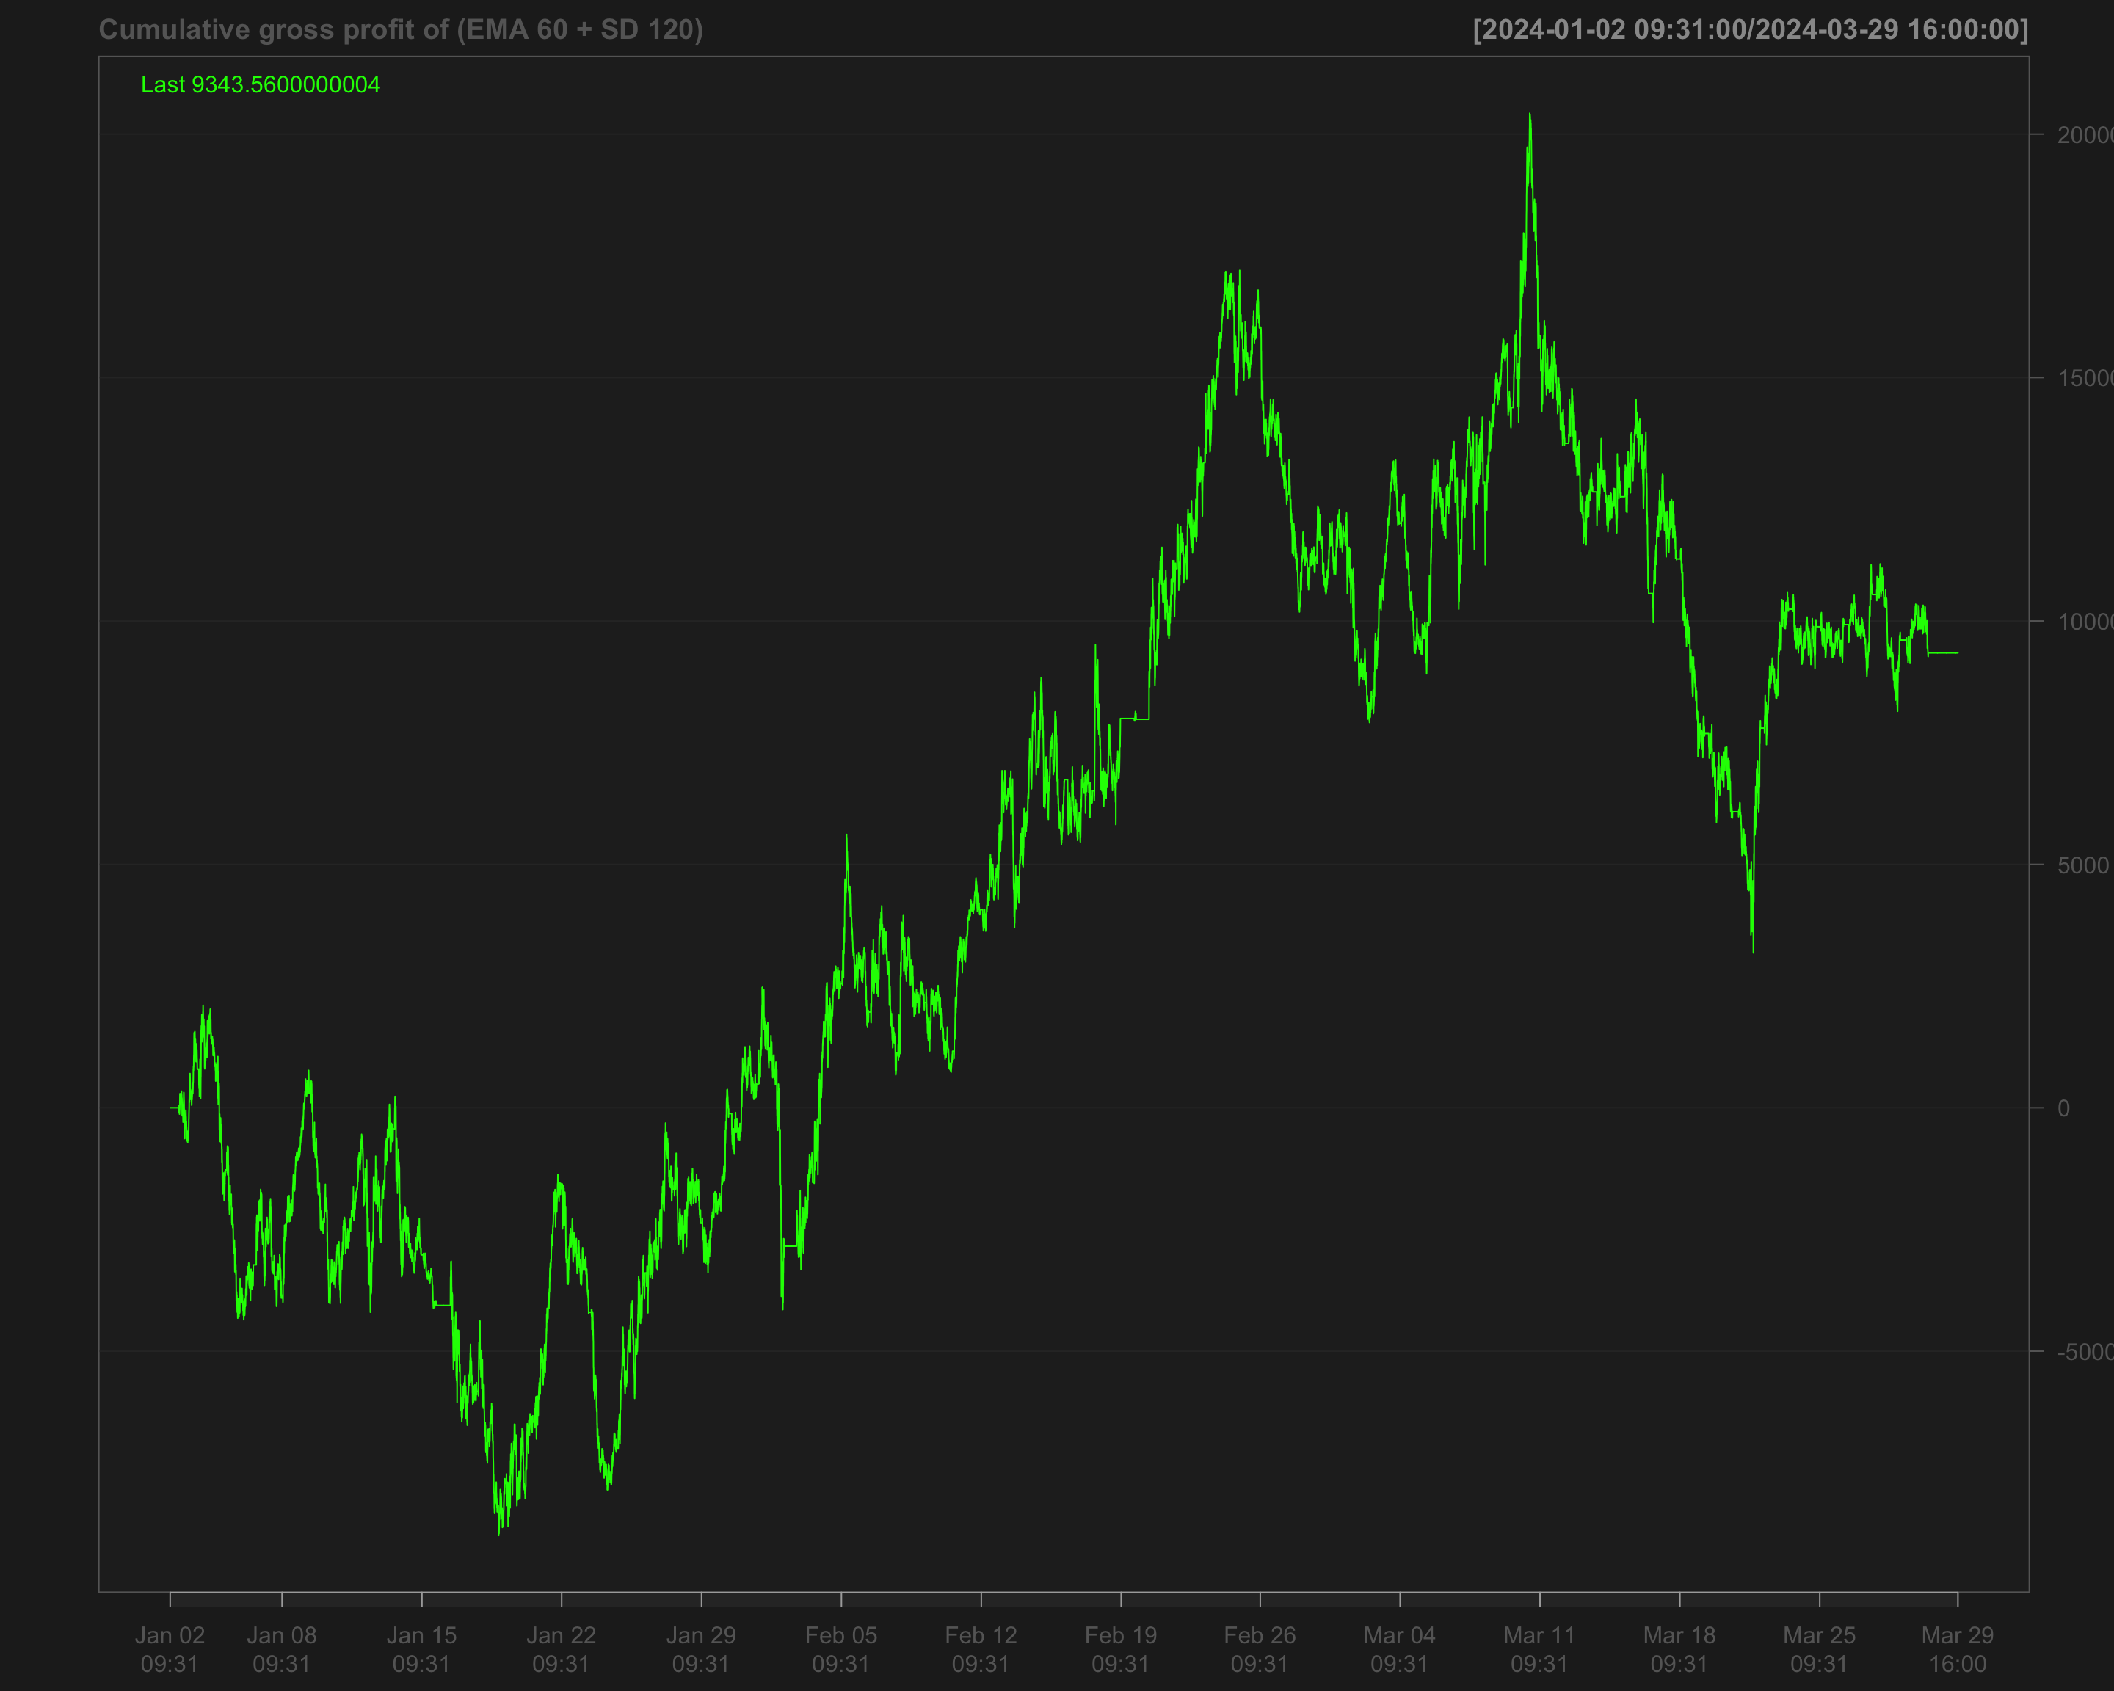

# Identify transactions by calculating the absolute change in position ('position_sd_ema')  
data1_2024_Q1$ntrans_sd_ema <- abs(diff.xts(data1_2024_Q1$position_sd_ema))

# Set the first transaction value to 0, as there's no previous position to compare  
data1_2024_Q1$ntrans_sd_ema[1] <- 0

### Net profit of volatility breakout strategy

# Calculate net profit by subtracting transaction costs (based on the number of transactions and a cost factor of 12) from the gross profit  
data1_2024_Q1$net_profit_sd_ema <- data1_2024_Q1$gross_profit_sd_ema - data1_2024_Q1$ntrans_sd_ema * 12

# Plot the cumulative net profit over time using a chart, based on the 'net_profit_sd_ema' column  
chartSeries(cumsum(data1_2024_Q1$net_profit_sd_ema),   
 name = "Cumulative Net Profit for (EMA 60 + SD 120)")

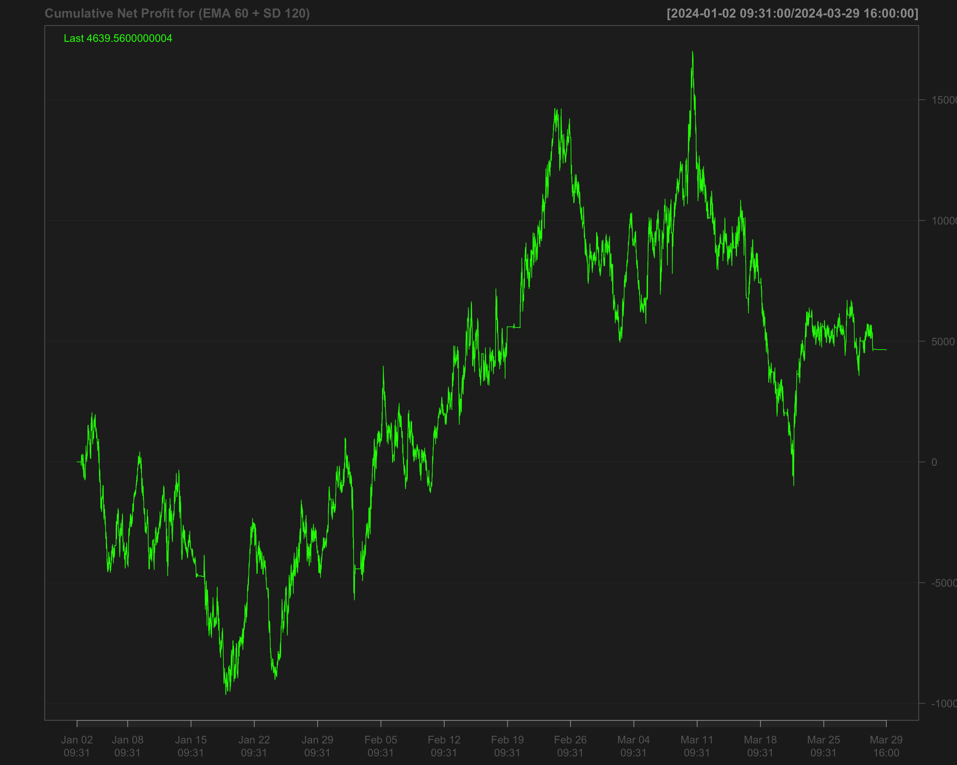

# Strategies based on 2024 Q2

data1_2024_Q2["T09:31/T09:35",] <- NA # Remove data between 09:31 and 09:35 by setting it to NA  
data1_2024_Q2["T15:56/T16:00",] <- NA # Remove data between 15:56 and 16:00 by setting it to NA

## Single EMA of ‘NQ’ with a 120-period window

data1_2024_Q2$ema_120 <- EMA(na.locf(data1_2024_Q2$NQ,   
 na.rm = FALSE),  
 120) # Calculate the 120-period EMA of 'NQ' after filling missing values using the last observation carried forward

data1_2024_Q2$ema_120[is.na(data1_2024_Q2$NQ)] <- NA # Set EMA values to NA where the original 'NQ' values are missing

data1_2024_Q2$position_ema_120 <- ifelse(lag.xts(data1_2024_Q2$NQ) >   
 lag.xts(data1_2024_Q2$ema_120), 1, -1) # Generate trading positions: 1 if 'NQ' is above its lagged EMA, -1 otherwise

# Set trading positions to 0 outside the active trading window (before 09:40:00 or after 15:50:00)  
data1_2024_Q2$position_ema_120[times(times_data_2024_Q2) <= times("9:40:00") |   
 times(times_data_2024_Q2) > times("15:50:00")] <- 0

# Fill missing positions with the most recent non-missing value (Last Observation Carried Forward)  
data1_2024_Q2$position_ema_120 <- na.locf(data1_2024_Q2$position_ema_120,  
 na.rm = FALSE)

### Gross profit for Single EMA

# Calculate gross profit based on the position (ema_120), the change in 'NQ' prices, and a factor of 20  
data1_2024_Q2$gross_profit_ema_120 <- data1_2024_Q2$position_ema_120 * diff.xts(data1_2024_Q2$NQ) * 20

# Set any missing values in 'gross_profit_ema_120' to 0  
data1_2024_Q2$gross_profit_ema_120[is.na(data1_2024_Q2$gross_profit_ema_120)] <- 0  
chartSeries(cumsum(data1_2024_Q2$gross_profit_ema_120),  
 name = "Cumulative gross profit of EMA_120")

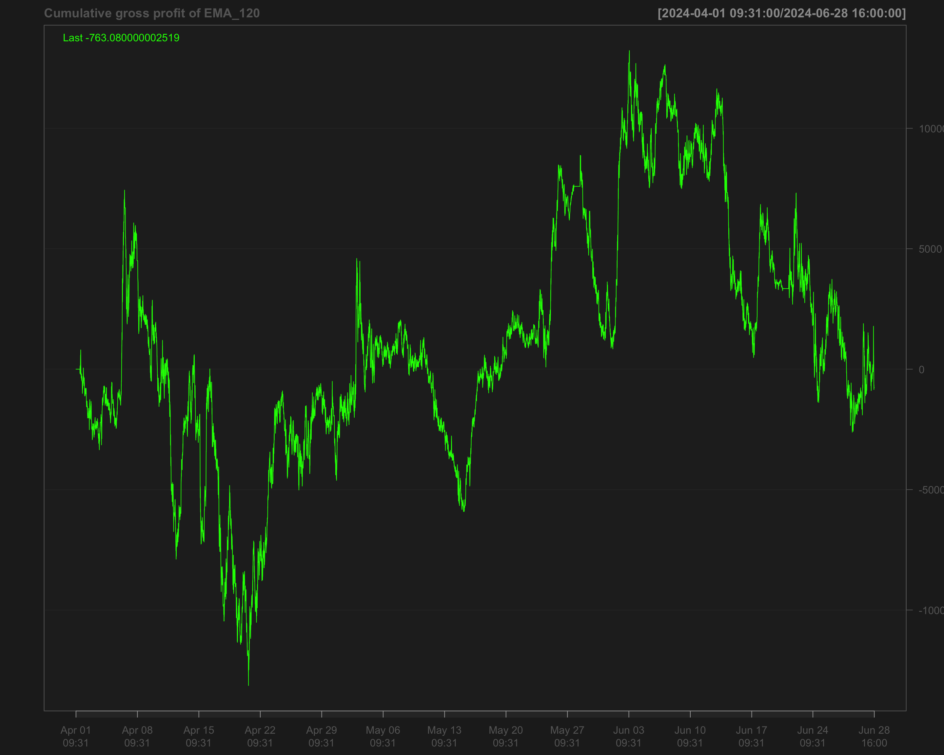

# Identify transactions by calculating the absolute change in position (every time the position changes)  
data1_2024_Q2$ntrans_ema_120 <- abs(diff.xts(data1_2024_Q2$position_ema_120))

# Set the first transaction value to 0, as there's no previous position to compare  
data1_2024_Q2$ntrans_ema_120[1] <- 0

### Net profit for EMA 120

# Calculate net profit by subtracting transaction costs (based on the number of transactions and a cost factor of 12) from the gross profit  
data1_2024_Q2$net_profit_ema_120 <- data1_2024_Q2$gross_profit_ema_120 - data1_2024_Q2$ntrans_ema_120 * 12

# Plot the cumulative sum of the net profit to visualize the overall performance over time  
chartSeries(cumsum(data1_2024_Q2$net_profit_ema_120),   
 name = "Cumulative Net Profit for EMA 120 Strategy")

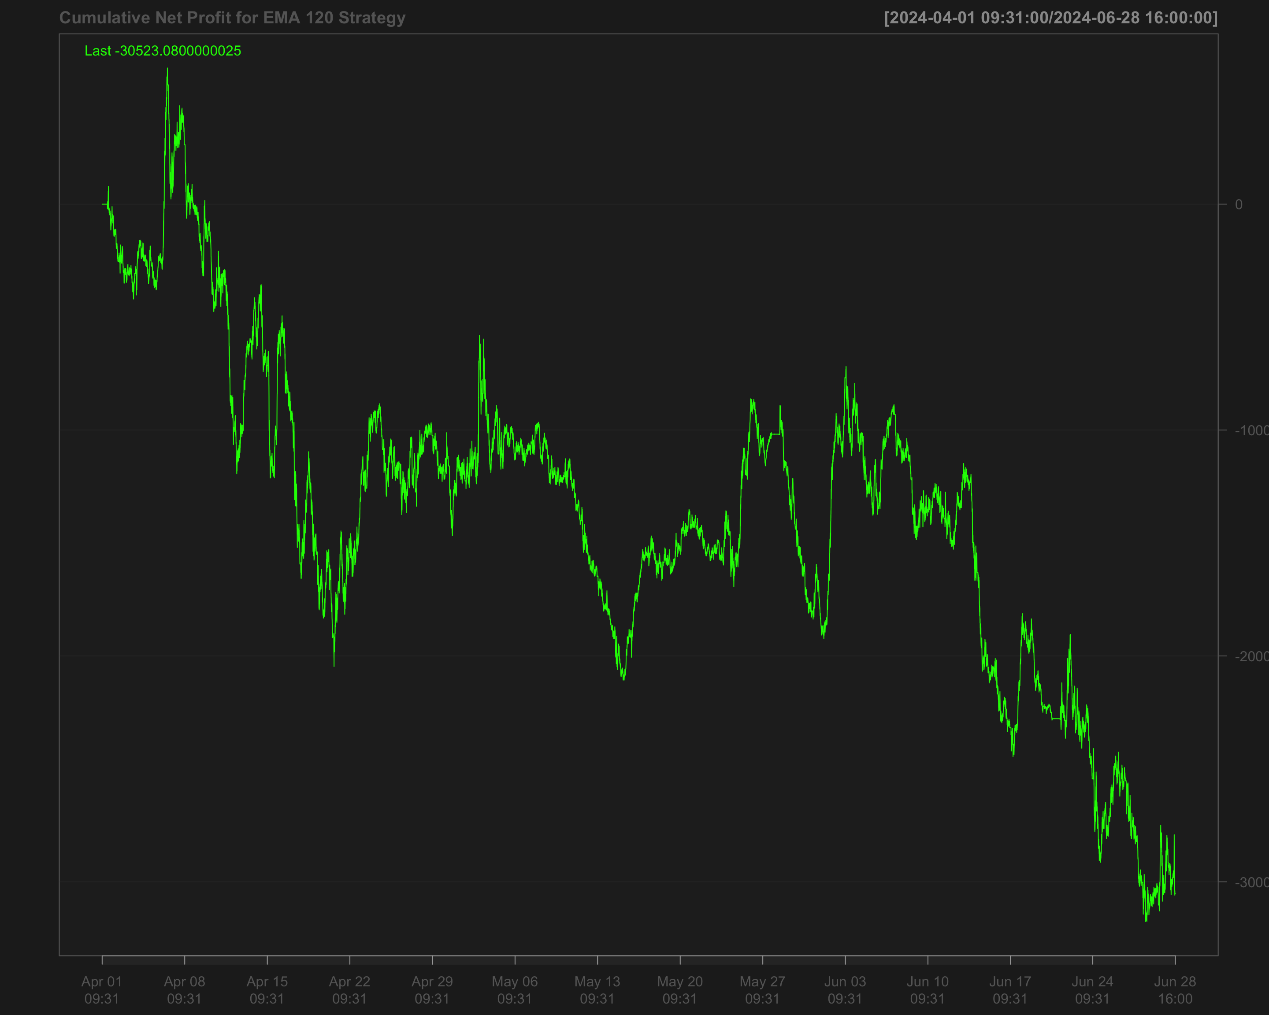

## Volatility breakout strategy using EMA 60 and SD 120

# Calculate the 60-period rolling mean of 'NQ' after filling missing values using the last observation carried forward  
data1_2024_Q2$mean_60 <- roll_mean(na.locf(data1_2024_Q2$NQ, na.rm = FALSE), 60)

# Calculate the 120-period rolling standard deviation of 'NQ' after filling missing values using the last observation carried forward  
data1_2024_Q2$sd_120 <- roll_sd(na.locf(data1_2024_Q2$NQ, na.rm = FALSE), 120)

# Measure the execution time for calculating the position based on a strategy using the 'positionVB' function  
system.time(  
 data1_2024_Q2$position_sd_ema <-   
 positionVB(signal = data1_2024_Q2$NQ,  
 upper = data1_2024_Q2$mean_60 + 1.5 * data1_2024_Q2$sd_120, # Upper bound based on 60-period mean and 1.5 times 120-period SD  
 lower = data1_2024_Q2$mean_60 - 1.5 * data1_2024_Q2$sd_120, # Lower bound based on 60-period mean and 1.5 times 120-period SD  
 times_data = times_data_2024_Q2, # Column with times  
 time_lower = "09:40:00", # Start time for trading  
 time_upper = "15:50:00", # Exit time for all positions  
 strategy = "mom" # Momentum strategy  
 )  
)

# Fill missing position values with the most recent non-missing value (Last Observation Carried Forward)  
data1_2024_Q2$position_sd_ema <- na.locf(data1_2024_Q2$position_sd_ema,  
 na.rm = FALSE)

### Gross profit of volatility breakout strategy

# Calculate gross profit for the strategy by multiplying position with the change in 'NQ' prices and a factor of 20  
data1_2024_Q2$gross_profit_sd_ema <- data1_2024_Q2$position_sd_ema * diff.xts(data1_2024_Q2$NQ) * 20

# Replace any missing values in the gross profit column with 0  
data1_2024_Q2$gross_profit_sd_ema[is.na(data1_2024_Q2$gross_profit_sd_ema)] <- 0  
chartSeries(cumsum(data1_2024_Q2$gross_profit_sd_ema),  
 name = "Cumulative gross profit of (EMA 60 + SD 120)")

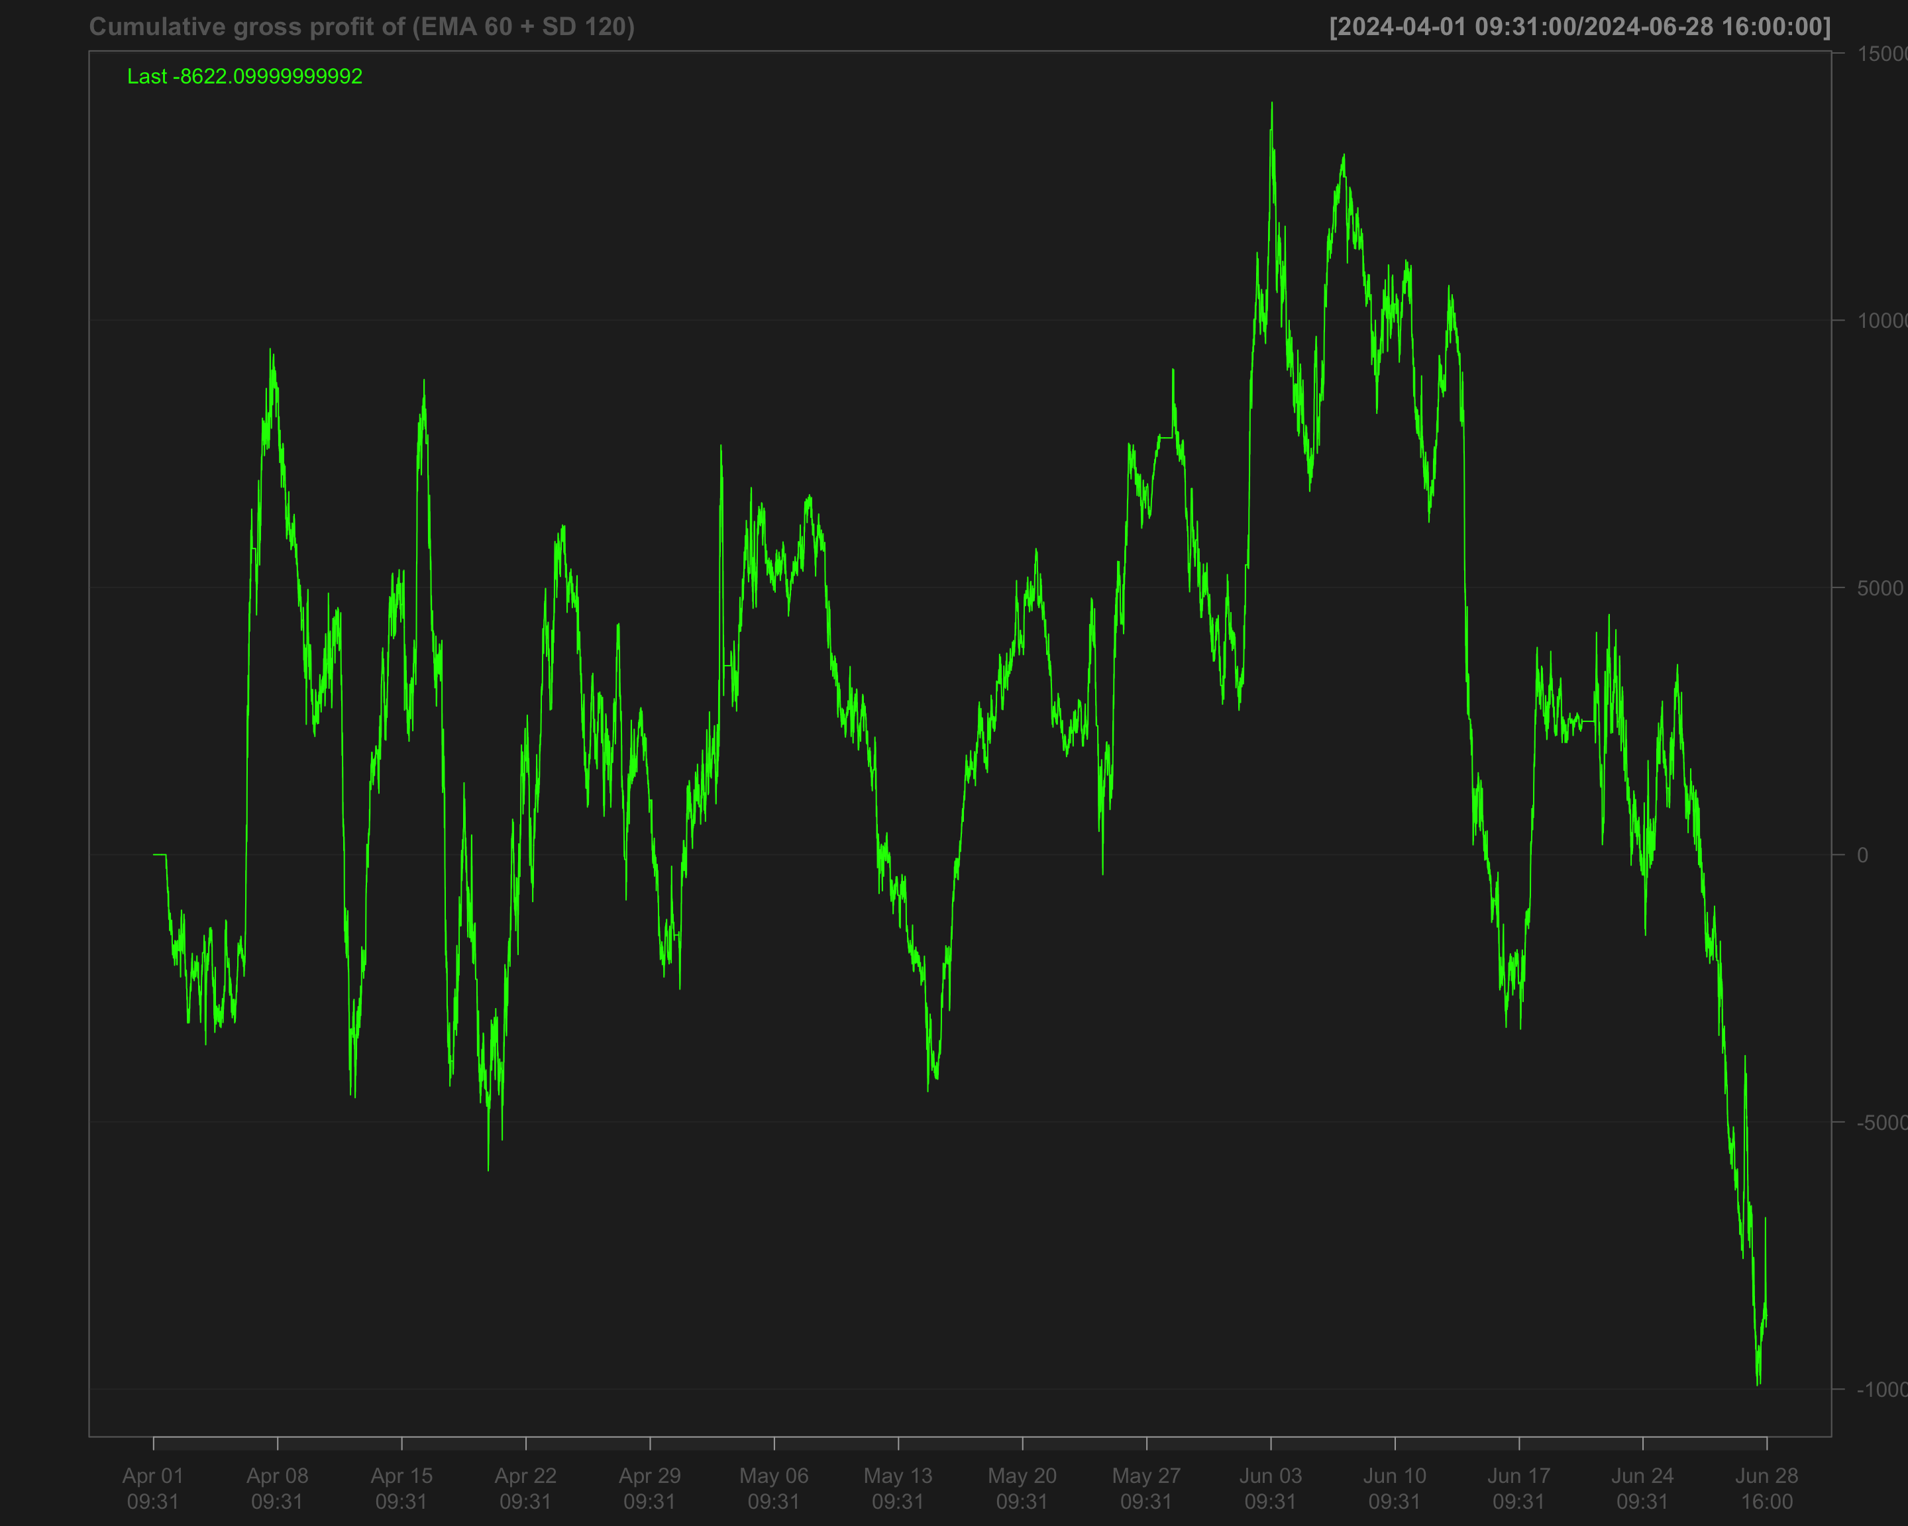

# Identify transactions by calculating the absolute change in position ('position_sd_ema')  
data1_2024_Q2$ntrans_sd_ema <- abs(diff.xts(data1_2024_Q2$position_sd_ema))

# Set the first transaction value to 0, as there's no previous position to compare  
data1_2024_Q2$ntrans_sd_ema[1] <- 0

### Net profit of volatility breakout strategy

# Calculate net profit by subtracting transaction costs (based on the number of transactions and a cost factor of 12) from the gross profit  
data1_2024_Q2$net_profit_sd_ema <- data1_2024_Q2$gross_profit_sd_ema - data1_2024_Q2$ntrans_sd_ema * 12

# Plot the cumulative net profit over time using a chart, based on the 'net_profit_sd_ema' column  
chartSeries(cumsum(data1_2024_Q2$net_profit_sd_ema),   
 name = "Cumulative Net Profit for (EMA 60 + SD 120)")

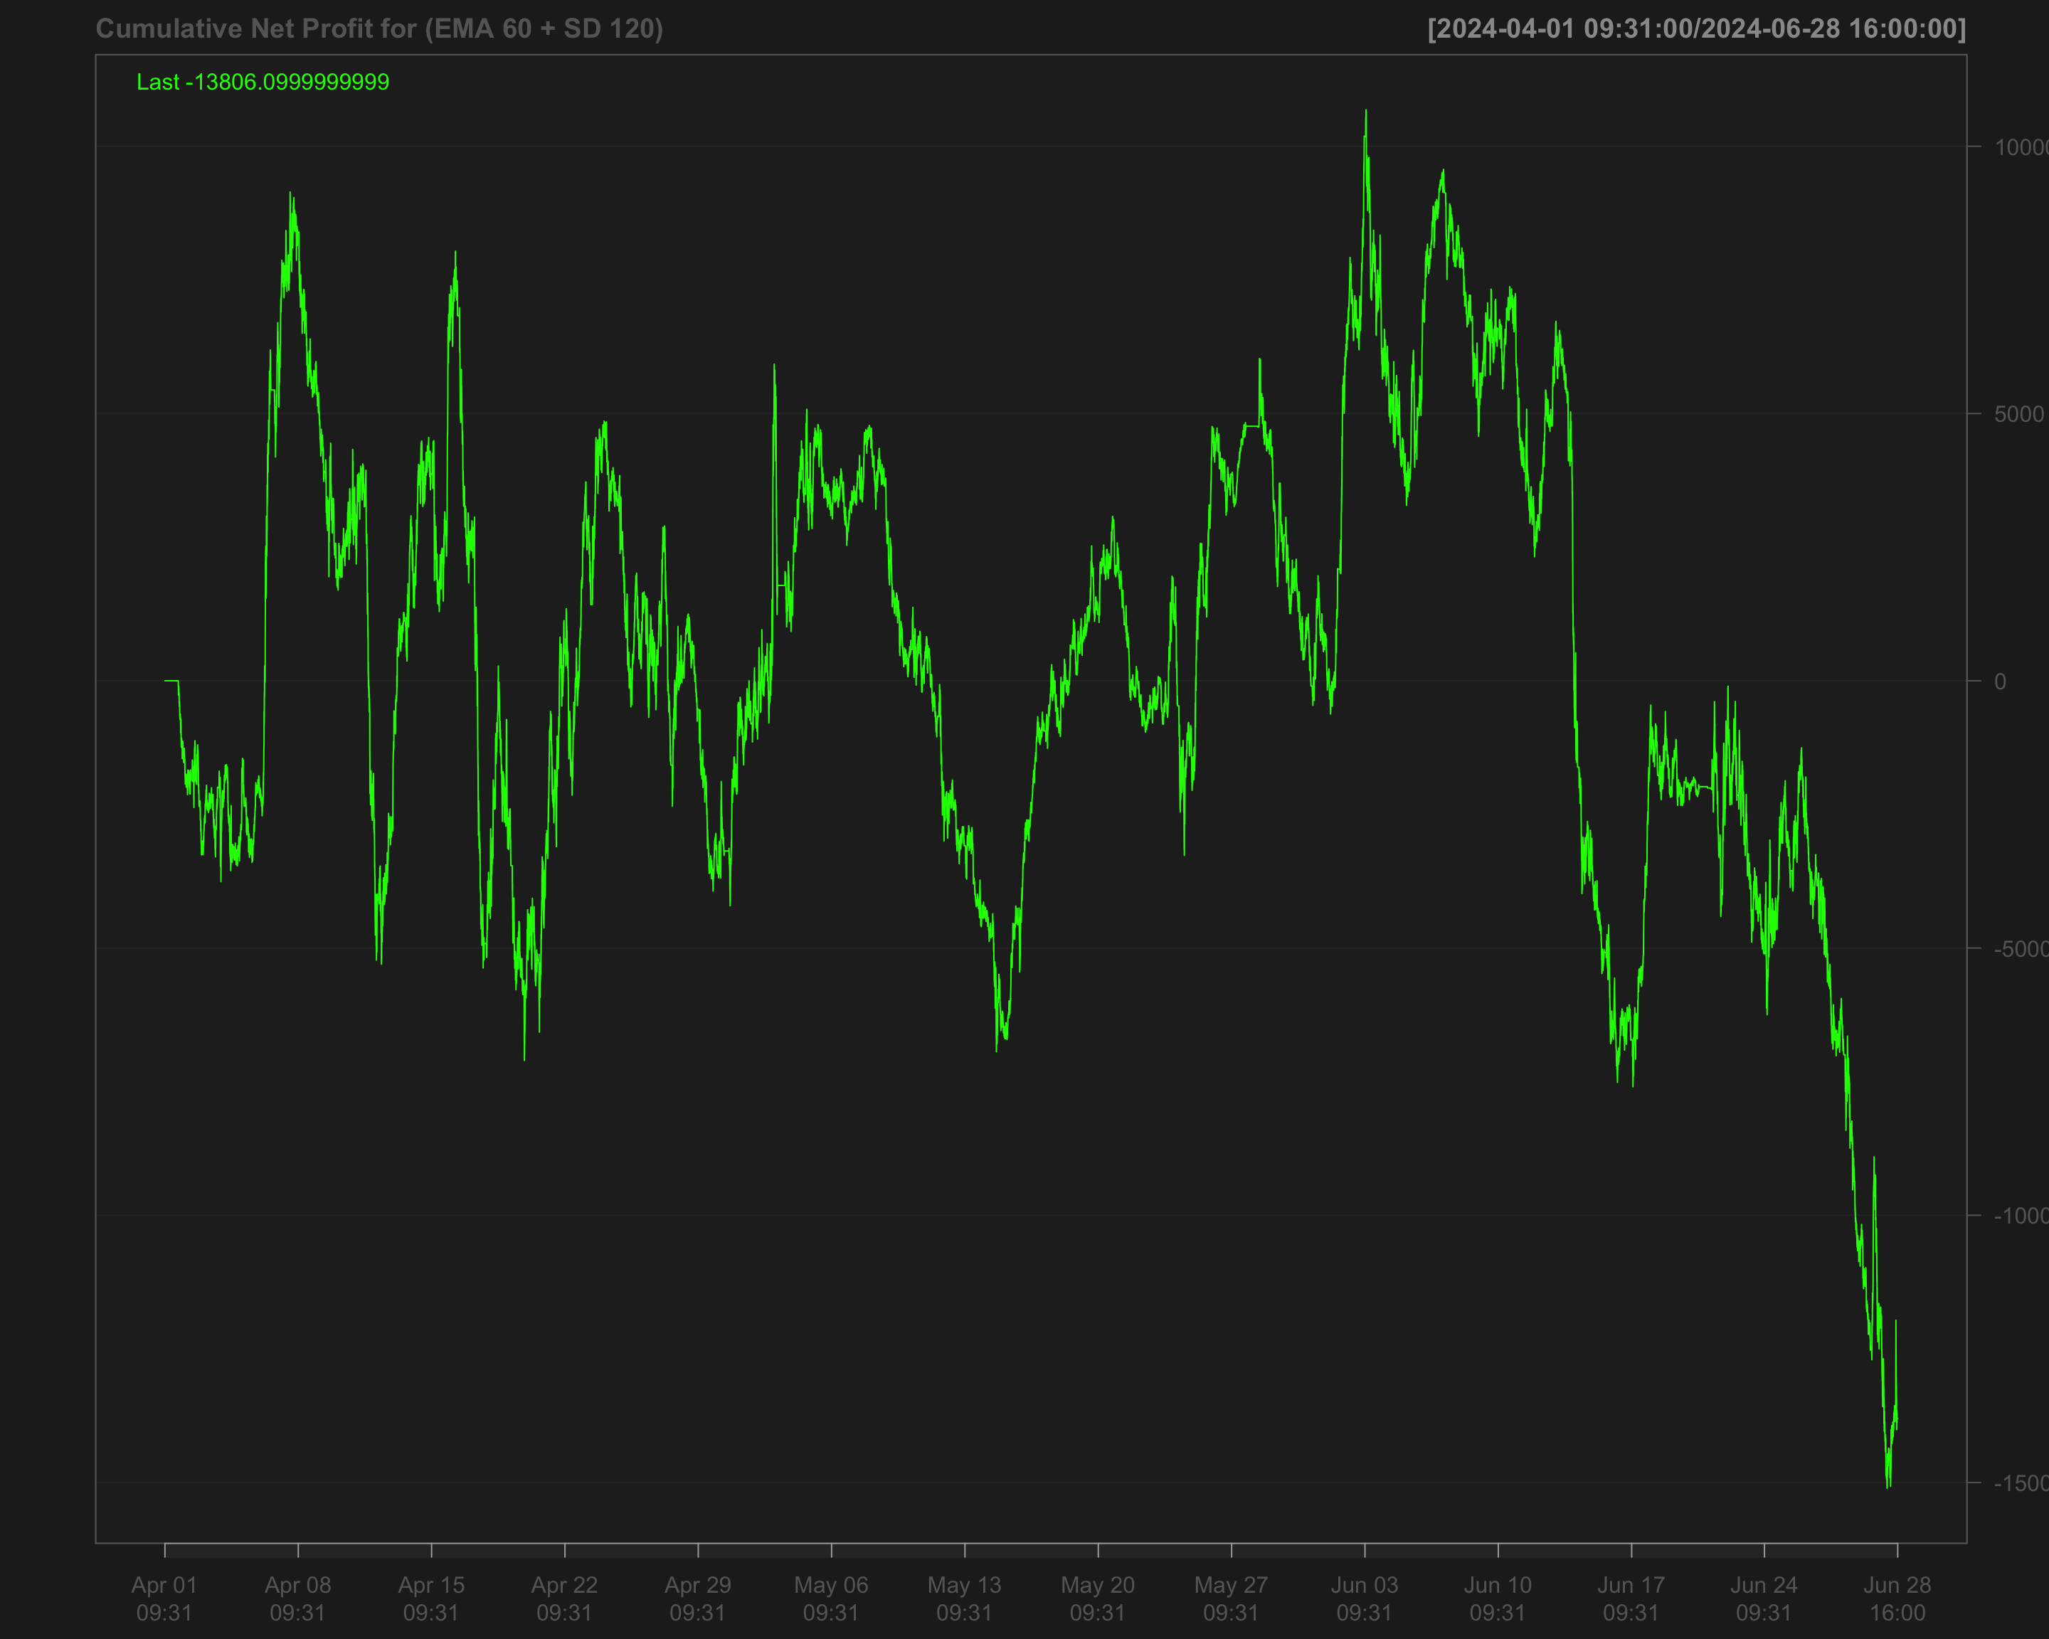

# Strategies based on 2024 Q3

data1_2024_Q3["T09:31/T09:35",] <- NA # Remove data between 09:31 and 09:35 by setting it to NA  
data1_2024_Q3["T15:56/T16:00",] <- NA # Remove data between 15:56 and 16:00 by setting it to NA

## Single EMA of ‘NQ’ with a 120-period window

data1_2024_Q3$ema_120 <- EMA(na.locf(data1_2024_Q3$NQ,   
 na.rm = FALSE),  
 120) # Calculate the 120-period EMA of 'NQ' after filling missing values using the last observation carried forward

data1_2024_Q3$ema_120[is.na(data1_2024_Q3$NQ)] <- NA # Set EMA values to NA where the original 'NQ' values are missing

data1_2024_Q3$position_ema_120 <- ifelse(lag.xts(data1_2024_Q3$NQ) >   
 lag.xts(data1_2024_Q3$ema_120), 1, -1) # Generate trading positions: 1 if 'NQ' is above its lagged EMA, -1 otherwise

# Set trading positions to 0 outside the active trading window (before 09:40:00 or after 15:50:00)  
data1_2024_Q3$position_ema_120[times(times_data_2024_Q3) <= times("9:40:00") |   
 times(times_data_2024_Q3) > times("15:50:00")] <- 0

# Fill missing positions with the most recent non-missing value (Last Observation Carried Forward)  
data1_2024_Q3$position_ema_120 <- na.locf(data1_2024_Q3$position_ema_120,  
 na.rm = FALSE)

### Gross profit for Single EMA

# Calculate gross profit based on the position (ema_120), the change in 'NQ' prices, and a factor of 20  
data1_2024_Q3$gross_profit_ema_120 <- data1_2024_Q3$position_ema_120 * diff.xts(data1_2024_Q3$NQ) * 20

# Set any missing values in 'gross_profit_ema_120' to 0  
data1_2024_Q3$gross_profit_ema_120[is.na(data1_2024_Q3$gross_profit_ema_120)] <- 0  
chartSeries(cumsum(data1_2024_Q3$gross_profit_ema_120),  
 name = "Cumulative gross profit of EMA_120")

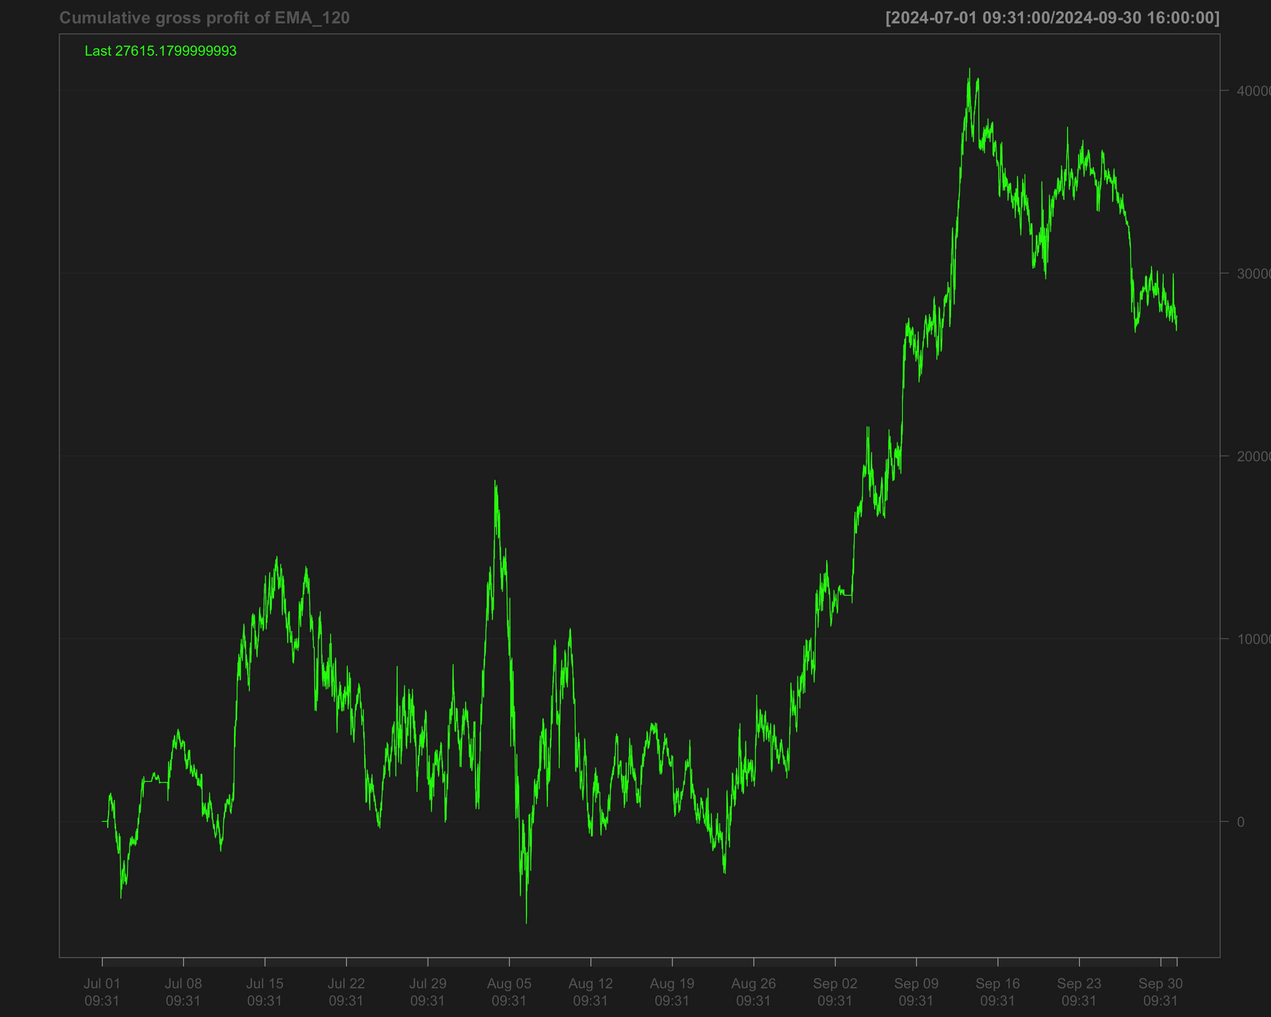

# Identify transactions by calculating the absolute change in position (every time the position changes)  
data1_2024_Q3$ntrans_ema_120 <- abs(diff.xts(data1_2024_Q3$position_ema_120))

# Set the first transaction value to 0, as there's no previous position to compare  
data1_2024_Q3$ntrans_ema_120[1] <- 0

### Net profit for EMA 120

# Calculate net profit by subtracting transaction costs (based on the number of transactions and a cost factor of 12) from the gross profit  
data1_2024_Q3$net_profit_ema_120 <- data1_2024_Q3$gross_profit_ema_120 - data1_2024_Q3$ntrans_ema_120 * 12

# Plot the cumulative sum of the net profit to visualize the overall performance over time  
chartSeries(cumsum(data1_2024_Q3$net_profit_ema_120),   
 name = "Cumulative Net Profit for EMA 120 Strategy")

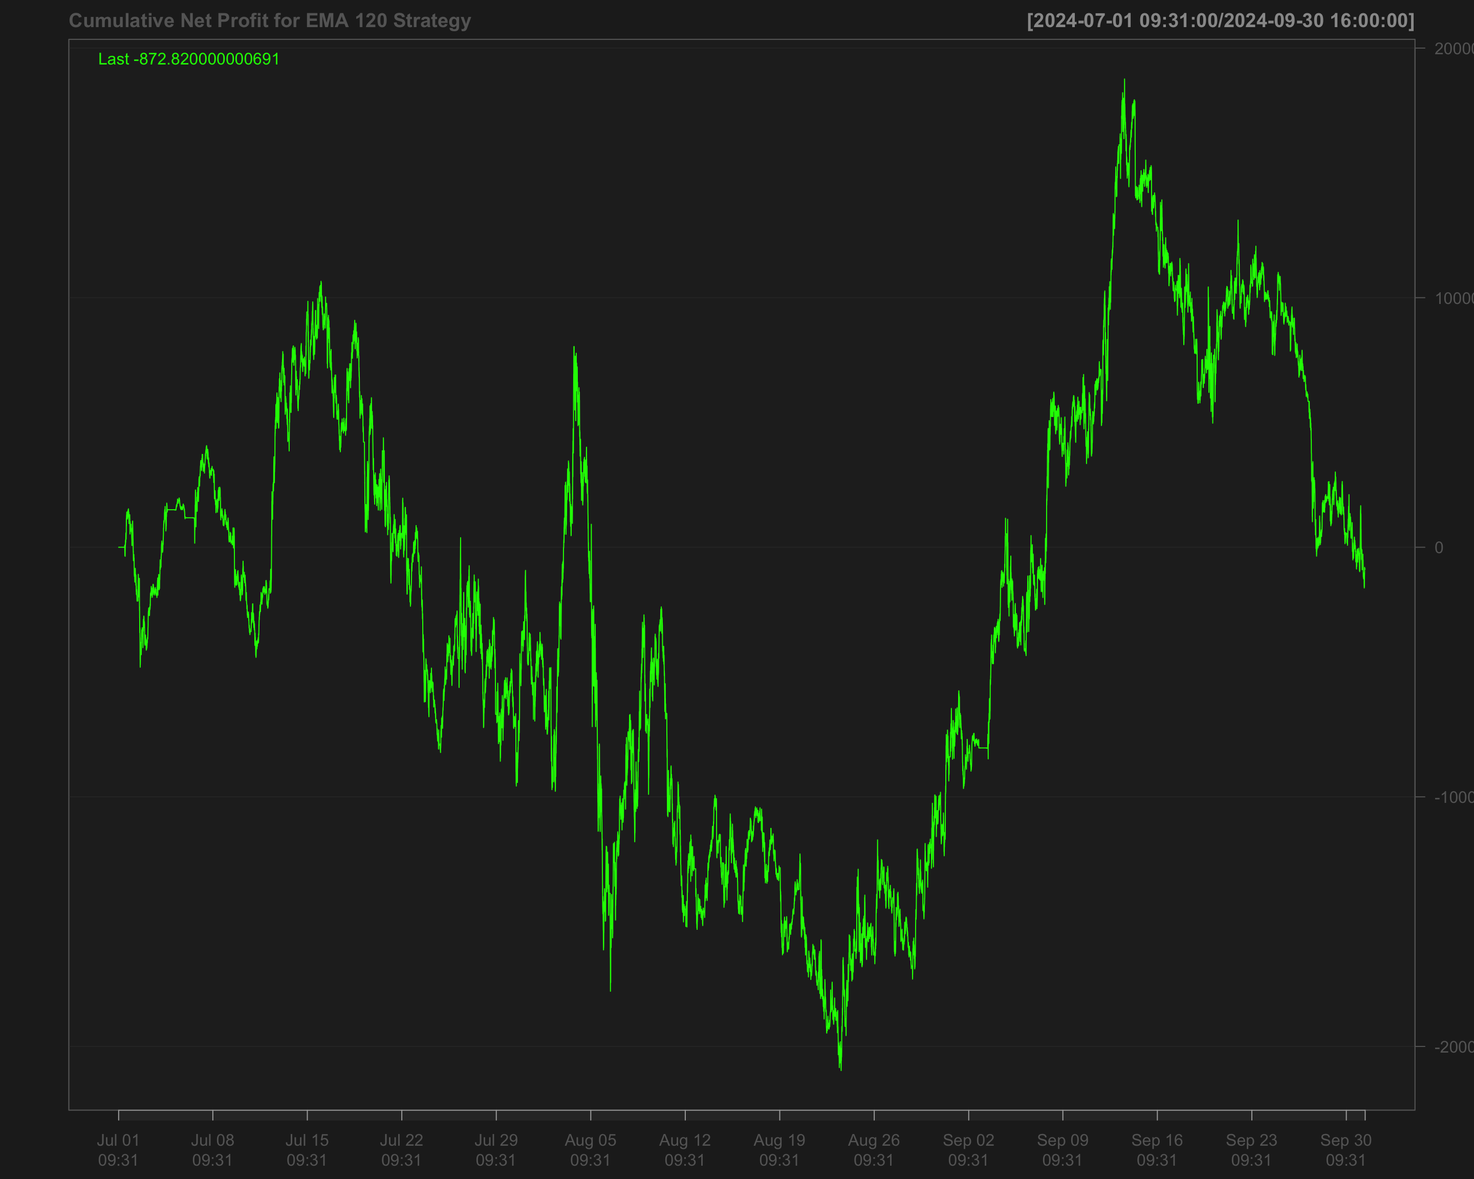

## Volatility breakout strategy using EMA 60 and SD 120

# Calculate the 60-period rolling mean of 'NQ' after filling missing values using the last observation carried forward  
data1_2024_Q3$mean_60 <- roll_mean(na.locf(data1_2024_Q3$NQ, na.rm = FALSE), 60)

# Calculate the 120-period rolling standard deviation of 'NQ' after filling missing values using the last observation carried forward  
data1_2024_Q3$sd_120 <- roll_sd(na.locf(data1_2024_Q3$NQ, na.rm = FALSE), 120)

# Measure the execution time for calculating the position based on a strategy using the 'positionVB' function  
system.time(  
 data1_2024_Q3$position_sd_ema <-   
 positionVB(signal = data1_2024_Q3$NQ,  
 upper = data1_2024_Q3$mean_60 + 1.5 * data1_2024_Q3$sd_120, # Upper bound based on 60-period mean and 1.5 times 120-period SD  
 lower = data1_2024_Q3$mean_60 - 1.5 * data1_2024_Q3$sd_120, # Lower bound based on 60-period mean and 1.5 times 120-period SD  
 times_data = times_data_2024_Q3, # Column with times  
 time_lower = "09:40:00", # Start time for trading  
 time_upper = "15:50:00", # Exit time for all positions  
 strategy = "mom" # Momentum strategy  
 )  
)

# Fill missing position values with the most recent non-missing value (Last Observation Carried Forward)  
data1_2024_Q3$position_sd_ema <- na.locf(data1_2024_Q3$position_sd_ema,  
 na.rm = FALSE)

### Gross profit of volatility breakout strategy

# Calculate gross profit for the strategy by multiplying position with the change in 'NQ' prices and a factor of 20  
data1_2024_Q3$gross_profit_sd_ema <- data1_2024_Q3$position_sd_ema * diff.xts(data1_2024_Q3$NQ) * 20

# Replace any missing values in the gross profit column with 0  
data1_2024_Q3$gross_profit_sd_ema[is.na(data1_2024_Q3$gross_profit_sd_ema)] <- 0  
chartSeries(cumsum(data1_2024_Q3$gross_profit_sd_ema),  
 name = "Cumulative gross profit of (EMA 60 + SD 120)")

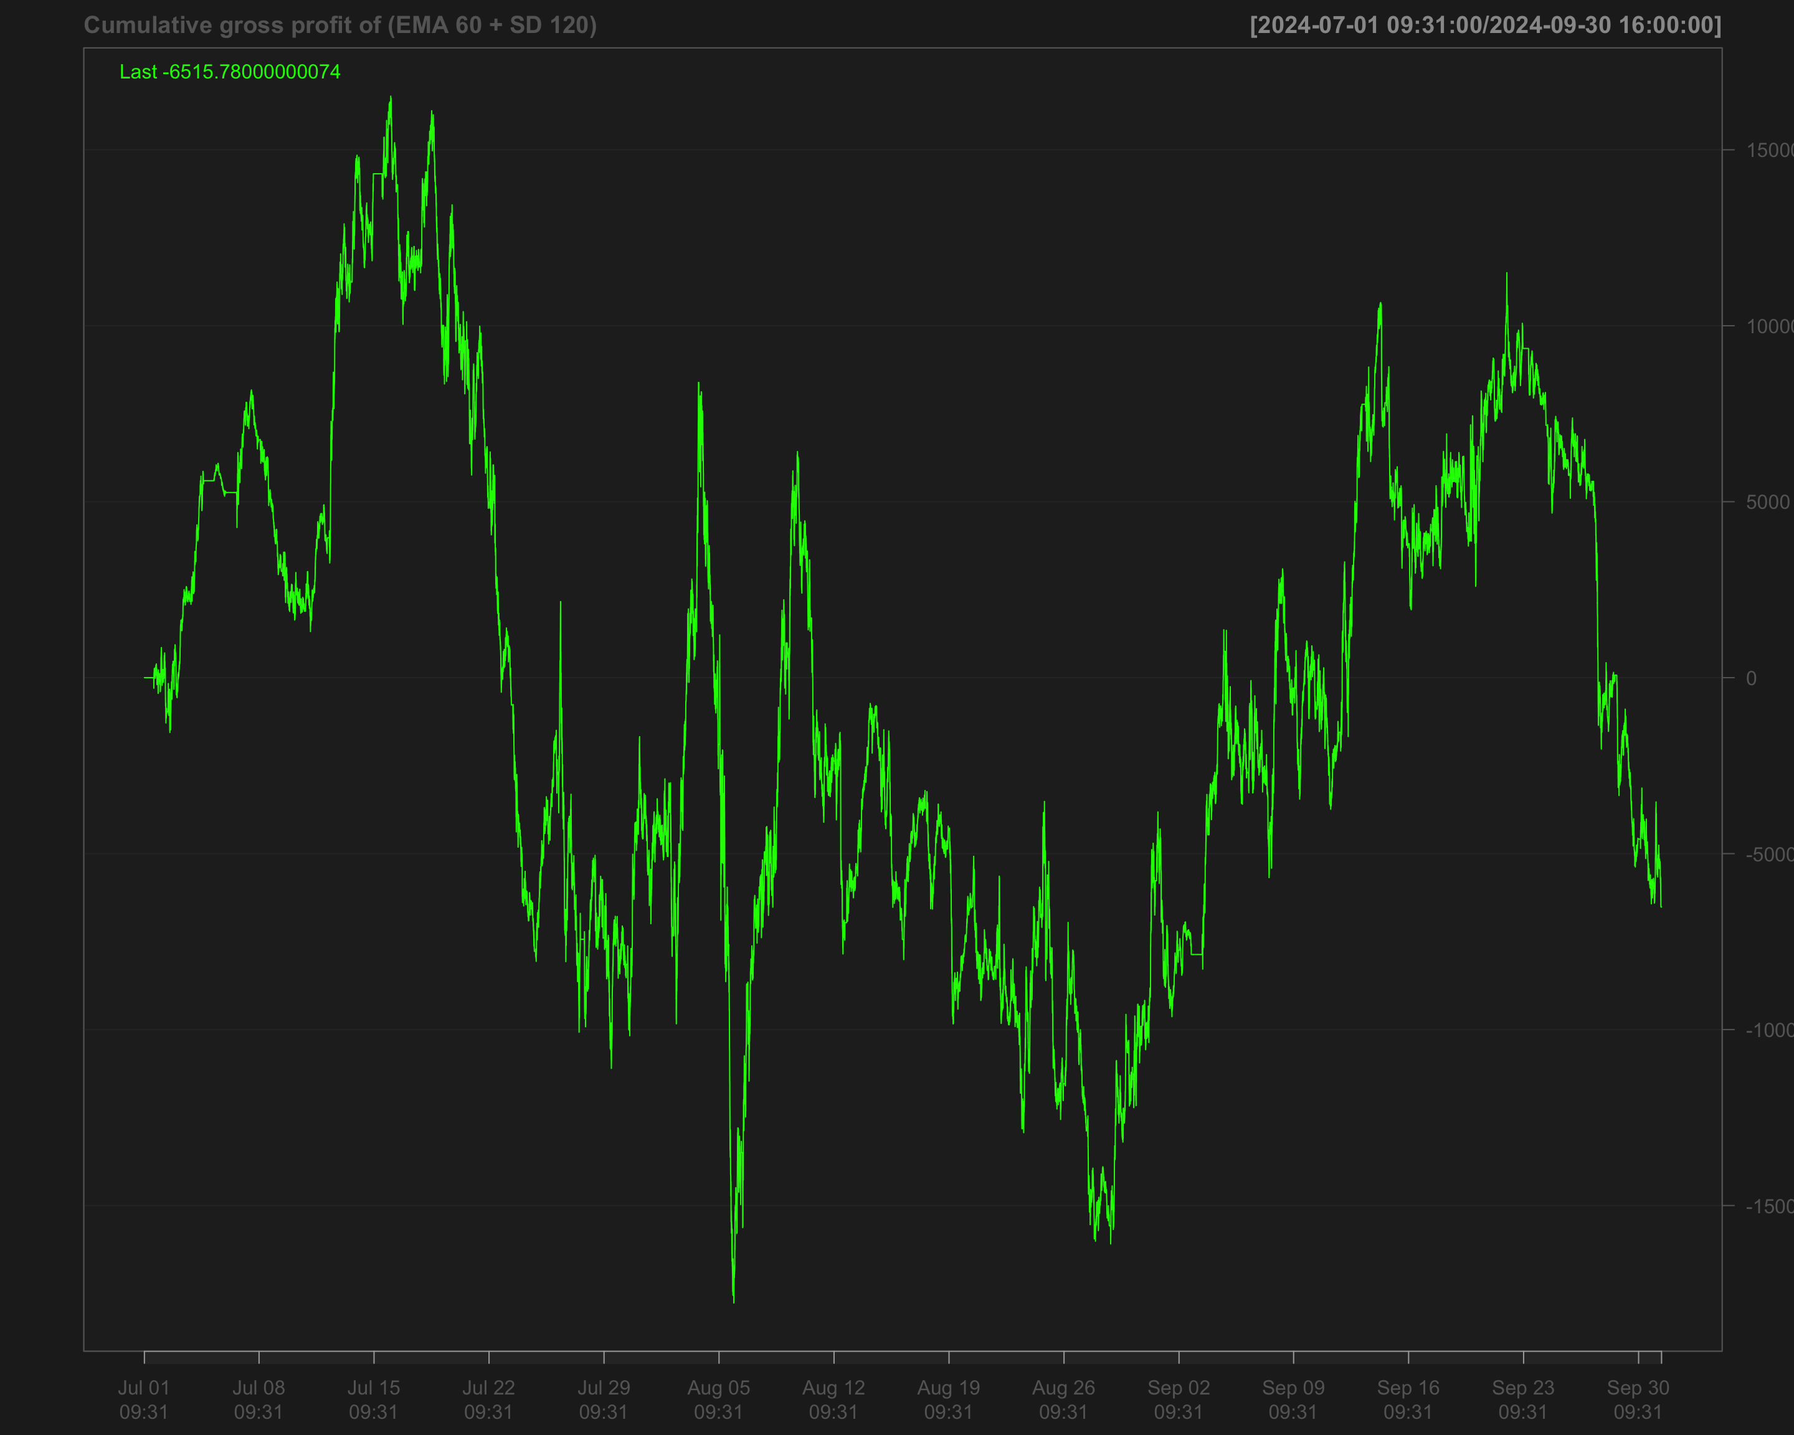

# Identify transactions by calculating the absolute change in position ('position_sd_ema')  
data1_2024_Q3$ntrans_sd_ema <- abs(diff.xts(data1_2024_Q3$position_sd_ema))

# Set the first transaction value to 0, as there's no previous position to compare  
data1_2024_Q3$ntrans_sd_ema[1] <- 0

### Net profit of volatility breakout strategy

# Calculate net profit by subtracting transaction costs (based on the number of transactions and a cost factor of 12) from the gross profit  
data1_2024_Q3$net_profit_sd_ema <- data1_2024_Q3$gross_profit_sd_ema - data1_2024_Q3$ntrans_sd_ema * 12

# Plot the cumulative net profit over time using a chart, based on the 'net_profit_sd_ema' column  
chartSeries(cumsum(data1_2024_Q3$net_profit_sd_ema),   
 name = "Cumulative Net Profit for (EMA 60 + SD 120)")

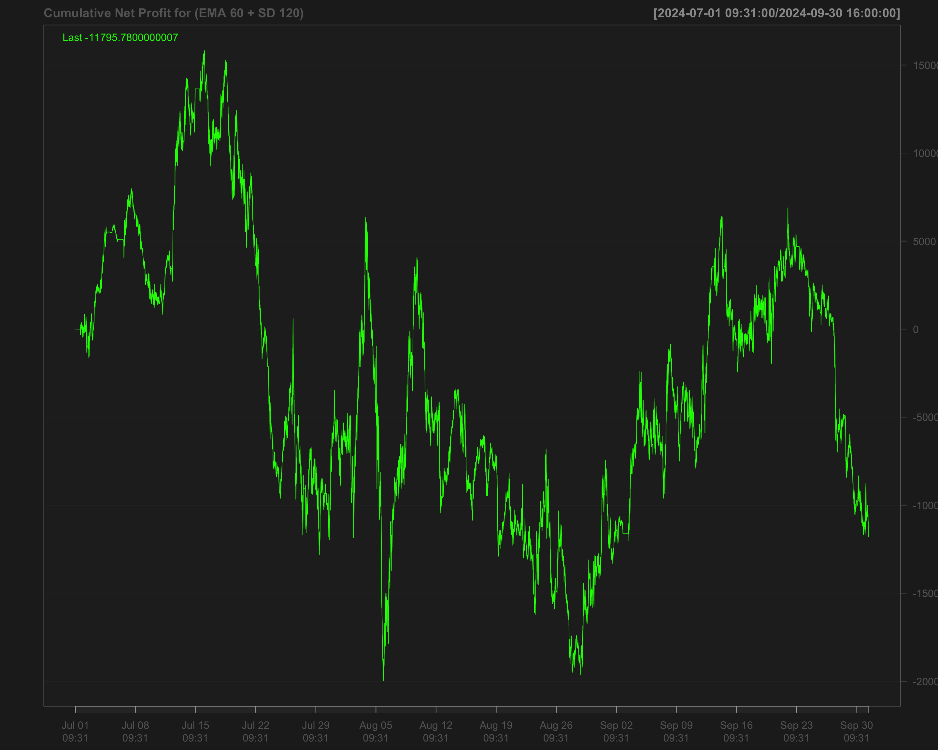

# Strategies based on 2024 Q4

data1_2024_Q4["T09:31/T09:35",] <- NA # Remove data between 09:31 and 09:35 by setting it to NA  
data1_2024_Q4["T15:56/T16:00",] <- NA # Remove data between 15:56 and 16:00 by setting it to NA

## Single EMA of ‘NQ’ with a 120-period window

data1_2024_Q4$ema_120 <- EMA(na.locf(data1_2024_Q4$NQ,   
 na.rm = FALSE),  
 120) # Calculate the 120-period EMA of 'NQ' after filling missing values using the last observation carried forward

data1_2024_Q4$ema_120[is.na(data1_2024_Q4$NQ)] <- NA # Set EMA values to NA where the original 'NQ' values are missing

data1_2024_Q4$position_ema_120 <- ifelse(lag.xts(data1_2024_Q4$NQ) >   
 lag.xts(data1_2024_Q4$ema_120), 1, -1) # Generate trading positions: 1 if 'NQ' is above its lagged EMA, -1 otherwise

# Set trading positions to 0 outside the active trading window (before 09:40:00 or after 15:50:00)  
data1_2024_Q4$position_ema_120[times(times_data_2024_Q4) <= times("9:40:00") |   
 times(times_data_2024_Q4) > times("15:50:00")] <- 0

# Fill missing positions with the most recent non-missing value (Last Observation Carried Forward)  
data1_2024_Q4$position_ema_120 <- na.locf(data1_2024_Q4$position_ema_120,  
 na.rm = FALSE)

### Gross profit for Single EMA

# Calculate gross profit based on the position (ema_120), the change in 'NQ' prices, and a factor of 20  
data1_2024_Q4$gross_profit_ema_120 <- data1_2024_Q4$position_ema_120 * diff.xts(data1_2024_Q4$NQ) * 20

# Set any missing values in 'gross_profit_ema_120' to 0  
data1_2024_Q4$gross_profit_ema_120[is.na(data1_2024_Q4$gross_profit_ema_120)] <- 0  
chartSeries(cumsum(data1_2024_Q4$gross_profit_ema_120),  
 name = "Cumulative gross profit of EMA_120")

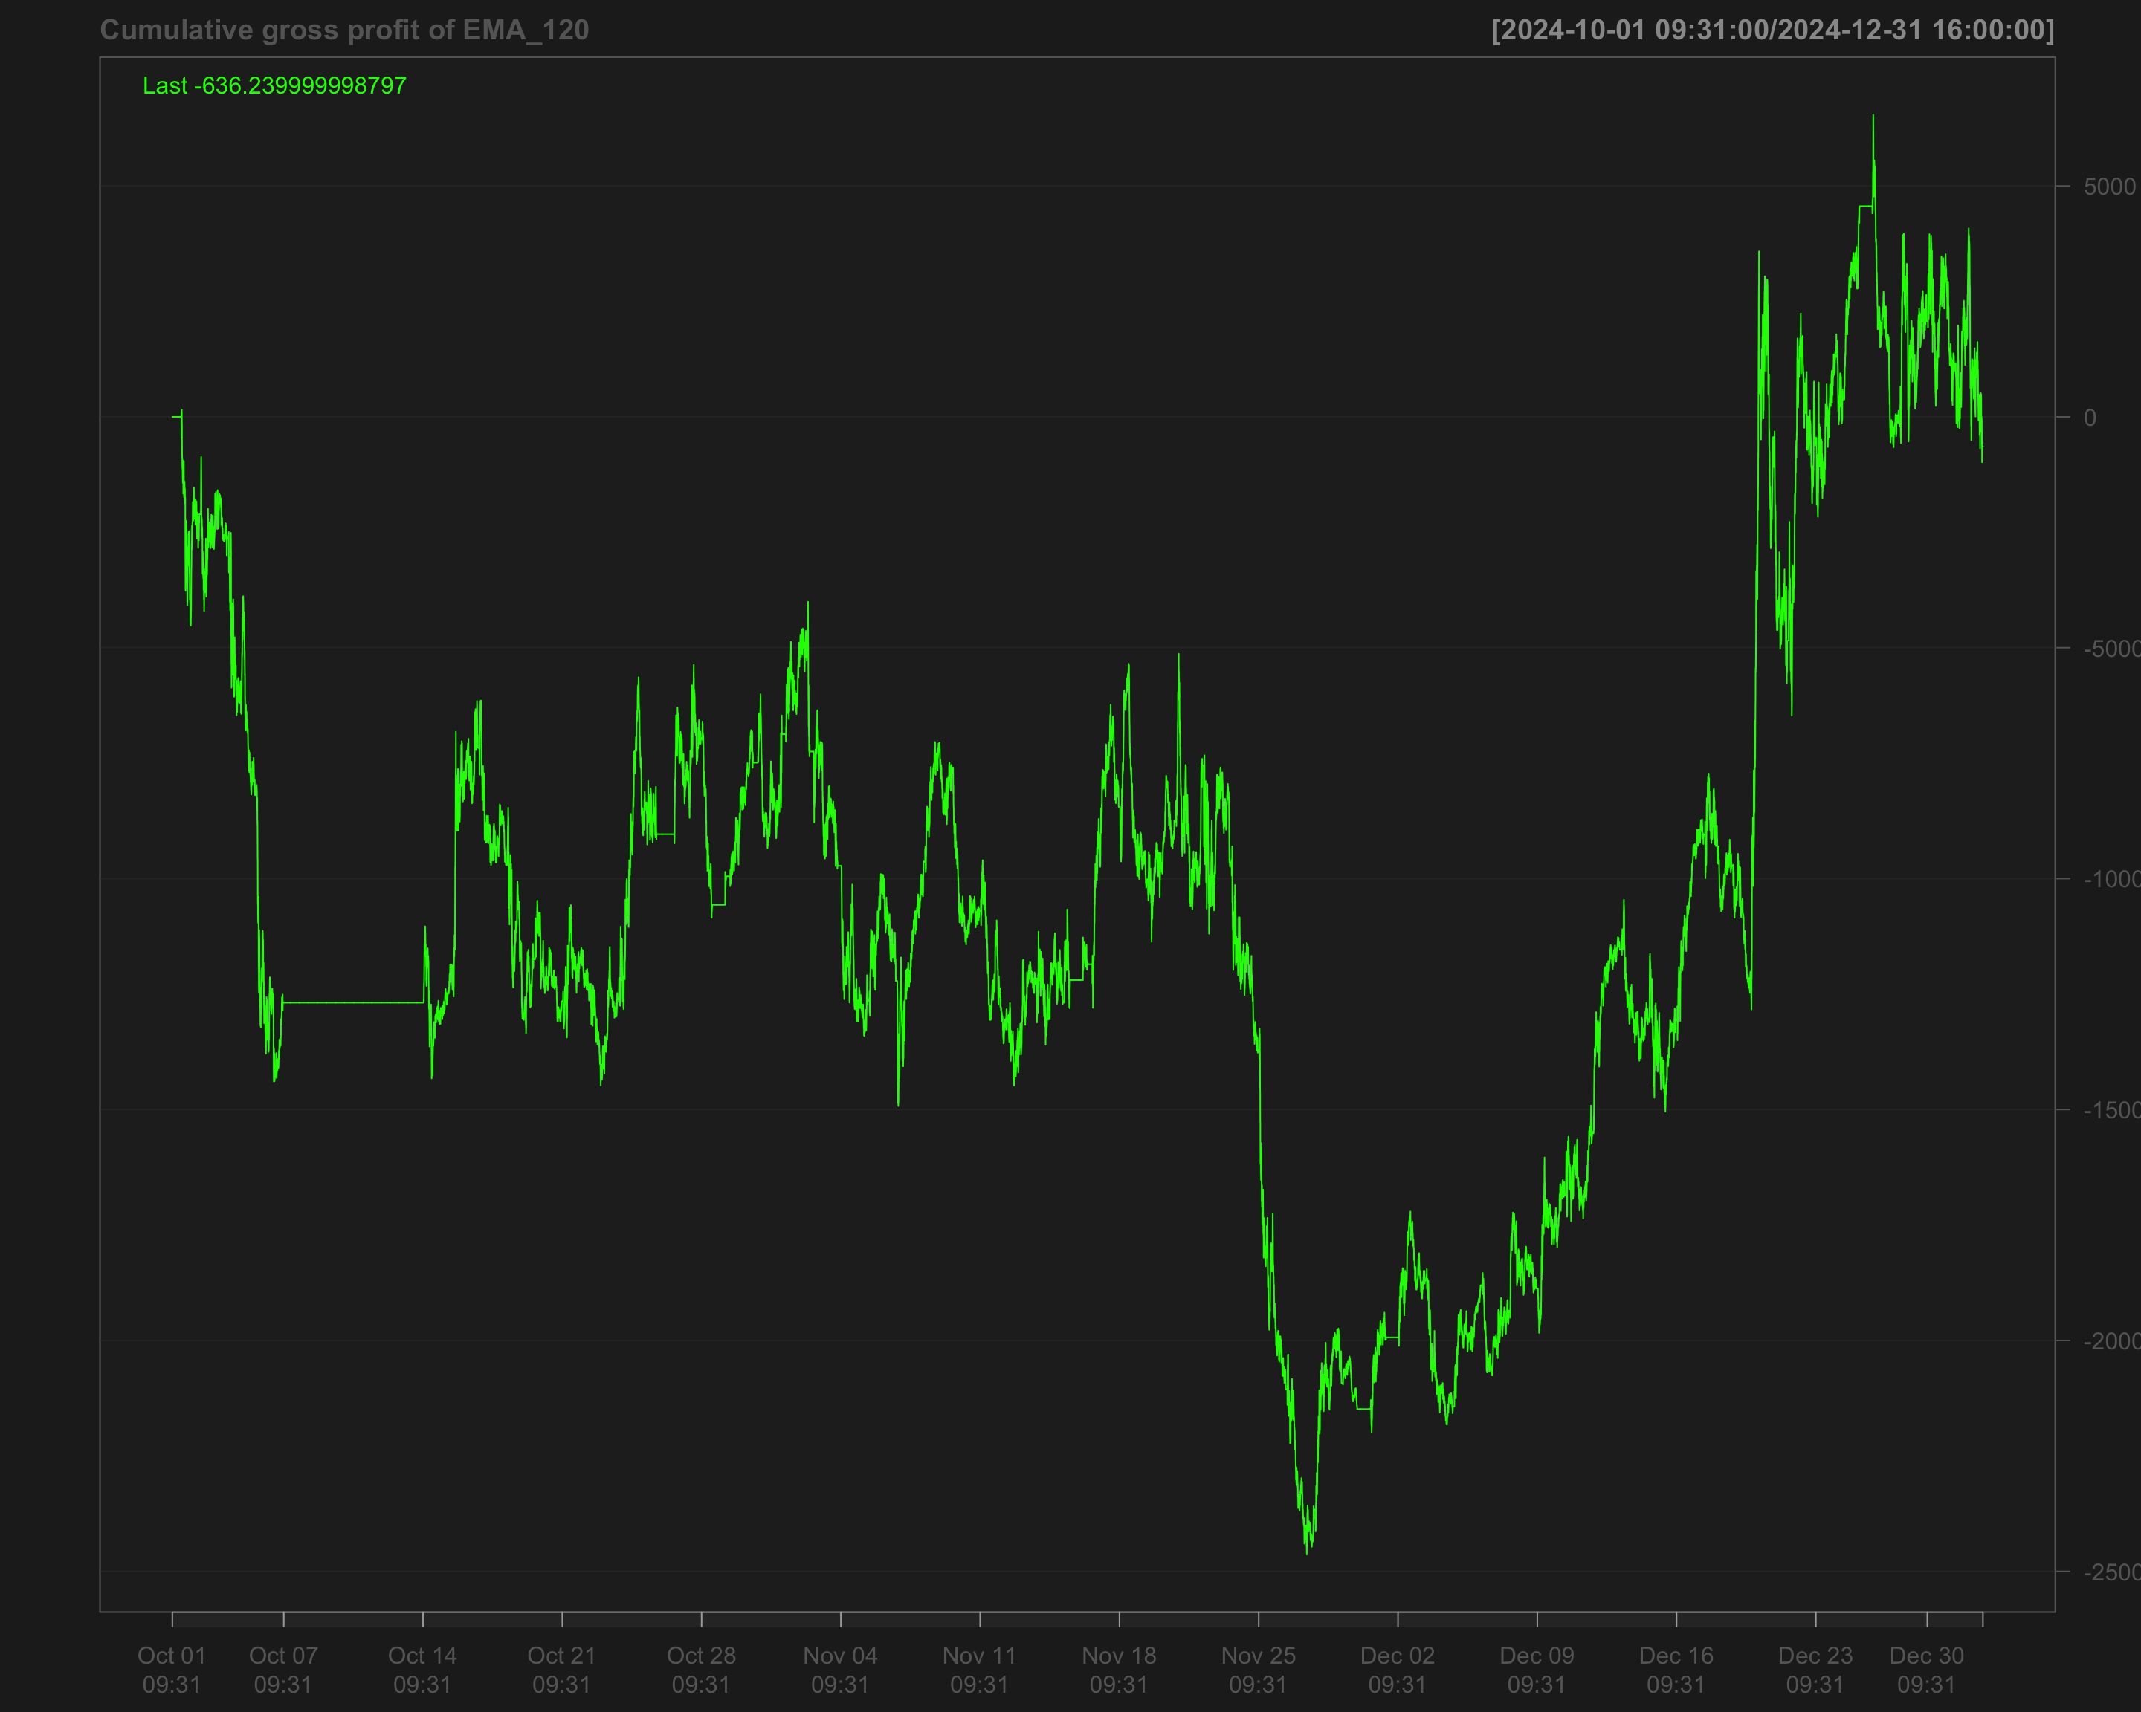

# Identify transactions by calculating the absolute change in position (every time the position changes)  
data1_2024_Q4$ntrans_ema_120 <- abs(diff.xts(data1_2024_Q4$position_ema_120))

# Set the first transaction value to 0, as there's no previous position to compare  
data1_2024_Q4$ntrans_ema_120[1] <- 0

### Net profit for EMA 120

# Calculate net profit by subtracting transaction costs (based on the number of transactions and a cost factor of 12) from the gross profit  
data1_2024_Q4$net_profit_ema_120 <- data1_2024_Q4$gross_profit_ema_120 - data1_2024_Q4$ntrans_ema_120 * 12

# Plot the cumulative sum of the net profit to visualize the overall performance over time  
chartSeries(cumsum(data1_2024_Q4$net_profit_ema_120),   
 name = "Cumulative Net Profit for EMA 120 Strategy")

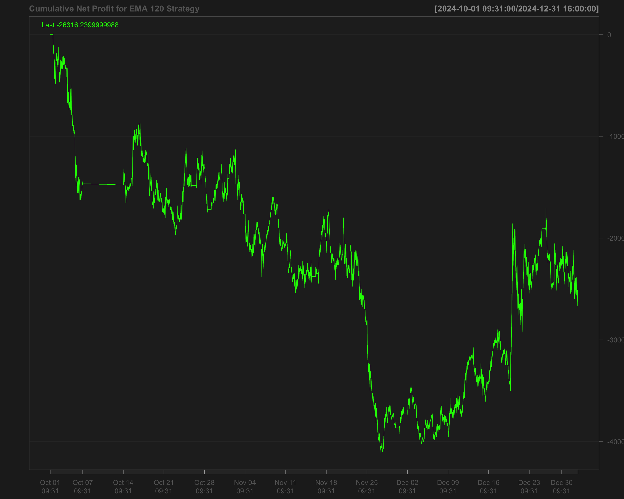

## Volatility breakout strategy using EMA 60 and SD 120

# Calculate the 60-period rolling mean of 'NQ' after filling missing values using the last observation carried forward  
data1_2024_Q4$mean_60 <- roll_mean(na.locf(data1_2024_Q4$NQ, na.rm = FALSE), 60)

# Calculate the 120-period rolling standard deviation of 'NQ' after filling missing values using the last observation carried forward  
data1_2024_Q4$sd_120 <- roll_sd(na.locf(data1_2024_Q4$NQ, na.rm = FALSE), 120)

# Measure the execution time for calculating the position based on a strategy using the 'positionVB' function  
system.time(  
 data1_2024_Q4$position_sd_ema <-   
 positionVB(signal = data1_2024_Q4$NQ,  
 upper = data1_2024_Q4$mean_60 + 1.5 * data1_2024_Q4$sd_120, # Upper bound based on 60-period mean and 1.5 times 120-period SD  
 lower = data1_2024_Q4$mean_60 - 1.5 * data1_2024_Q4$sd_120, # Lower bound based on 60-period mean and 1.5 times 120-period SD  
 times_data = times_data_2024_Q4, # Column with times  
 time_lower = "09:40:00", # Start time for trading  
 time_upper = "15:50:00", # Exit time for all positions  
 strategy = "mom" # Momentum strategy  
 )  
)

# Fill missing position values with the most recent non-missing value (Last Observation Carried Forward)  
data1_2024_Q4$position_sd_ema <- na.locf(data1_2024_Q4$position_sd_ema,  
 na.rm = FALSE)

### Gross profit of volatility breakout strategy

# Calculate gross profit for the strategy by multiplying position with the change in 'NQ' prices and a factor of 20  
data1_2024_Q4$gross_profit_sd_ema <- data1_2024_Q4$position_sd_ema * diff.xts(data1_2024_Q4$NQ) * 20

# Replace any missing values in the gross profit column with 0  
data1_2024_Q4$gross_profit_sd_ema[is.na(data1_2024_Q4$gross_profit_sd_ema)] <- 0  
chartSeries(cumsum(data1_2024_Q4$gross_profit_sd_ema),  
 name = "Cumulative gross profit of (EMA 60 + SD 120)")

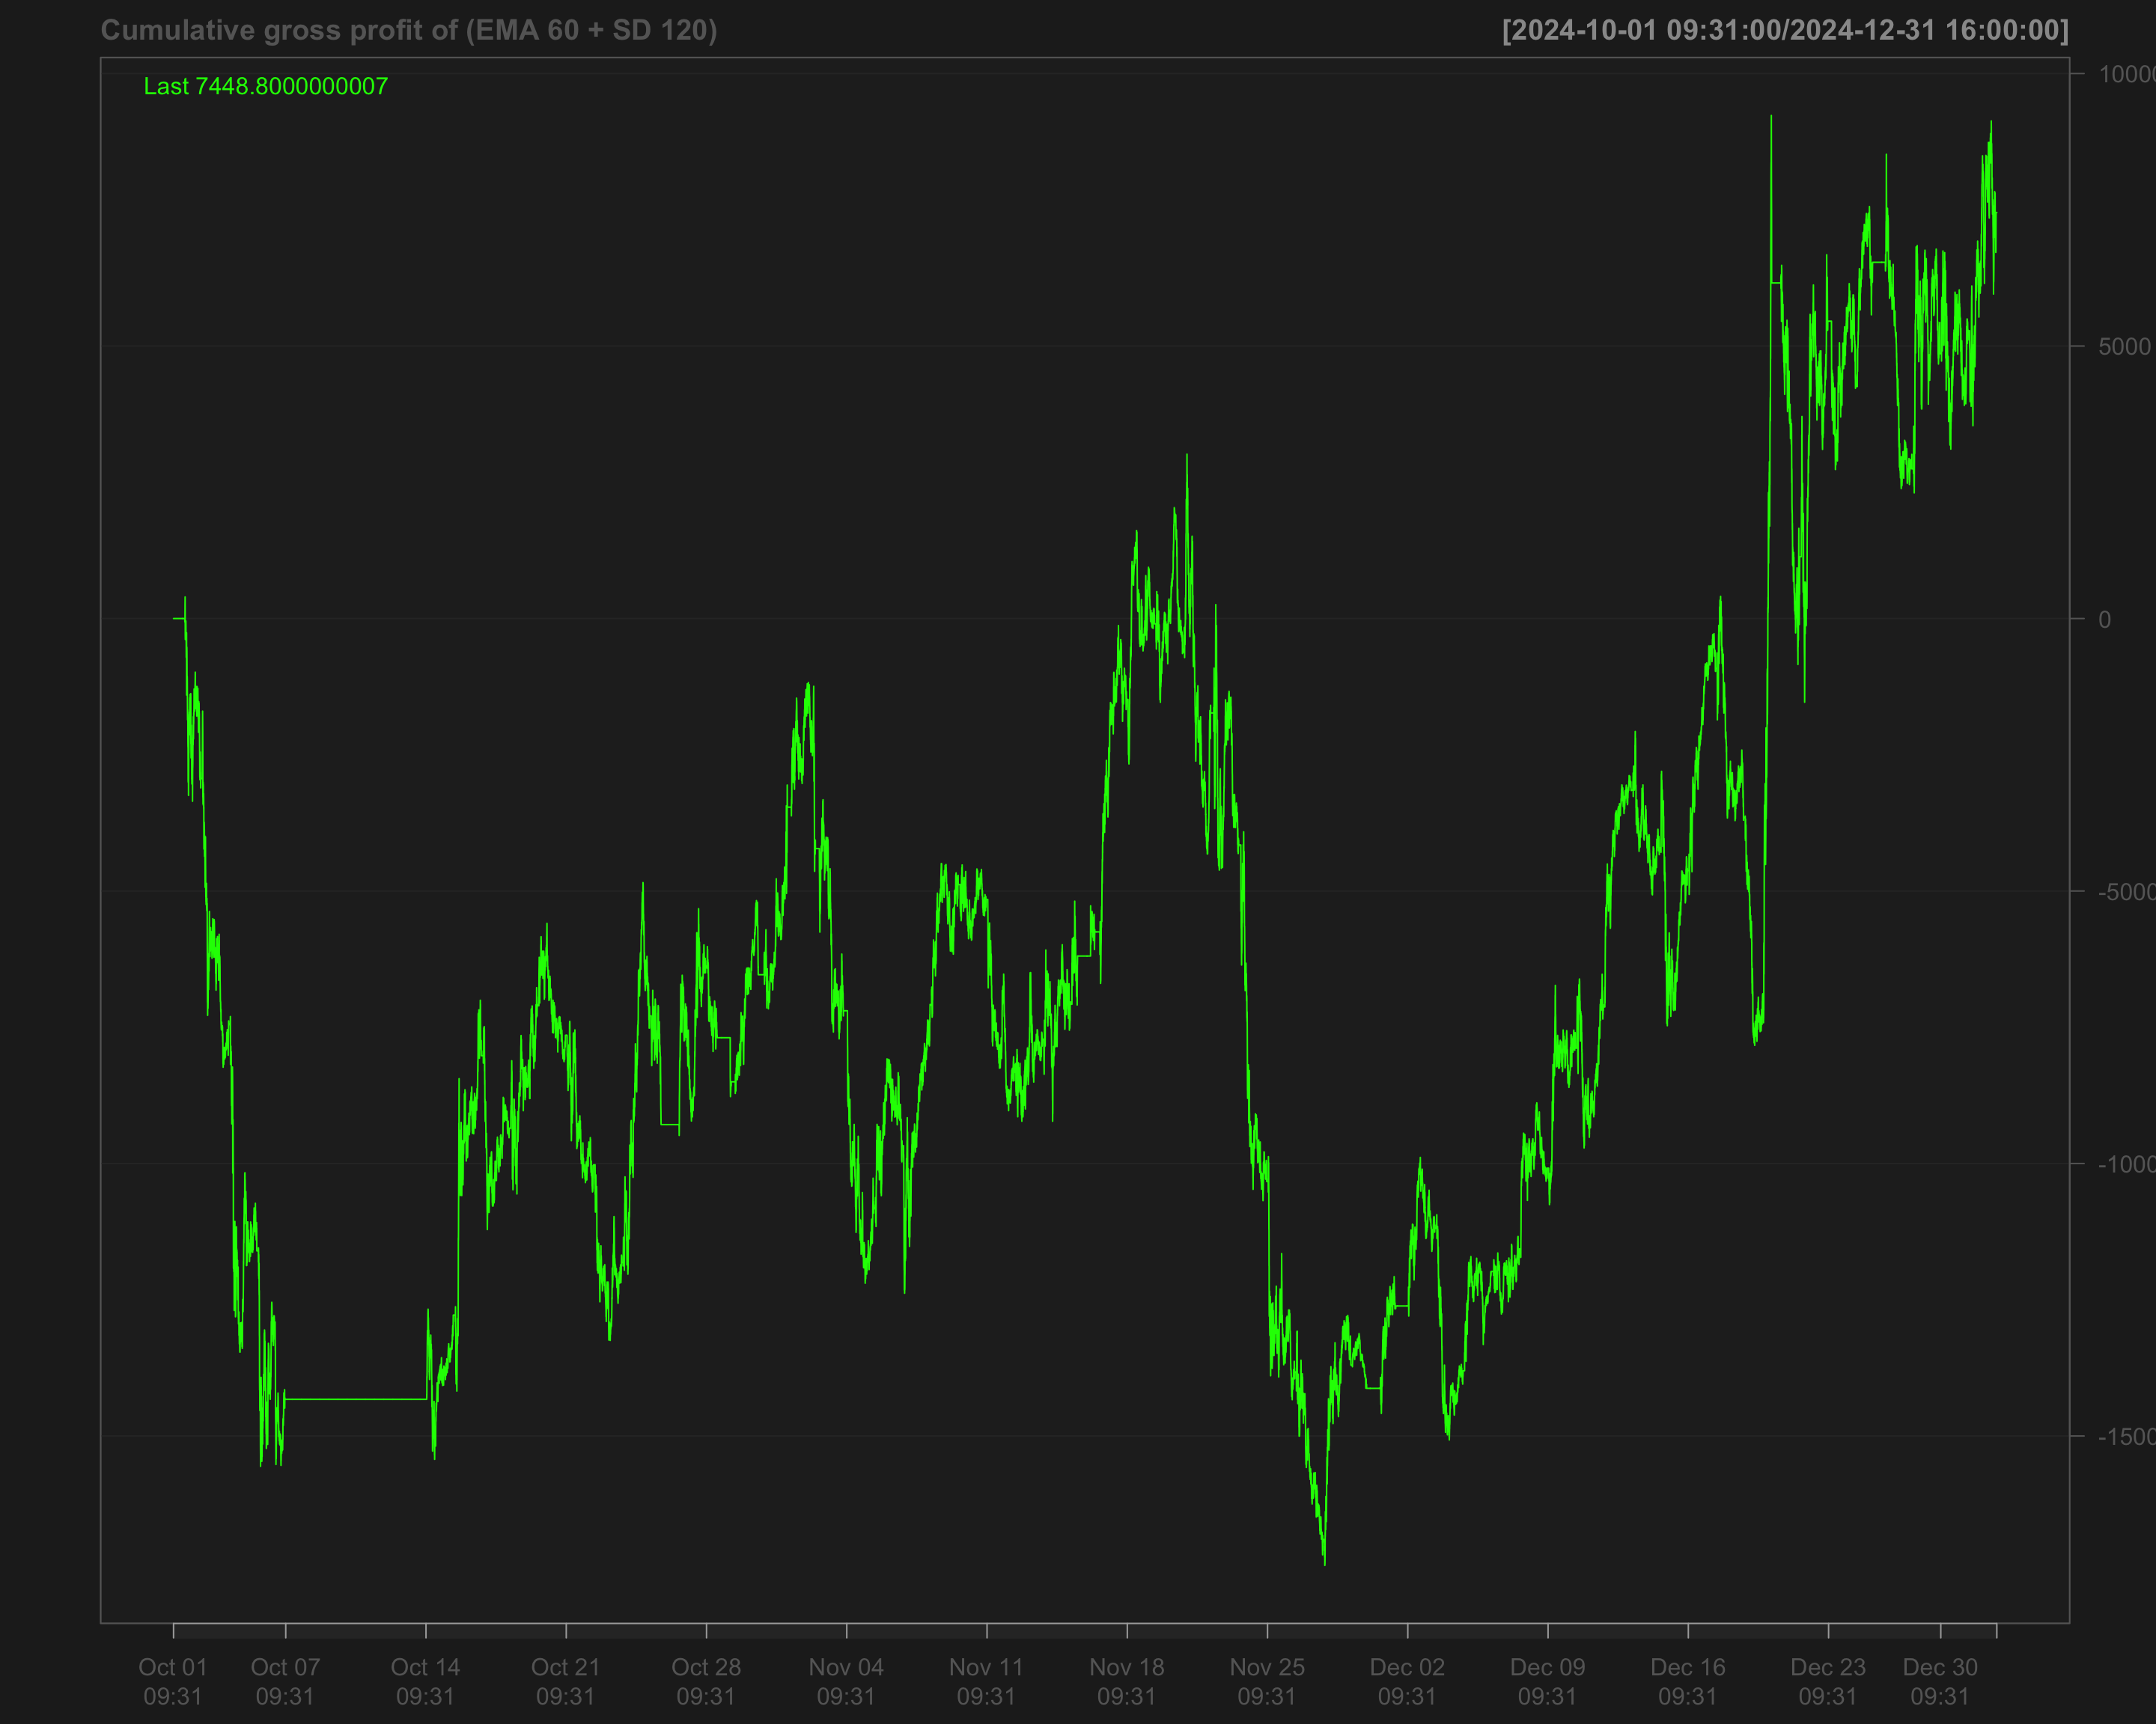

# Identify transactions by calculating the absolute change in position ('position_sd_ema')  
data1_2024_Q4$ntrans_sd_ema <- abs(diff.xts(data1_2024_Q4$position_sd_ema))

# Set the first transaction value to 0, as there's no previous position to compare  
data1_2024_Q4$ntrans_sd_ema[1] <- 0

### Net profit of volatility breakout strategy

# Calculate net profit by subtracting transaction costs (based on the number of transactions and a cost factor of 12) from the gross profit  
data1_2024_Q4$net_profit_sd_ema <- data1_2024_Q4$gross_profit_sd_ema - data1_2024_Q4$ntrans_sd_ema * 12

# Plot the cumulative net profit over time using a chart, based on the 'net_profit_sd_ema' column  
chartSeries(cumsum(data1_2024_Q4$net_profit_sd_ema),   
 name = "Cumulative Net Profit for (EMA 60 + SD 120)")

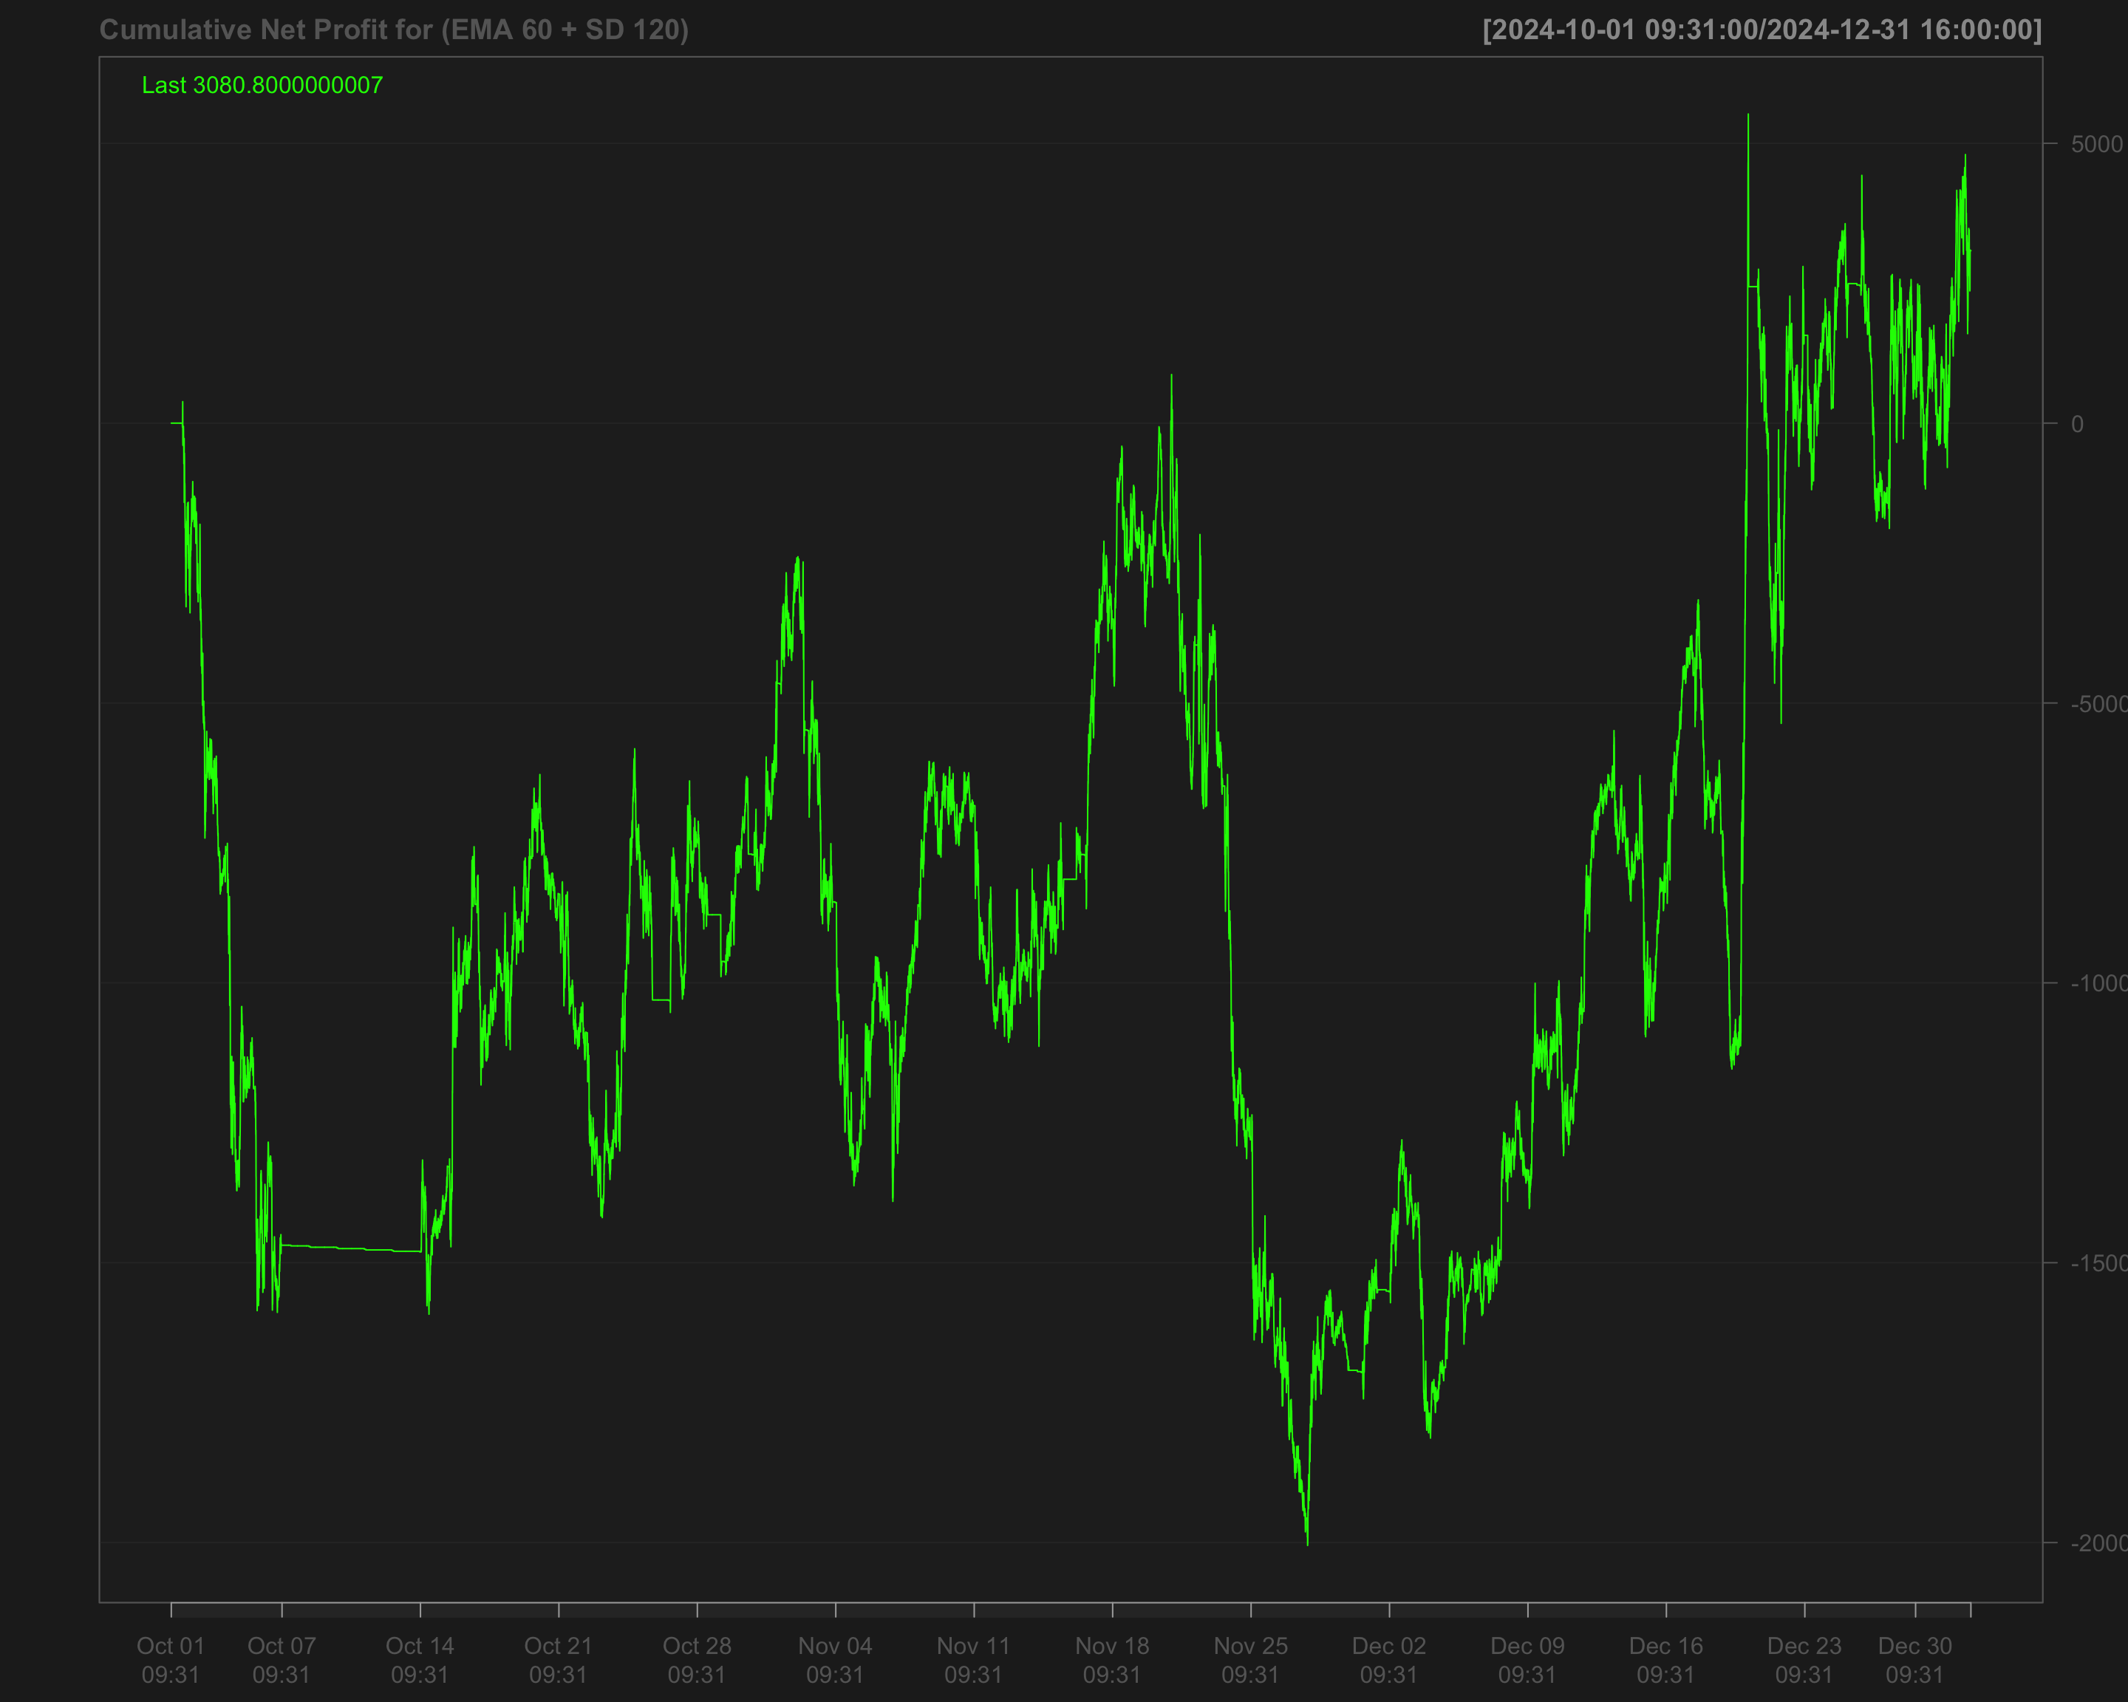

# User function

myCalmarRatio <-myCalmarRatio <- function(x, # x = series of returns  
 # scale parameter = Nt  
 scale) {  
 scale * mean(coredata(x), na.rm = TRUE) /   
 maxdrawdown(cumsum(x))$maxdrawdown  
   
}

# Write the result to CSV

## Create dataframes

result_ema_120 <- data.frame(  
 Period = c("2022 Q1", "2022 Q2", "2022 Q3", "2022 Q4", "2023 Q1", "2023 Q2", "2023 Q3", "2023 Q4", "2024 Q1", "2024 Q2", "2024 Q3", "2024 Q4"),  
 Gross_SR_EMA_120 = c(SortinoRatio(data1_2022_Q1$gross_profit_ema_120),  
 SortinoRatio(data1_2022_Q2$gross_profit_ema_120),  
 SortinoRatio(data1_2022_Q3$gross_profit_ema_120),  
 SortinoRatio(data1_2022_Q4$gross_profit_ema_120),  
 SortinoRatio(data1_2023_Q1$gross_profit_ema_120),  
 SortinoRatio(data1_2023_Q2$gross_profit_ema_120),  
 SortinoRatio(data1_2023_Q3$gross_profit_ema_120),  
 SortinoRatio(data1_2023_Q4$gross_profit_ema_120),  
 SortinoRatio(data1_2024_Q1$gross_profit_ema_120),  
 SortinoRatio(data1_2024_Q2$gross_profit_ema_120),  
 SortinoRatio(data1_2024_Q3$gross_profit_ema_120),  
 SortinoRatio(data1_2024_Q4$gross_profit_ema_120)),  
 Net_SR_EMA_120 = c(SortinoRatio(data1_2022_Q1$net_profit_ema_120),  
 SortinoRatio(data1_2022_Q2$net_profit_ema_120),  
 SortinoRatio(data1_2022_Q3$net_profit_ema_120),  
 SortinoRatio(data1_2022_Q4$net_profit_ema_120),  
 SortinoRatio(data1_2023_Q1$net_profit_ema_120),  
 SortinoRatio(data1_2023_Q2$net_profit_ema_120),  
 SortinoRatio(data1_2023_Q3$net_profit_ema_120),  
 SortinoRatio(data1_2023_Q4$net_profit_ema_120),  
 SortinoRatio(data1_2024_Q1$net_profit_ema_120),  
 SortinoRatio(data1_2024_Q2$net_profit_ema_120),  
 SortinoRatio(data1_2024_Q3$net_profit_ema_120),  
 SortinoRatio(data1_2024_Q4$net_profit_ema_120)),  
 Gross_CR_EMA_120 = c(myCalmarRatio(data1_2022_Q1$gross_profit_ema_120, scale = 252),  
 myCalmarRatio(data1_2022_Q2$gross_profit_ema_120, scale = 252),  
 myCalmarRatio(data1_2022_Q3$gross_profit_ema_120, scale = 252),  
 myCalmarRatio(data1_2022_Q4$gross_profit_ema_120, scale = 252),  
 myCalmarRatio(data1_2023_Q1$gross_profit_ema_120, scale = 252),  
 myCalmarRatio(data1_2023_Q2$gross_profit_ema_120, scale = 252),  
 myCalmarRatio(data1_2023_Q3$gross_profit_ema_120, scale = 252),  
 myCalmarRatio(data1_2023_Q4$gross_profit_ema_120, scale = 252),  
 myCalmarRatio(data1_2024_Q1$gross_profit_ema_120, scale = 252),  
 myCalmarRatio(data1_2024_Q2$gross_profit_ema_120, scale = 252),  
 myCalmarRatio(data1_2024_Q3$gross_profit_ema_120, scale = 252),  
 myCalmarRatio(data1_2024_Q4$gross_profit_ema_120, scale = 252)),  
 Net_CR_EMA_120 = c(myCalmarRatio(data1_2022_Q1$net_profit_ema_120, scale = 252),  
 myCalmarRatio(data1_2022_Q2$net_profit_ema_120, scale = 252),  
 myCalmarRatio(data1_2022_Q3$net_profit_ema_120, scale = 252),  
 myCalmarRatio(data1_2022_Q4$net_profit_ema_120, scale = 252),  
 myCalmarRatio(data1_2023_Q1$net_profit_ema_120, scale = 252),  
 myCalmarRatio(data1_2023_Q2$net_profit_ema_120, scale = 252),  
 myCalmarRatio(data1_2023_Q3$net_profit_ema_120, scale = 252),  
 myCalmarRatio(data1_2023_Q4$net_profit_ema_120, scale = 252),  
 myCalmarRatio(data1_2024_Q1$net_profit_ema_120, scale = 252),  
 myCalmarRatio(data1_2024_Q2$net_profit_ema_120, scale = 252),  
 myCalmarRatio(data1_2024_Q3$net_profit_ema_120, scale = 252),  
 myCalmarRatio(data1_2024_Q4$net_profit_ema_120, scale = 252)),  
 Gross_cumPnL_EMA_120 = c(tail(cumsum(data1_2022_Q1$gross_profit_ema_120), 1),  
 tail(cumsum(data1_2022_Q2$gross_profit_ema_120), 1),  
 tail(cumsum(data1_2022_Q3$gross_profit_ema_120), 1),  
 tail(cumsum(data1_2022_Q4$gross_profit_ema_120), 1),  
 tail(cumsum(data1_2023_Q1$gross_profit_ema_120), 1),  
 tail(cumsum(data1_2023_Q2$gross_profit_ema_120), 1),  
 tail(cumsum(data1_2023_Q3$gross_profit_ema_120), 1),  
 tail(cumsum(data1_2023_Q4$gross_profit_ema_120), 1),  
 tail(cumsum(data1_2024_Q1$gross_profit_ema_120), 1),  
 tail(cumsum(data1_2024_Q2$gross_profit_ema_120), 1),  
 tail(cumsum(data1_2024_Q3$gross_profit_ema_120), 1),  
 tail(cumsum(data1_2024_Q4$gross_profit_ema_120), 1)),  
 Net_cumPnL_EMA_120 = c(tail(cumsum(data1_2022_Q1$net_profit_ema_120), 1),  
 tail(cumsum(data1_2022_Q2$net_profit_ema_120), 1),  
 tail(cumsum(data1_2022_Q3$net_profit_ema_120), 1),  
 tail(cumsum(data1_2022_Q4$net_profit_ema_120), 1),  
 tail(cumsum(data1_2023_Q1$net_profit_ema_120), 1),  
 tail(cumsum(data1_2023_Q2$net_profit_ema_120), 1),  
 tail(cumsum(data1_2023_Q3$net_profit_ema_120), 1),  
 tail(cumsum(data1_2023_Q4$net_profit_ema_120), 1),  
 tail(cumsum(data1_2024_Q1$net_profit_ema_120), 1),  
 tail(cumsum(data1_2024_Q2$net_profit_ema_120), 1),  
 tail(cumsum(data1_2024_Q3$net_profit_ema_120), 1),  
 tail(cumsum(data1_2024_Q4$net_profit_ema_120), 1)),  
 Avg_nTrades_EMA_120 = c(mean(data1_2022_Q1$ntrans_ema_120),  
 mean(data1_2022_Q2$ntrans_ema_120),  
 mean(data1_2022_Q3$ntrans_ema_120),  
 mean(data1_2022_Q4$ntrans_ema_120),  
 mean(data1_2023_Q1$ntrans_ema_120),  
 mean(data1_2023_Q2$ntrans_ema_120),  
 mean(data1_2023_Q3$ntrans_ema_120),  
 mean(data1_2023_Q4$ntrans_ema_120),  
 mean(data1_2024_Q1$ntrans_ema_120),  
 mean(data1_2024_Q2$ntrans_ema_120),  
 mean(data1_2024_Q3$ntrans_ema_120),  
 mean(data1_2024_Q4$ntrans_ema_120)),  
 Summary_Statistic_EMA_120 = c(  
 myCalmarRatio(data1_2022_Q1$net_profit_ema_120, scale = 252) * max(log(abs(data1_2022_Q1$net_profit_ema_120))),  
 myCalmarRatio(data1_2022_Q2$net_profit_ema_120, scale = 252) * max(log(abs(data1_2022_Q2$net_profit_ema_120))),  
 myCalmarRatio(data1_2022_Q3$net_profit_ema_120, scale = 252) * max(log(abs(data1_2022_Q3$net_profit_ema_120))),  
 myCalmarRatio(data1_2022_Q4$net_profit_ema_120, scale = 252) * max(log(abs(data1_2022_Q4$net_profit_ema_120))),  
 myCalmarRatio(data1_2023_Q1$net_profit_ema_120, scale = 252) * max(log(abs(data1_2023_Q1$net_profit_ema_120))),  
 myCalmarRatio(data1_2023_Q2$net_profit_ema_120, scale = 252) * max(log(abs(data1_2023_Q2$net_profit_ema_120))),  
 myCalmarRatio(data1_2023_Q3$net_profit_ema_120, scale = 252) * max(log(abs(data1_2023_Q3$net_profit_ema_120))),  
 myCalmarRatio(data1_2023_Q4$net_profit_ema_120, scale = 252) * max(log(abs(data1_2023_Q4$net_profit_ema_120))),  
 myCalmarRatio(data1_2024_Q1$net_profit_ema_120, scale = 252) * max(log(abs(data1_2024_Q1$net_profit_ema_120))),  
 myCalmarRatio(data1_2024_Q2$net_profit_ema_120, scale = 252) * max(log(abs(data1_2024_Q2$net_profit_ema_120))),  
 myCalmarRatio(data1_2024_Q3$net_profit_ema_120, scale = 252) * max(log(abs(data1_2024_Q3$net_profit_ema_120))),  
 myCalmarRatio(data1_2024_Q4$net_profit_ema_120, scale = 252) * max(log(abs(data1_2024_Q4$net_profit_ema_120)))  
 )  
)  
  
# Create the "Total" row  
total_row <- data.frame(  
 Period = "Total",  
 Gross_SR_EMA_120 = sum(result_ema_120$Gross_SR_EMA_120, na.rm = TRUE),  
 Net_SR_EMA_120 = sum(result_ema_120$Net_SR_EMA_120, na.rm = TRUE),  
 Gross_CR_EMA_120 = sum(result_ema_120$Gross_CR_EMA_120, na.rm = TRUE),  
 Net_CR_EMA_120 = sum(result_ema_120$Net_CR_EMA_120, na.rm = TRUE),  
 Gross_cumPnL_EMA_120 = sum(result_ema_120$Gross_cumPnL_EMA_120, na.rm = TRUE),  
 Net_cumPnL_EMA_120 = sum(result_ema_120$Net_cumPnL_EMA_120, na.rm = TRUE),  
 Avg_nTrades_EMA_120 = mean(result_ema_120$Avg_nTrades_EMA_120, na.rm = TRUE),  
 Summary_Statistic_EMA_120 = sum(result_ema_120$Summary_Statistic_EMA_120, na.rm = TRUE),  
 stringsAsFactors = FALSE  
)  
  
# Ensure column names of total_row match result  
colnames(total_row) <- colnames(result_ema_120)  
  
# Append the "Total" row to the dataframe  
result_ema_120 <- rbind(result_ema_120, total_row)  
  
# Reset row names to remove indexing numbers  
rownames(result_ema_120) <- NULL

result_ema_sd <- data.frame(  
 Period = c(  
 "2022 Q1", "2022 Q2", "2022 Q3", "2022 Q4",  
 "2023 Q1", "2023 Q2", "2023 Q3", "2023 Q4",  
 "2024 Q1", "2024 Q2", "2024 Q3", "2024 Q4"  
 ),  
   
 Gross_SR_SD_EMA = c(  
 SortinoRatio(data1_2022_Q1$gross_profit_sd_ema),  
 SortinoRatio(data1_2022_Q2$gross_profit_sd_ema),  
 SortinoRatio(data1_2022_Q3$gross_profit_sd_ema),  
 SortinoRatio(data1_2022_Q4$gross_profit_sd_ema),  
 SortinoRatio(data1_2023_Q1$gross_profit_sd_ema),  
 SortinoRatio(data1_2023_Q2$gross_profit_sd_ema),  
 SortinoRatio(data1_2023_Q3$gross_profit_sd_ema),  
 SortinoRatio(data1_2023_Q4$gross_profit_sd_ema),  
 SortinoRatio(data1_2024_Q1$gross_profit_sd_ema),  
 SortinoRatio(data1_2024_Q2$gross_profit_sd_ema),  
 SortinoRatio(data1_2024_Q3$gross_profit_sd_ema),  
 SortinoRatio(data1_2024_Q4$gross_profit_sd_ema)  
 ),  
   
 Net_SR_SD_EMA = c(  
 SortinoRatio(data1_2022_Q1$net_profit_sd_ema),  
 SortinoRatio(data1_2022_Q2$net_profit_sd_ema),  
 SortinoRatio(data1_2022_Q3$net_profit_sd_ema),  
 SortinoRatio(data1_2022_Q4$net_profit_sd_ema),  
 SortinoRatio(data1_2023_Q1$net_profit_sd_ema),  
 SortinoRatio(data1_2023_Q2$net_profit_sd_ema),  
 SortinoRatio(data1_2023_Q3$net_profit_sd_ema),  
 SortinoRatio(data1_2023_Q4$net_profit_sd_ema),  
 SortinoRatio(data1_2024_Q1$net_profit_sd_ema),  
 SortinoRatio(data1_2024_Q2$net_profit_sd_ema),  
 SortinoRatio(data1_2024_Q3$net_profit_sd_ema),  
 SortinoRatio(data1_2024_Q4$net_profit_sd_ema)  
 ),  
   
 Gross_CR_SD_EMA = c(  
 myCalmarRatio(data1_2022_Q1$gross_profit_sd_ema, scale = 252),  
 myCalmarRatio(data1_2022_Q2$gross_profit_sd_ema, scale = 252),  
 myCalmarRatio(data1_2022_Q3$gross_profit_sd_ema, scale = 252),  
 myCalmarRatio(data1_2022_Q4$gross_profit_sd_ema, scale = 252),  
 myCalmarRatio(data1_2023_Q1$gross_profit_sd_ema, scale = 252),  
 myCalmarRatio(data1_2023_Q2$gross_profit_sd_ema, scale = 252),  
 myCalmarRatio(data1_2023_Q3$gross_profit_sd_ema, scale = 252),  
 myCalmarRatio(data1_2023_Q4$gross_profit_sd_ema, scale = 252),  
 myCalmarRatio(data1_2024_Q1$gross_profit_sd_ema, scale = 252),  
 myCalmarRatio(data1_2024_Q2$gross_profit_sd_ema, scale = 252),  
 myCalmarRatio(data1_2024_Q3$gross_profit_sd_ema, scale = 252),  
 myCalmarRatio(data1_2024_Q4$gross_profit_sd_ema, scale = 252)  
 ),  
   
 Net_CR_SD_EMA = c(  
 myCalmarRatio(data1_2022_Q1$net_profit_sd_ema, scale = 252),  
 myCalmarRatio(data1_2022_Q2$net_profit_sd_ema, scale = 252),  
 myCalmarRatio(data1_2022_Q3$net_profit_sd_ema, scale = 252),  
 myCalmarRatio(data1_2022_Q4$net_profit_sd_ema, scale = 252),  
 myCalmarRatio(data1_2023_Q1$net_profit_sd_ema, scale = 252),  
 myCalmarRatio(data1_2023_Q2$net_profit_sd_ema, scale = 252),  
 myCalmarRatio(data1_2023_Q3$net_profit_sd_ema, scale = 252),  
 myCalmarRatio(data1_2023_Q4$net_profit_sd_ema, scale = 252),  
 myCalmarRatio(data1_2024_Q1$net_profit_sd_ema, scale = 252),  
 myCalmarRatio(data1_2024_Q2$net_profit_sd_ema, scale = 252),  
 myCalmarRatio(data1_2024_Q3$net_profit_sd_ema, scale = 252),  
 myCalmarRatio(data1_2024_Q4$net_profit_sd_ema, scale = 252)  
 ),  
   
 Gross_cumPnL_SD_EMA = c(  
 tail(cumsum(data1_2022_Q1$gross_profit_sd_ema), 1),  
 tail(cumsum(data1_2022_Q2$gross_profit_sd_ema), 1),  
 tail(cumsum(data1_2022_Q3$gross_profit_sd_ema), 1),  
 tail(cumsum(data1_2022_Q4$gross_profit_sd_ema), 1),  
 tail(cumsum(data1_2023_Q1$gross_profit_sd_ema), 1),  
 tail(cumsum(data1_2023_Q2$gross_profit_sd_ema), 1),  
 tail(cumsum(data1_2023_Q3$gross_profit_sd_ema), 1),  
 tail(cumsum(data1_2023_Q4$gross_profit_sd_ema), 1),  
 tail(cumsum(data1_2024_Q1$gross_profit_sd_ema), 1),  
 tail(cumsum(data1_2024_Q2$gross_profit_sd_ema), 1),  
 tail(cumsum(data1_2024_Q3$gross_profit_sd_ema), 1),  
 tail(cumsum(data1_2024_Q4$gross_profit_sd_ema), 1)  
 ),  
   
 Net_cumPnL_SD_EMA = c(  
 tail(cumsum(data1_2022_Q1$net_profit_sd_ema), 1),  
 tail(cumsum(data1_2022_Q2$net_profit_sd_ema), 1),  
 tail(cumsum(data1_2022_Q3$net_profit_sd_ema), 1),  
 tail(cumsum(data1_2022_Q4$net_profit_sd_ema), 1),  
 tail(cumsum(data1_2023_Q1$net_profit_sd_ema), 1),  
 tail(cumsum(data1_2023_Q2$net_profit_sd_ema), 1),  
 tail(cumsum(data1_2023_Q3$net_profit_sd_ema), 1),  
 tail(cumsum(data1_2023_Q4$net_profit_sd_ema), 1),  
 tail(cumsum(data1_2024_Q1$net_profit_sd_ema), 1),  
 tail(cumsum(data1_2024_Q2$net_profit_sd_ema), 1),  
 tail(cumsum(data1_2024_Q3$net_profit_sd_ema), 1),  
 tail(cumsum(data1_2024_Q4$net_profit_sd_ema), 1)  
 ),  
   
 Avg_nTrades_SD_EMA = c(  
 mean(data1_2022_Q1$ntrans_ema_120),  
 mean(data1_2022_Q2$ntrans_ema_120),  
 mean(data1_2022_Q3$ntrans_ema_120),  
 mean(data1_2022_Q4$ntrans_ema_120),  
 mean(data1_2023_Q1$ntrans_ema_120),  
 mean(data1_2023_Q2$ntrans_ema_120),  
 mean(data1_2023_Q3$ntrans_ema_120),  
 mean(data1_2023_Q4$ntrans_ema_120),  
 mean(data1_2024_Q1$ntrans_ema_120),  
 mean(data1_2024_Q2$ntrans_ema_120),  
 mean(data1_2024_Q3$ntrans_ema_120),  
 mean(data1_2024_Q4$ntrans_ema_120)  
 ),  
   
 Summary_Statistic_SD_EMA = c(  
 myCalmarRatio(data1_2022_Q1$net_profit_sd_ema, scale = 252) * max(log(abs(data1_2022_Q1$net_profit_sd_ema))),  
 myCalmarRatio(data1_2022_Q2$net_profit_sd_ema, scale = 252) * max(log(abs(data1_2022_Q2$net_profit_sd_ema))),  
 myCalmarRatio(data1_2022_Q3$net_profit_sd_ema, scale = 252) * max(log(abs(data1_2022_Q3$net_profit_sd_ema))),  
 myCalmarRatio(data1_2022_Q4$net_profit_sd_ema, scale = 252) * max(log(abs(data1_2022_Q4$net_profit_sd_ema))),  
 myCalmarRatio(data1_2023_Q1$net_profit_sd_ema, scale = 252) * max(log(abs(data1_2023_Q1$net_profit_sd_ema))),  
 myCalmarRatio(data1_2023_Q2$net_profit_sd_ema, scale = 252) * max(log(abs(data1_2023_Q2$net_profit_sd_ema))),  
 myCalmarRatio(data1_2023_Q3$net_profit_sd_ema, scale = 252) * max(log(abs(data1_2023_Q3$net_profit_sd_ema))),  
 myCalmarRatio(data1_2023_Q4$net_profit_sd_ema, scale = 252) * max(log(abs(data1_2023_Q4$net_profit_sd_ema))),  
 myCalmarRatio(data1_2024_Q1$net_profit_sd_ema, scale = 252) * max(log(abs(data1_2024_Q1$net_profit_sd_ema))),  
 myCalmarRatio(data1_2024_Q2$net_profit_sd_ema, scale = 252) * max(log(abs(data1_2024_Q2$net_profit_sd_ema))),  
 myCalmarRatio(data1_2024_Q3$net_profit_sd_ema, scale = 252) * max(log(abs(data1_2024_Q3$net_profit_sd_ema))),  
 myCalmarRatio(data1_2024_Q4$net_profit_sd_ema, scale = 252) * max(log(abs(data1_2024_Q4$net_profit_sd_ema)))  
 )  
)  
  
total_row <- data.frame(  
 Period = "Total",  
 Gross_SR_SD_EMA = sum(result_ema_sd$Gross_SR_SD_EMA, na.rm = TRUE),  
 Net_SR_SD_EMA = sum(result_ema_sd$Net_SR_SD_EMA, na.rm = TRUE),  
 Gross_CR_SD_EMA = sum(result_ema_sd$Gross_CR_SD_EMA, na.rm = TRUE),  
 Net_CR_SD_EMA = sum(result_ema_sd$Net_CR_SD_EMA, na.rm = TRUE),  
 Gross_cumPnL_SD_EMA = sum(result_ema_sd$Gross_cumPnL_SD_EMA, na.rm = TRUE),  
 Net_cumPnL_SD_EMA = sum(result_ema_sd$Net_cumPnL_SD_EMA, na.rm = TRUE),  
 Avg_nTrades_SD_EMA = mean(result_ema_sd$Avg_nTrades_SD_EMA, na.rm = TRUE),  
 Summary_Statistic_SD_EMA = sum(result_ema_sd$Summary_Statistic_SD_EMA, na.rm = TRUE),  
 stringsAsFactors = FALSE  
)  
  
# Ensure column names of total_row match result  
colnames(total_row) <- colnames(result_ema_sd)  
# Append the total row and reset row names  
result_ema_sd <- rbind(result_ema_sd, total_row)  
rownames(result_ema_sd) <- NULL

## Create csv file for the result

final_result <- merge(result_ema_120, result_ema_sd, all = TRUE)  
write.csv(final_result, file = "/Users/elgun/Desktop/Quantitative-strategies-on-High-Frequency-Data/result.csv", row.names = FALSE)

# **Conclusion**

## **Overall Performance**

* The **first strategy** (EMA) yielded a **cumulative net loss of -10,261.30**, with significant losses in some periods, such as **2022 Q2** and **2022 Q4**, despite some gains in periods like **2022 Q1** (**net profit of 42,429.88**).
* The **second strategy** (EMA with Volatility Band) demonstrated a more stable performance, with **gross profit averaging 2,593.61** and cumulative net profit of **-1,951.62**. It performed better in periods like **2022 Q1** but was weighed down by negative results in other periods like **2022 Q2**.

## **Key Strengths and Weaknesses**

1. **Strengths**:
   * **Second Strategy (Volatility Band)** achieved positive gross profits in key periods (e.g., **2022 Q1: 85,882.60**) and better stability metrics, including a relatively positive **Net Calmar Ratio** in a few quarters.
   * The **first strategy** showed sporadic profitability, with a notable performance in **2022 Q1**.
2. **Weaknesses**:
   * Both strategies had **low risk-adjusted returns**, as seen in the **negative Net Sortino Ratio** for most periods.
   * **Sustained losses** in periods such as **2022 Q2** and **2023 Q1** eroded the overall profitability of both strategies.

## **Risk-Adjusted Metrics**

* The **Net Sortino Ratio** for both strategies remained negative across most periods, emphasizing poor downside risk-adjusted returns.
* The **Net Calmar Ratio** for the second strategy was slightly positive in isolated periods but was not consistent enough for reliable long-term use.

## **Decision**

* Based on the analysis, the **second strategy (EMA with Volatility Band)** is the preferred choice. While neither strategy is optimal, the second strategy demonstrated better gross profit stability and lower volatility in some periods, making it more viable for further refinement and testing.